## Validation of Cat-PROM5 Benefits Prediction Models

Validation of Cat-PROM5 Benefits Prediction Models

**Involve-CAT**

Validation of predictive model for benefit from surgery

Analyses and first draft by Mariusz Grzeda

Writing completed by John Sparrow

Background

The overarching aim of the cataract research programme was to investigate possible ways to improve decision making processes for people approaching cataract surgery. During the first Work Package of the programme (WP1) the PROM, Cat-PROM5 was developed and validated. In WP2 predictive models for PCR and VA Loss were developed and validated. In WP3 factors predicting self-reported benefits from a cataract operation were explored with regards to a change in the Cat-PROM5 measure between pre- and post-operative time-points. Based on these factors predictive models were constructed to provide patients considering surgery with personalised information on their likelihood of self-reporting benefit from an operation. The developed prediction models were included in a cataract decision aid. The aim of the final work package (WP4) was to incorporate the predictive models for risks of harm and self-reported benefits into a decision aid and to assess how this was perceived by, and influenced patients approaching cataract surgery and the clinicians delivering their care. This final work package took the form of a feasibility study for a possible future fully powered RCT. The data from this feasibility study were analysed to assess the validity of the benefits prediction models on an independent group.

Data

The sample size of the feasibility trial was 42 participants from 3 collaborating centres (Bristol, Brighton, Torbay), full details of the participants are provided in the main WP4 Involve-CAT report. Data for the model validation analysis presented here were available for 27 cases with measurements on Cat-PROM5 both for pre- and postoperative time points as well as all the required risk predictors.

Results

Scatter plots comparing predicted and observed values are shown in Figures 1, and 2a&b. Plots indicate that the observed and predicted values are positively correlated. The correlation coefficient for the model predicting the change or self-reported Cat-PROM5 benefit (*delta approach*) is 0.215 while for the model predicting post-operative follow-up values it is substantially higher at 0.570 (after transforming back to original units this correlation was 0.578). The R squares from the linear regression models predicting observed values for outcome variables as a function of values obtained by the implementation of the predictive models developed in WP3, were 0.046, 0.325 and 0.334, for the delta, follow-up transformed, and follow-up back transformed approaches respectively.

The equation for the delta approach (Figure 1) has the following form

*benefit_observed=-1.624+0.310*predicted_benefit,*

for the follow-up approach (Figure 2a) is

*transf_follow_up_observed =-0.855 +1.234*predicted_transf_follow_up*

and for back transformed follow-up approach (Figure 2b) the regression equation is

*follow_up_observed= 0.279+1.222*predicted_transf_back_follow_up*

Figure 1. Scatter plot for predicting the change on Cat-PROM5.

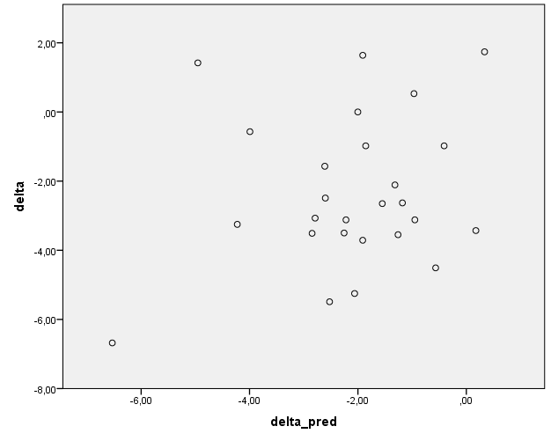

Figure 2a. Scatter plot for predicting the follow-up measure on Cat-PROM5 (transformed by the following operation Cat-PROM5_transformed=ln(-Cat-PROM5+36.826).

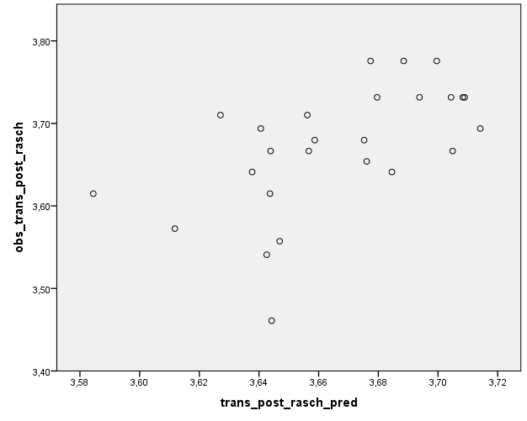

Figure 2b. Scatter plot for predicting the follow-up measure on Cat-PROM5 (back transformed to the original unit of Cat-PROM5: Rasch_pred_trans_back =‑exp(Rasch_transformed_pred) + 36.821.

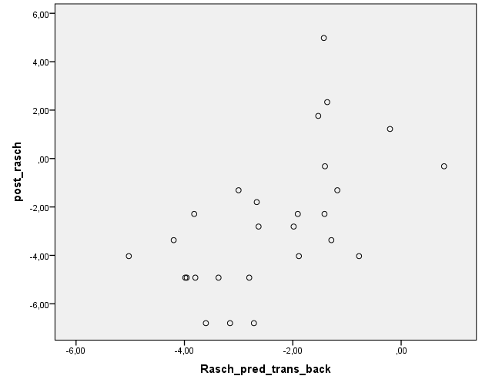

Discussion

Despite the reduced number of available cases the validation analyses have been possible and in general have confirmed that the models do predict self-reported benefit. These results illustrate that both approaches produce reasonably valid predictions, however the model for the follow-up approach is clearly superior. This reflects the fact that the delta approach models a *difference* between two Rasch measures and is therefore subject to a higher measurement error component than the follow-up approach. This is a consequence of the fact that with the delta approach errors from the two subtracted measures accumulate, producing a higher random component in the composite variable than in each of the contributing measurements singly. In terms of making predictions, and as observed here, predictions based on a variable created by the delta approach are subject to higher levels of uncertainty. For these reasons, for future implementation in wider clinical settings, we recommend the follow-up approach as the more robust option.

Conclusion

This exercise on independent data provide an assessment of the performance of the prediction models for self-reported Cat-PROM5 benefit from cataract surgery. Although predictions of both the final score are and improvement (delta approach) are possible, the former is prone to less uncertainty and is proposed as the preferable option.