#### Supplementary Material File 2: Recording instrument for non-participant observations

**NON-PARTICIPANT OBSERVATION TOPIC GUIDE FOR STAKEHOLDER MEETINGS**

**Core evaluation questions as set out in study protocol:**

1. What are the different forms of GP collaboration in primary care in England and how have they been implemented in a sample of urban and rural settings?
2. What are the rationales and incentives for general practices to enter into different forms of collaboration, and what are the reasons for and consequences of not doing so? In particular, what role do financial incentives play in facilitating or inhibiting collaboration? What are the expected outcomes of GP collaborations?
3. What evidence exists about the positive or negative impacts associated with different experiences of establishing (or not) GP collaborations?
4. What are the barriers to and facilitators of effective collaboration across GP practices, both with respect to successful and unsuccessful collaboration, and achieving impact or not?

**Before the meeting begins**

* Reiterate the purpose and approach of the study, and who is funding it and why, and the current stage of the research.
* Ensure the participant has read the information leaflet.
* Ensure the participant feels able to ask any questions about the evaluation including issues about confidentiality, the findings and/or dissemination before giving verbal consent.
* Ensure those participants who do not give consent are informed that no notes will be taken of their contribution.
* Ensure you are seated where you can hear and observe discussions taking place without causing distraction.
* Start making notes.
* At the end of the meeting, reiterate purpose of the study and what happens next, and thank all present for letting us observe.

**Sociogram (including meeting room layout)**

A sociogram is an illustrative representation of social relationships. It is a diagram that details the structure of interpersonal relations in a group situation.

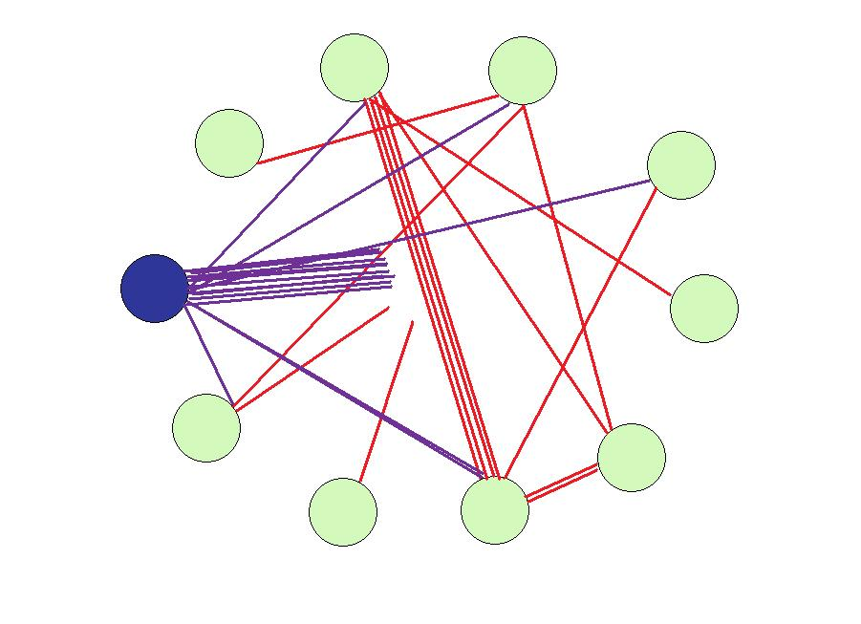

**Themes/content discussed during observation:**

|  |  |  |  |
| --- | --- | --- | --- |
| **Site location:** | **Date:** | **Start time:** | **End time:** |
| **Non-participant observation notes**   1. **Note taking will be content-focused, on what is being said by attendees** 2. **One row of this form should be used for each item on the agenda** 3. **Include identifiers (i.e. initials) within notes to distinguish between attendees** | | | |
| **Agenda item being discussion** | **Time** | **Notes** | **Further Questions/Areas to investigate** |
| **1. Meeting information:**   * **Name/Purpose of meeting** * **Number of attendees** * **Role of each attendee** * **What is covered on the agenda?** |  |  |  |

**Reflexive note taking post non-participant observation (notes should be specific to content discussed within meetings as opposed to researcher interpretations)**

|  |  |
| --- | --- |
| **Theme** | **Comments** |
| Leadership: was a there a demonstration of authority and leadership by some? |  |
| Alliances formed during the meeting? |  |
| Which attendees were impacting upon decision making actions? |  |
| Were some speaking more than others?  Why might that be? |  |
| If this is a follow up meeting, how have contributions from different attendees changed since the previous meeting? |  |
| Was discussion inclusive to support leadership and management as part of the collaboration? |  |
| How were challenges to discussions manifested by attendees?  And what was the nature of any responses to such challenges? |  |
| How was the meeting chaired? What was effective/ineffective with regard to how the discussions were facilitated? |  |
| Is there evidence of attendees being led or influenced by discussions? |  |
| Was strategic direction of PCN clear among discussion?  Was there clarification and evidence to support discussion? |  |
| Were there attendees that were silent or contributed little to discussions?  What may explain their lack of contribution? |  |
| Did the meeting key to time? If not, why?  Did the meeting achieve its main objectives? |  |
| Any other comments? |  |