Table S10.1 shows demographic information for participants recruited in the pre-lockdown data collection period, split by contact centre.

Table S10.1. Baseline demographics for participants involved in pre-lockdown data collection, stratified by contact centre
 |  |  |  | Centre |  |  |  |  |  |  |  |  |  |  |  | Total
 |  |  |  | 1 |  | 2 |  | 3 |  | 6 |  | 10 |  | 11
Age (years) [n=153] | 18-24 |  | 8 |  | 0 |  | 2 |  | 0 |  | 1 |  | 3 |  | 14
 |  |  | 38.1% |  | 0.0% |  | 7.4% |  | 0.0% |  | 3.1% |  | 13.0% |  | 9.2%
 | 25-34 |  | 6 |  | 5 |  | 16 |  | 7 |  | 9 |  | 8 |  | 51
 |  |  | 28.6% |  | 18.5% |  | 59.3% |  | 30.4% |  | 28.1% |  | 34.8% |  | 33.3%
 | 35-44 |  | 2 |  | 6 |  | 4 |  | 8 |  | 13 |  | 9 |  | 42
 |  |  | 9.5% |  | 22.2% |  | 14.8% |  | 34.8% |  | 40.6% |  | 39.1% |  | 27.5%
 | 45-54 |  | 4 |  | 9 |  | 5 |  | 4 |  | 4 |  | 1 |  | 27
 |  |  | 19.0% |  | 33.3% |  | 18.5% |  | 17.4% |  | 12.5% |  | 4.3% |  | 17.6%
 | 55-64 |  | 1 |  | 7 |  | 0 |  | 3 |  | 4 |  | 1 |  | 16
 |  |  | 4.8% |  | 25.9% |  | 0.0% |  | 13.0% |  | 12.5% |  | 4.3% |  | 10.5%
 | > 65 |  | 0 |  | 0 |  | 0 |  | 1 |  | 1 |  | 1 |  | 3
 |  |  | 0.0% |  | 0.0% |  | 0.0% |  | 4.3% |  | 3.1% |  | 4.3% |  | 2.0%
Gender [n=153] | Male |  | 15 |  | 10 |  | 11 |  | 3 |  | 10 |  | 3 |  | 52
 |  |  | 71.4% |  | 37.0% |  | 40.7% |  | 13.0% |  | 31.3% |  | 13.0% |  | 34.0%
 | Female |  | 6 |  | 17 |  | 16 |  | 20 |  | 22 |  | 20 |  | 101
 |  |  | 28.6% |  | 63.0% |  | 59.3% |  | 87.0% |  | 68.8% |  | 87.0% |  | 66.0%
Job title [n=151] | Call handler/ customer services advisor |  | 3 |  | 8 |  | 12 |  | 9 |  | 26 |  | 19 |  | 77
 |  |  | 14.3% |  | 29.6% |  | 44.4% |  | 42.9% |  | 81.3% |  | 82.6% |  | 51.0%
 | Supervisor/ manager/team leader |  | 8 |  | 10 |  | 11 |  | 2 |  | 3 |  | 3 |  | 37
 |  |  | 38.1% |  | 37.0% |  | 40.7% |  | 9.5% |  | 9.4% |  | 13.0% |  | 24.5%
 | Other |  | 10 |  | 9 |  | 4 |  | 10 |  | 3 |  | 1 |  | 37
 |  |  | 47.6% |  | 33.3% |  | 14.8% |  | 47.6% |  | 9.4% |  | 4.3% |  | 24.5%
Employment type [n=151] | Full time |  | 21 |  | 23 |  | 25 |  | 7 |  | 23 |  | 12 |  | 111
 |  |  | 100.0% |  | 88.5% |  | 96.2% |  | 31.8% |  | 69.7% |  | 52.2% |  | 73.5%
 | Part time |  | 0 |  | 3 |  | 1 |  | 15 |  | 10 |  | 11 |  | 40
 |  |  | 0.0% |  | 11.5% |  | 3.8% |  | 68.2% |  | 30.3% |  | 47.8% |  | 26.5%
How long have you been working for this contact centre? [n=154] | <3 months |  | 0 |  | 0 |  | 0 |  | 0 |  | 3 |  | 4 |  | 7
 |  |  | 0.0% |  | 0.0% |  | 0.0% |  | 0.0% |  | 9.1% |  | 17.4% |  | 4.5%
 | 3-6 months |  | 0 |  | 0 |  | 0 |  | 1 |  | 3 |  | 3 |  | 7
 |  |  | 0.0% |  | 0.0% |  | 0.0% |  | 4.3% |  | 9.1% |  | 13.0% |  | 4.5%
 | 6-12 months |  | 0 |  | 0 |  | 6 |  | 7 |  | 0 |  | 1 |  | 14
 |  |  | 0.0% |  | 0.0% |  | 22.2% |  | 30.4% |  | 0.0% |  | 4.3% |  | 9.1%
 | 1-2 years |  | 7 |  | 1 |  | 4 |  | 1 |  | 3 |  | 3 |  | 19
 |  |  | 33.3% |  | 3.7% |  | 14.8% |  | 4.3% |  | 9.1% |  | 13.0% |  | 12.3%
 | 2-3 years |  | 2 |  | 1 |  | 2 |  | 3 |  | 10 |  | 2 |  | 20
 |  |  | 9.5% |  | 3.7% |  | 7.4% |  | 13.0% |  | 30.3% |  | 8.7% |  | 13.0%
 | >3 years |  | 12 |  | 25 |  | 15 |  | 11 |  | 14 |  | 10 |  | 87
 |  |  | 57.1% |  | 92.6% |  | 55.6% |  | 47.8% |  | 42.4% |  | 43.5% |  | 56.5%
Health problems reported that may prevent participant from standing and moving more at work [n=154] | No |  | 17 |  | 22 |  | 25 |  | 19 |  | 30 |  | 22 |  | 135
 |  |  | 81.0% |  | 78.6% |  | 92.6% |  | 82.6% |  | 90.9% |  | 95.7% |  | 87.1%
 | Yes |  | 4 |  | 6 |  | 2 |  | 4 |  | 3 |  | 1 |  | 20
 |  |  | 19.0% |  | 21.4% |  | 7.4% |  | 17.4% |  | 9.1% |  | 4.3% |  | 12.9%

Table S10.2: Baseline demographics for participants involved in post-lockdown data collection, stratified by centre (n=51)
 |  |  |  | Centre |  |  |  |  |  |  |  |  |  | Total
 |  |  |  | 3 |  | 6 |  | 7 |  | 10 |  | 11
Age (years) [n=51] | 18-24 |  | 0 |  | 0 |  | 3 |  | 1 |  | 0 |  | 4
 |  |  | 0.0% |  | 0.0% |  | 16.7% |  | 5.6% |  | 0.0% |  | 7.8%
 | 25-34 |  | 2 |  | 1 |  | 11 |  | 2 |  | 2 |  | 18
 |  |  | 40.0% |  | 14.3% |  | 61.1% |  | 11.1% |  | 66.7% |  | 35.3%
 | 35-44 |  | 2 |  | 4 |  | 2 |  | 7 |  | 0 |  | 15
 |  |  | 40.0% |  | 57.1% |  | 11.1% |  | 38.9% |  | 0.0% |  | 29.4%
 | 45-54 |  | 1 |  | 1 |  | 1 |  | 5 |  | 0 |  | 8
 |  |  | 20.0% |  | 14.3% |  | 5.6% |  | 27.8% |  | 0.0% |  | 15.7%
 | 55-64 |  | 0 |  | 1 |  | 1 |  | 2 |  | 1 |  | 5
 |  |  | 0.0% |  | 14.3% |  | 5.6% |  | 11.1% |  | 33.3% |  | 9.8%
 | > 65 |  | 0 |  | 0 |  | 0 |  | 1 |  | 0 |  | 1
 |  |  | 0.0% |  | 0.0% |  | 0.0% |  | 5.6% |  | 0.0% |  | 2.0%
Gender [n=51] | Male |  | 2 |  | 2 |  | 13 |  | 6 |  | 0 |  | 23
 |  |  | 40.0% |  | 28.6% |  | 72.2% |  | 33.3% |  | 0.0% |  | 45.1%
 | Female |  | 3 |  | 5 |  | 5 |  | 12 |  | 3 |  | 28
 |  |  | 60.0% |  | 71.4% |  | 27.8% |  | 66.7% |  | 100.0% |  | 54.9%
Job title [n=51] | Call handler/customer services advisor |  | 3 |  | 2 |  | 18 |  | 18 |  | 3 |  | 44
 |  |  | 60.0% |  | 28.6% |  | 100.0% |  | 100.0% |  | 100.0% |  | 86.3%
 | Supervisor/manager/team leader |  | 2 |  | 3 |  | 0 |  | 0 |  | 0 |  | 5
 |  |  | 40.0% |  | 42.9% |  | 0.0% |  | 0.0% |  | 0.0% |  | 9.8%
 | Other |  | 0 |  | 2 |  | 0 |  | 0 |  | 0 |  | 2
 |  |  | 0.0% |  | 28.6% |  | 0.0% |  | 0.0% |  | 0.0% |  | 3.9%
Employment type [n=51] | Full time |  | 5 |  | 4 |  | 17 |  | 12 |  | 1 |  | 39
 |  |  | 100.0% |  | 57.1% |  | 94.4% |  | 66.7% |  | 33.3% |  | 76.5%
 | Part time |  | 0 |  | 3 |  | 1 |  | 6 |  | 2 |  | 12
 |  |  | 0.0% |  | 42.9% |  | 5.6% |  | 33.3% |  | 66.7% |  | 23.5%
How long have you been working for this contact centre? [n=51] | <3 months |  | 0 |  | 0 |  | 0 |  | 0 |  | 0 |  | 0
 |  |  | 0.0% |  | 0.0% |  | 0.0% |  | 0.0% |  | 0.0% |  | 0.0%
 | 3-6 months |  | 0 |  | 0 |  | 2 |  | 0 |  | 0 |  | 2
 |  |  | 0.0% |  | 0.0% |  | 11.1% |  | 0.0% |  | 0.0% |  | 3.9%
 | 6-12 months |  | 4 |  | 0 |  | 0 |  | 1 |  | 1 |  | 6
 |  |  | 80.0% |  | 0.0% |  | 0.0% |  | 5.6% |  | 33.3% |  | 11.8%
 | 1-2 years |  | 0 |  | 0 |  | 5 |  | 3 |  | 1 |  | 9
 |  |  | 0.0% |  | 0.0% |  | 27.8% |  | 16.7% |  | 33.3% |  | 17.6%
 | 2-3 years |  | 0 |  | 1 |  | 1 |  | 4 |  | 0 |  | 6
 |  |  | 0.0% |  | 14.3% |  | 5.6% |  | 22.2% |  | 0.0% |  | 11.8%
 | >3 years |  | 1 |  | 6 |  | 10 |  | 10 |  | 1 |  | 28
 |  |  | 20.0% |  | 85.7% |  | 55.6% |  | 55.6% |  | 33.3% |  | 54.9%
Health problems reported that may prevent participant from standing and moving more at work [n=154] | No |  | 4 |  | 7 |  | 14 |  | 16 |  | 3 |  | 44
 |  |  | 80.0% |  | 100.0% |  | 77.8% |  | 88.9% |  | 100.0% |  | 86.3%
 | Yes |  | 1 |  | 0 |  | 4 |  | 2 |  | 0 |  | 7
 |  |  | 20.0% |  | 0.0% |  | 22.2% |  | 11.1% |  | 0.0% |  | 13.7%

Figure S10.3: Hours sitting at work per week stratified by sequence
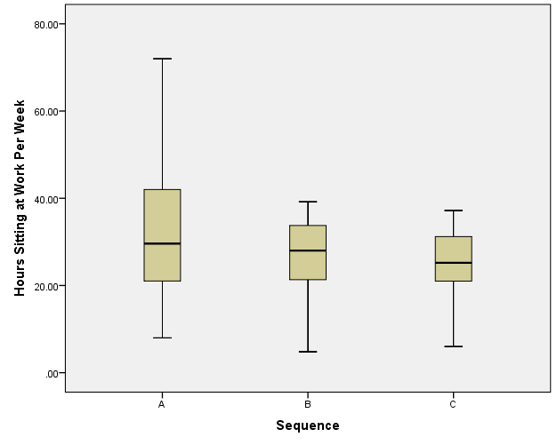
Figure S10.4: Hours sitting at work per week stratified by centre
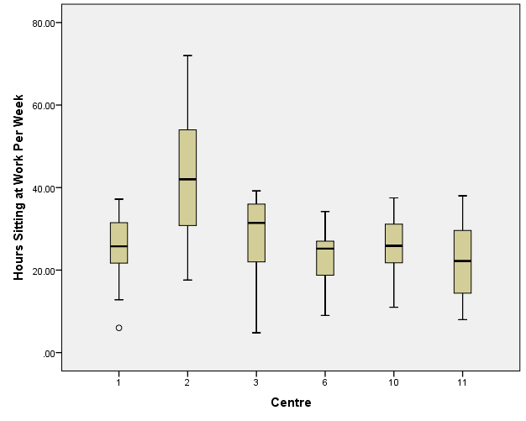

Figure S10.5: Minutes sitting at work per day stratified by sequence
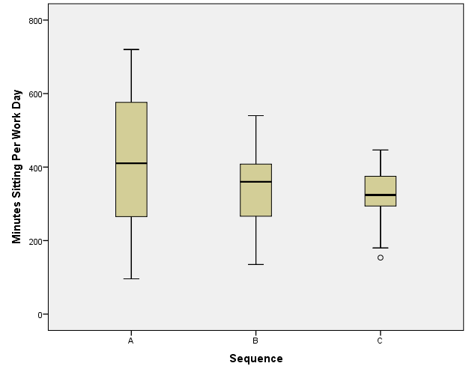
Figure S10.6: Minutes sitting at work per day stratified by centre
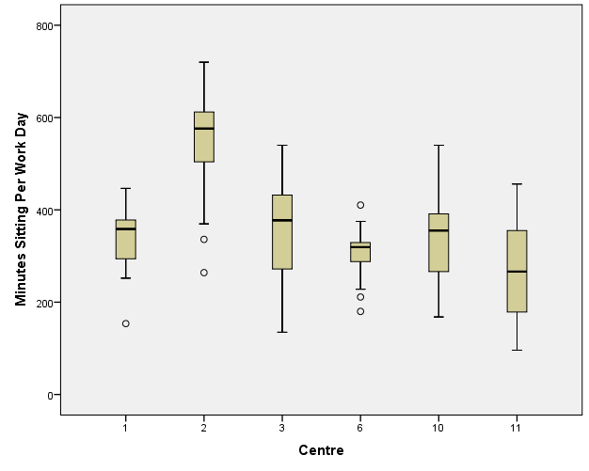

Figure S10.7: WEMWBS Total score stratified by sequence
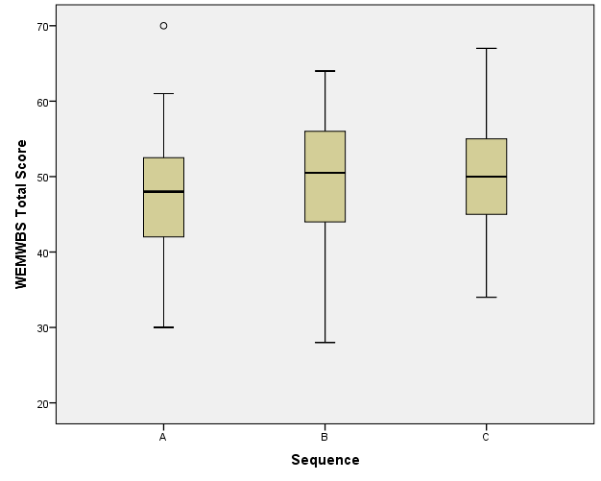
Figure S10.8: WEMWBS Total score stratified by centre
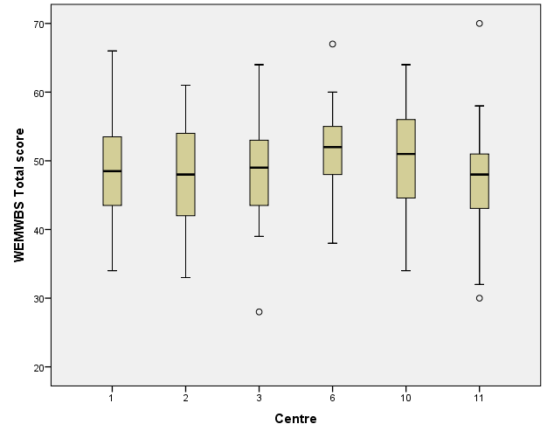

Figure S10.9: Mean UWES stratified by sequence
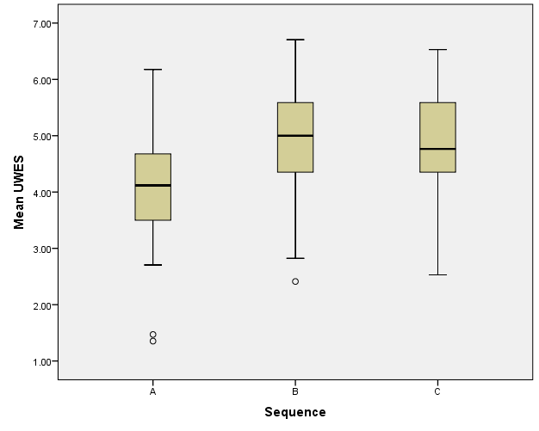
Figure S10.10: Mean UWES stratified by centre
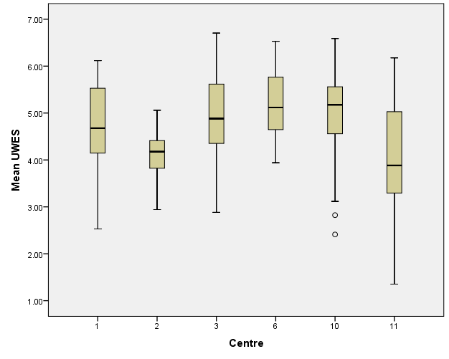

Figure S10.11: MSK Total Score stratified by sequence
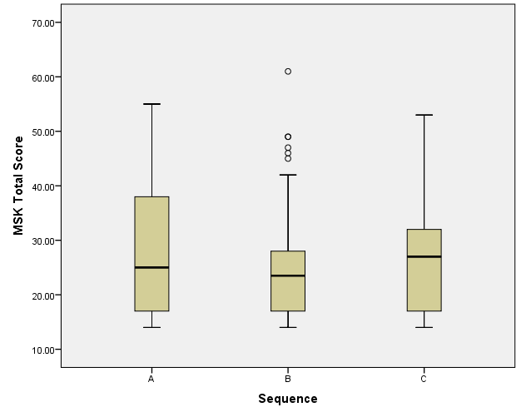

Figure S10.12: MSK Total Score stratified by centre

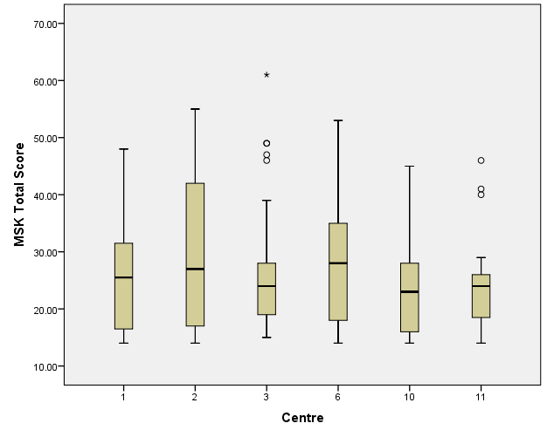

Figure S10.13: Scatterplot showing minutes sitting at work at baseline and 3 months follow-up
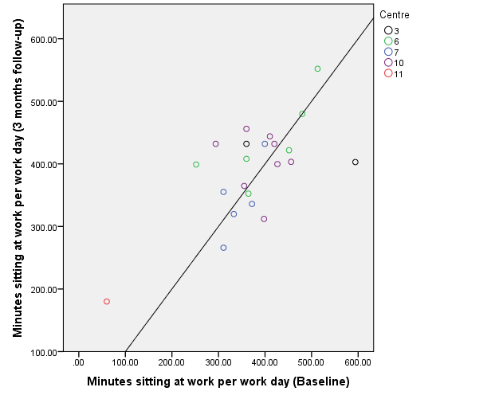

Figure S10.14: Scatterplot showing total WEMWBS at baseline and 3 months follow-up
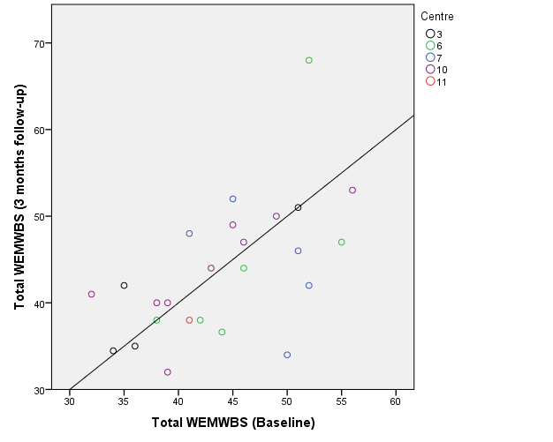

Figure S10.15: Scatterplot showing mean UWES at baseline and 3 months follow-up
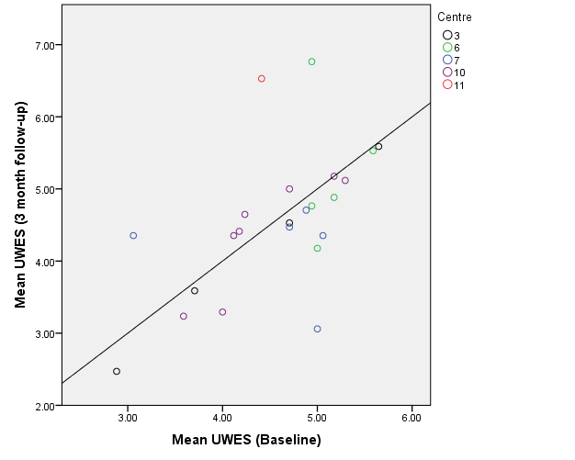

Figure S10.16: Scatterplot showing MSK-HQ Total score at baseline and 3 months follow-up

