

**Stand Up for Health**

**Evaluation Questionnaire**

Name of participant:

Contact Centre:

Date:

Participant id (to be added by researcher):

1. **About You**

Please provide the following demographic information or select the appropriate option.

1. Age:

 < 18 years  18-24 years  25-34 years

 35-44 years  45-54 years  55-64 years  > 65 years

1. Gender. I self identify as:

 Male  Female  Non-binary  Other  Prefer not to say

1. Job title: ________________________________
2. Employment type: Full-time Part-time
3. How long have you been working for this contact centre?

 < 3 months  3 – 6 months  6 – 12 months

 1 – 2 years  2 -3 years  > 3 years

1. Have you previously worked for a company which used the Stand Up for Health intervention?

 Yes

 No

If yes, please specify:

Name of the previous organisation: ________________________________

Location of previous organisation: _________________________________

1. Is there anything you would like to tell us about your health which would prevent you from standing and moving more at work?
2. **The Occupational Sitting and Physical Activity Questionnaire (OSPAQ)**
3. How many hours did you work in the last 7 days?

______________ hours

1. During the last 7 days, how many days were you at work?

_____________ days

1. How would you describe your **typical** work day in the last 7 days? (this involves only your work day, and does not include travel to and from work, or what you did in your leisure time)

a. Sitting (including driving) ________%  
b. Standing ________%  
c. Walking ________%  
d. Heavy labour or physically demanding tasks. ________%

Make sure this adds up to 100%

Total ________%

*Chau, JY., et al. Validity of the occupational sitting and physical activity questionnaire. Medicine and Science In Sports & Exercise. 2011, 44: 118-25.*

1. **The Warwick–Edinburgh Mental Well-being Scale (WEMWBS)**

Below are some statements about feelings and thoughts.  
Please circle the box that best describes your experience of each over the **last 2 weeks.**

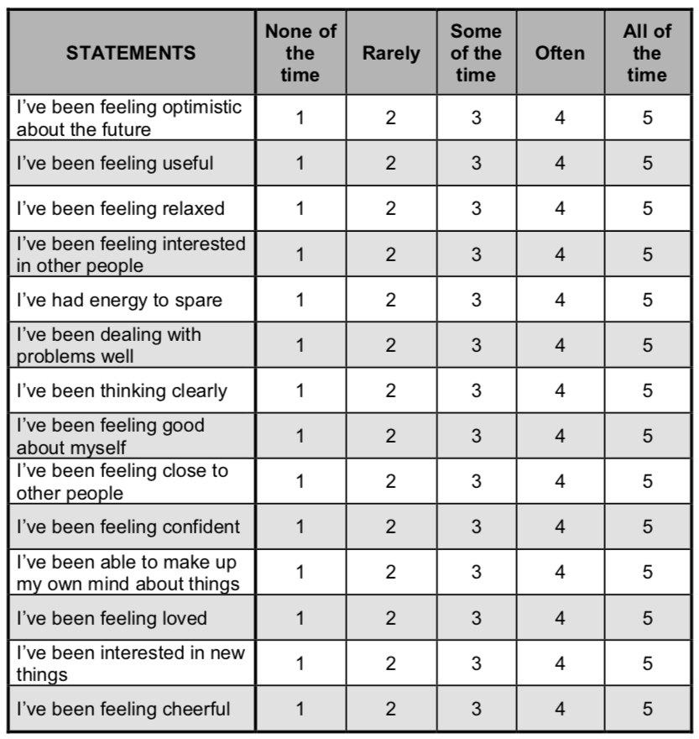

Warwick–Edinburgh Mental Well-being Scale (WEMWBS)  
© NHS Health Scotland, University of Warwick and University of Edinburgh, 2006, all rights reserved

1. **Work & Well-being Survey (UWES) ©**

The following 17 statements are about how you feel at work. Please read each statement carefully and decide if you ever feel this way about your job. If you have never had this feeling, tick the ‘0’ (zero) in the space after the statement. If you have had this feeling, indicate how often you feel it by ticking the number (from 1 to 6) that best describes how frequently you feel that way.

|  |  |  |  |  |  |  |  |  |
| --- | --- | --- | --- | --- | --- | --- | --- | --- |
|  |  | **0**  **Never** | **Almost never**  **1**  **A few times a year or less** | **Rarely**  **2**  **Once a month or less** | **Sometimes**  **3**  **A few times a month** | **Often**  **4**  **Once a week** | **Very often**  **5**  **A few times a week** | **Always**  **6**  **Every day** |
| 1 | At my work, I feel bursting with energy |  |  |  |  |  |  |  |
| 2 | I find the work that I do full of meaning and purpose |  |  |  |  |  |  |  |
| 3 | Time flies when I'm working |  |  |  |  |  |  |  |
| 4 | At my job, I feel strong and vigorous |  |  |  |  |  |  |  |
| 5 | I am enthusiastic about my job |  |  |  |  |  |  |  |
| 6 | When I am working, I forget everything else around me |  |  |  |  |  |  |  |
| 7 | My job inspires me |  |  |  |  |  |  |  |
| 8 | When I get up in the morning, I feel like going to work |  |  |  |  |  |  |  |
| 9 | I feel happy when I am working intensely |  |  |  |  |  |  |  |
| 10 | I am proud of the work that I do |  |  |  |  |  |  |  |
| 11 | I am immersed in my work |  |  |  |  |  |  |  |
| 12 | I can continue working for very long periods at a time |  |  |  |  |  |  |  |
| 13 | To me, my job is challenging |  |  |  |  |  |  |  |
| 14 | I get carried away when I’m working |  |  |  |  |  |  |  |
| 15 | At my job, I am very resilient, mentally |  |  |  |  |  |  |  |
| 16 | It is difficult to detach myself from my job |  |  |  |  |  |  |  |
| 17 | At my work I always persevere, even when things do not go well |  |  |  |  |  |  |  |

© Schaufeli & Bakker (2003).

1. **Musculoskeletal Health Questionnaire (MSK-HQ)**

This questionnaire is about any joint, back, neck, bone and muscle symptoms such as aches, pains and/or stiffness you may have experienced over the last 2 weeks.

For each question tick (🗸) one box to indicate which statement best describes you over the **last 2 weeks**.

|  |  |  |  |  |  |
| --- | --- | --- | --- | --- | --- |
| **1. Pain/stiffness** during the **day**  How severe was your usual joint or muscle pain and/or stiffness overall during the **day** in the last 2 weeks? | Not at all  4 | Slightly  3 | Moderately  2 | Fairly severe  1 | Very severe  0 |
| **2. Pain/stiffness** during the **night**  How severe was your usual joint or muscle pain and/or stiffness overall during the **night** in the last 2 weeks? | Not at all  4 | Slightly  3 | Moderately  2 | Fairly severe  1 | Very severe  0 |
| **3. Walking**  How much have your symptoms interfered with your ability to walk in the last 2 weeks? | Not at all  4 | Slightly  3 | Moderately  2 | Severely  1 | Unable to walk  0 |
| **4. Washing/Dressing**  How much have your symptoms interfered with your ability to wash or dress yourself in the last 2 weeks? | Not at all  4 | Slightly  3 | Moderately  2 | Severely  1 | Unable to wash or dress myself  0 |
| **5. Physical activity levels**  How much has it been a problem for you to do physical activities (e.g. going for a walk or jogging) to the level you want because of your joint or muscle symptoms in the last 2 weeks? | Not at all  4 | Slightly  3 | Moderately  2 | Very much  1 | Unable to do physical activities  0 |

|  |  |  |  |  |  |
| --- | --- | --- | --- | --- | --- |
| **6. Work/daily routine**  How much have your joint or muscle symptoms interfered with your work or daily routine in the last 2 weeks (including work & jobs around the house)? | Not at all  4 | Slightly  3 | Moderately  2 | Severely  1 | Extremely  0 |
| **7. Social activities and hobbies**  How much have your joint or muscle symptoms interfered with your social activities and hobbies in the last 2 weeks? | Not at all  4 | Slightly  3 | Moderately  2 | Severely  1 | Extremely  0 |
| **8. Needing help**  How often have you needed help from others (including family, friends or carers) because of your joint or muscle symptoms in the last 2 weeks? | Not at all  4 | Rarely  3 | Sometimes  2 | Frequently  1 | All the time  0 |
| **9. Sleep**  How often have you had trouble with either falling asleep or staying asleep because of your joint or muscle symptoms in the last 2 weeks? | Not at all  4 | Rarely  3 | Sometimes  2 | Frequently  1 | Every night  0 |
| **10. Fatigue or low energy**  How much fatigue or low energy have you felt in the last 2 weeks? | Not at all  4 | Slight  3 | Moderate  2 | Severe  1 | Extreme  0 |
| **11. Emotional well-being**  How much have you felt anxious or low in your mood because of your joint or muscle symptoms in the last 2 weeks? | Not at all  4 | Slightly  3 | Moderately  2 | Severely  1 | Extremely  0 |

|  |  |  |  |  |  |
| --- | --- | --- | --- | --- | --- |
| **12. Understanding of your condition and any current treatment** Thinking about your joint or muscle symptoms, how well do you feel you understand your condition and any current treatment (including your diagnosis and medication)? | Completely  4 | Very well  3 | Moderately  2 | Slightly  1 | Not at all  0 |
| **13. Confidence in being able to manage your symptoms** How confident have you felt in being able to manage your joint or muscle symptoms by yourself in the last 2 weeks (e.g. medication, changing lifestyle)? | Extremely  4 | Very  3 | Moderately  2 | Slightly  1 | Not at all  0 |
| **14. Overall impact**  How much have your joint or muscle symptoms bothered you overall in the last 2 weeks? | Not at all  4 | Slightly  3 | Moderately  2 | Very much  1 | Extremely  0 |

MSK-HQ – Questionnaire for joint, back, neck, bone and muscle symptoms

MSK-HQ © Copyright Oxford University Innovation Limited 2014. All Rights Reserved.

1. **Scottish Physical Activity Screening Question (Scot-PASQ)**

In the past week, on how many days have you been physically active for a total of 30 minutes or more? Physical activity may include: walking or cycling for recreation or to get to and from places; gardening; and exercise or sport which lasts for at least 10 minutes.

0 1 2 3 4 5 6 7

If four days or less, have you been physically active for at least two and a half hours (150 minutes) over the course of the past week?

 Yes  No

<http://www.paha.org.uk/Resource/scottish-physical-activity-screening-question-scot-pasq>

1. **Participant Activity Questionnaire**

Please find below a list of different groups of activities. Please indicate whether you participated in these activities in the last 3 months.

|  |  |  |  |
| --- | --- | --- | --- |
| **Activity** | Yes, I participated | No, I did not participate | Not sure |
| 1. Social activities (Step count challenge, walks/activities with those in your household/colleagues) |  |  |  |
| 2. Social activities- Virtual social activities with an active component (bingo/quiz with active component/virtual social exercise classes) |  |  |  |
| 3. Individual activity- Goal setting |  |  |  |
| 4. Individual activity- Desktop stretches |  |  |  |
| 5. Individual activities- Exercise videos and apps |  |  |  |
| 6. Individual activities- Other (e.g.: walking, running, cycling) |  |  |  |
| 7. Individual activity- Used mindfulness resources |  |  |  |
| 8. Individual activity- Used Stand Up for health website |  |  |  |
| 9. Environmental activity- Made changes to desk space to help reduce sitting |  |  |  |

**Thank you for taking the time to complete this questionnaire!**