Supplementary File 11: Dissemination pathways representing who currently receives feedback from a national comparative audit of blood transfusion. (from Gould et al. 2018)1

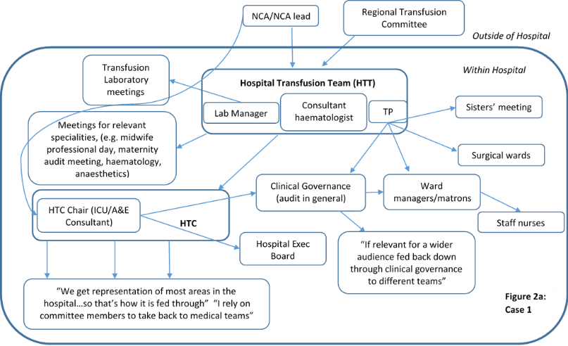 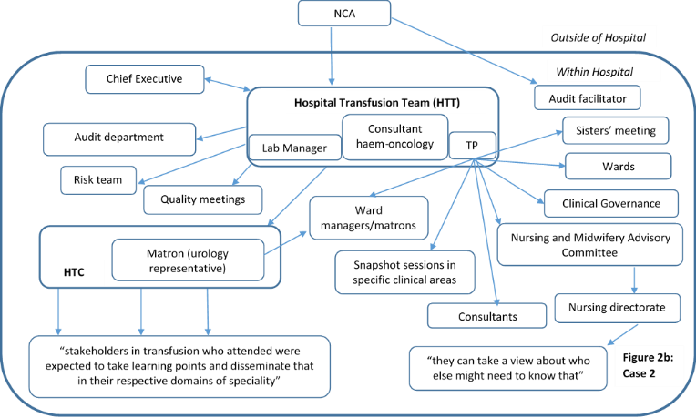

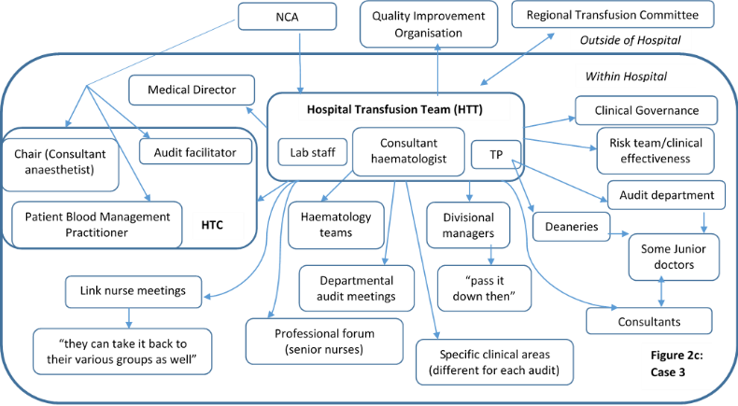 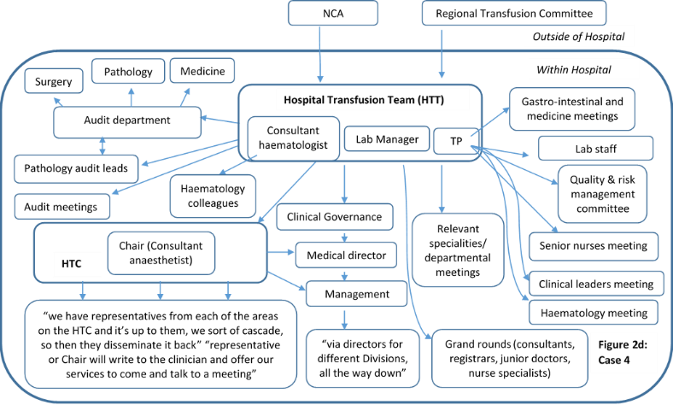

Note. A&E = Accident & Emergency; HTC = Hospital Transfusion Committee; ICU=Intensive Care Unit; NCA=National Comparative Audit; NHS=National Health Service; TP=Transfusion Practitioner

1Gould NJ, Lorencatto F, During C, Rowley M, Glidewell L, Walwyn R, Michie S, Foy R, Stanworth SJ, Grimshaw JM, Francis JJ. How do hospitals respond to feedback about blood transfusion practice? A multiple case study investigation. PloS one. 2018 Nov 1;13(11):e0206676.