Supplementary File 21: Presence of six proposed enhancements to design and content of feedback reports in Enhanced Content intervention reports in Trial 1 and 2

Enhancement | Brief Description | Example Trial 1 | Example Trial 2
Ensure feedback delivered is clearly related to an audit standard, and place supplementary findings in an appendix report | The main feedback report(s) should only contain information that is clearly linked to the audit standards. Minimal information on clinical context may be included to support interpretation of feedback. Remaining information on clinical context should be placed in a supplementary file/ appendix | Reports from both Trials were prepared taking a graded entry approach:  Key findings: headline findings and recommendations for agreed upon most important standards. Five pages maximum. Intended for wider circulation to front line staff from different clinical specialities  Full findings: feedback on performance in relation to each of the audit standards, alongside a recommendation for each standard and action plan. Only minimal background information presented to aid interpretation of feedback (e.g. essential information on patient case mix). Intended for use by hospital transfusion team and hospital transfusion committee.  Supplementary findings: All additional information and detailed findings not essential to interpreting feedback in relation to audit standards (e.g. additional detailed breakdown on patient characteristics).
Ensure audit standards, feedback, recommendations and action plans are behaviourally specific | Behavioural specificity = Who should do what, to whom, when, where?  - Who is responsible for performing behaviour (e.g. Nurses)  - What action is performed (e.g. Check wristband) - Who is the recipient of the behaviour (Patient group)  - When behaviour is performed (e.g. Immediately pre-transfusion)  - Where behaviour is performed (e.g. At the bedside) Specified behaviour = Nurses should check patients’ wristbands at the bedside immediately pre-transfusion.  To the extent that is appropriate/feasible, phrase audit standards, feedback, recommendations and action plans so that they are behaviourally specific | Surgical Patient Blood Management Standard 5:  For patients undergoing elective major blood loss surgery who are taking oral anticoagulants and/or antiplatelet agents (whom), clinical staff (who) must stop the oral anticoagulant and/or antiplatelet agents (what) at least 5 days pre-operatively (when). | Haematology Audit Standard 1:  Clinical staff (Who) should measure haemoglobin (what) prior to transfusion of red cells (when) in haematology patients (whom) (within 24 hours for inpatients and 72 hours for day patients (when).
Include behaviour change techniques (BCTs) consistent with Control Theory in each feedback report | In each feedback report, include at least one BCT from each cluster of BCTs associated with CT:  (1) Goal-setting - Goal-setting (Beh) - Goal-setting (Outcome) -Review Beh. Goal -Review Outcome Goal  (2) Monitoring - Self-monitoring (Beh.) - Self-monitoring (Outcome)  (3) Feedback -Feedback (Beh) -Feedback (Outcome) -Discrepancy between Beh/Goal  (4) Action Planning -Problem Solving - Action Planning | (1) Recommendation for change in light of feedback  e.g. Clinical staff should only prescribe a red cell transfusion in stable non- bleeding patients who have a pre-transfusion Hb of less than 70g/L or less than 80g/L in those with acute coronary syndrome  (2) Prompting self-monitoring:  e.g. The Hospital Transfusion / PBM team should work with clinicians to continue to monitor practice in relation to this standard by conducting further local audits of the proportions of patients receiving single or more than one unit transfusions, and feeding back these findings to clinical teams.  (3) Feedback on behaviour/ outcome:  e.g. Clinical staff stopped oral anticoagulation at least 5 days pre-operatively in 100% (3/3) of our patients compared to 87% (315/361) nationally.  (4) action planning  e.g. action plan template at end of each report | (1)Audit standards/ performance targets  e.g. Clinical staff should onl y transfuse red cells in normovolaemic haematology inpatients without additional risk factors (cardiovascular disease or signs or symptoms of cardiovascular compromise, severe sepsis or acute cerebral ischaemia) if their pre-transfusion Hb is less than 70g/L.  (2) Prompting self-monitoring:  The Trust should ensure that the HTC has an audit schedule that includes NCA, regional and local transfusion audits.  There are resources available to help continue regular local transfusion audits:  http://hospital.blood.co.uk/audits/  nhsbt-clinical-audit/  It is recommended that local audits are conducted annually.  (3) Feedback on behaviour/ outcome:  Our clinical staff transfused red cells in line with recommended practice in 0.0% (0/3) of haematology patients compared with 17.1% (163/955) nationally.  (4) action planning  e.g. action plan template at end of each report
Consider multiple comparators | Consider including alternative comparators in addition to the audit standards, National median, and regional comparisons currently used. In particular, include achievable comparators (i.e. top 10%). Graphs (see example below) can be an effective way of communicating multiple comparative data. Past performance is also a potential comparator. | Reports from both trials included graphs with multiple comparators:  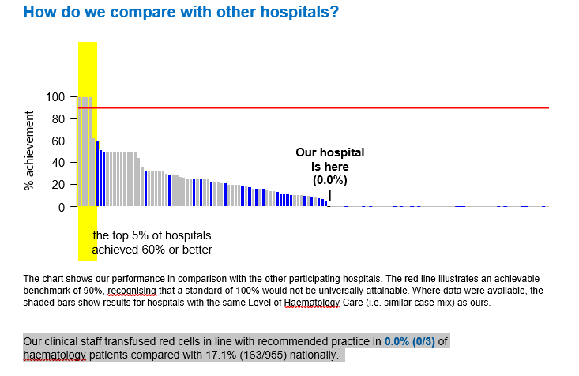
If performance is high/achieving the standard, include a positive message of encouragement | When hospitals achieve the standard/ achievable benchmark (or improve relative to past behaviour), include a recommendation outlining the importance of recognising, encouraging and maintaining this achievement. Also note that it is important to emphasise this achievement as it represents good patient care | Well done. We showed a high level of achievement in this standard. We are performing within the top third of hospitals nationally. This demonstrates strong support for PBM within our hospital. However, there is room to further improve our practice. | Well done. We showed a high level of achievement in this standard. We are performing within the top 80% of hospitals nationally.
Modes of delivery/ multiple modalities | Clinical staff consistently reported a strong preference for feedback delivered in a visual format (i.e. graphs, tables, charts) rather than text. • Where possible, consider presenting key findings in both writing and in a visual format. | Reports from both trials presented feedback on performance graphically, with an accompanying summary in writing:  