Supplementary File 6:. Behaviour Change Techniques (BCTs) identified at least once across all included feedback documents, presented in ranked order from highest to lowest proportion of feedback documents identified in. BCTs consistent with Control Theory are presented in italics and marked with *
BCT Label | AUDIT A  No. feedback documents identified in (max n=4) | AUDIT B  No. feedback documents identified in (max n=4) | AUDIT C  No. feedback documents identified in (max n=4) | TOTAL % documents identified in (n=12) | Examples
Feedback on the behaviour* | 4 | 3 | 4 | 92% | ‘The majority, 69% (2283/ 3296) of the platelet transfusions, were prophylactic and 34% (782/ 2283) of these were considered to be inappropriate, mostly 26% (602/ 2283) because of transfusion above the recommended platelet count’ [Cycle 2, Key findings report]
Information on health consequences of the behaviour | 3 | 4 | 4 | 92% | ‘There is a well-recognised risk of over transfusion leading to transfusion associated circulatory overload (TACO) as the result of doctors inappropriately prescribing the volume by units rather than millilitres (mls) to infants and young children’ [Cycle 3, Main audit findings report]
Goal setting (Behaviour)* | 4 | 4 | 3 | 92% | ‘An indication of whether or not the transfusion achieved the desired effect (either post transfusion increment rates or improvement in patient symptoms) and details of any reactions to the transfusion should be documented in the patient s notes’ [Cycle 3, Main audit findings report]
Feedback on outcome of the behaviour* | 4 | 2 | 3 | 75% | ‘Table presenting the percentage of patients that had a post-trans haemoglobin greater than 20g/dl for non-radiotherapy patients, presented nationally vs. ‘your site’ (i.e. the individual hospital whose findings are presented in the report). [Cycle 1, Audit findings report part 1]
Credible source | 4 | 3 | 2 | 75% | ‘Audit standards for the use of platelet transfusions were obtained from respective British Committee for Standards in Haematology (BCSH) guidelines on the use of platelet transfusions’ [Cycle 2, Main audit findings report]
Action planning* | 2 | 4 | 2 | 67% | Recommendation Compliance Action required by Action completed  The BCSH guidelines on the use of platelet transfusions should be updated BCSH Taskforce  [Cycle 2, Action Plan]
Discrepancy between current behaviour and goal* | 3 | 2 | 2 | 58% | ‘Standard 1: All patients should have a pre-transfusion haemoglobin taken, preferably within 72 hours. Our hospital achieved this standard for 82% of patients.’ [Cycle 1, Audit findings report part 2].
Social comparison | 2 | 2 | 2 | 50% | 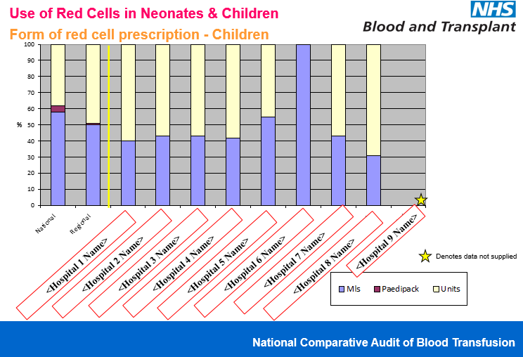  [Cycle 3, Regional Slideshow]
Instruction on how to perform a behaviour | 3 | 2 | 1 | 50% | ‘We suggest you use both your local audit findings and the national comparisons given to assist you in evaluating the quality of transfusion management of adult medical patients in your hospital.’ [Cycle 1, Audit findings report part 1]
Information on social/ environmental consequences of the behaviour | 2 | 2 | 0 | 33% | ‘In keeping with audits of blood use, the majority of patients receiving red cells are over 65 years and this has implications for future red cell demand’ [Cycle 1, Audit findings report part 1]
Behavioural substitution | 2 | 0 | 0 | 17% | ‘A 2 unit transfusion is the most common prescription; it may be that a single unit transfusion is sufficient to bring the Hb above the threshold’ [Cycle 1, Audit Findings report part 1]
Goal setting (outcome*) | 2 | 0 | 0 | 17% | ‘No-non-radiotherapy patient should have a post-transfusion Hb > 12g/dl’  [Cycle 1, Interim report]
Social support (practical) | 2 | 0 | 0 | 17% | National Blood Transfusion Committee patient blood management committee and National Institute for Health and Care excellence transfusion group will develop tools to guide appropriate transfusion decisions for physicians, and to support the recognition, investigation, and effective treatment of anaemia (i.e. anaemia toolkit). [Cycle 1; action plan in Audit findings report part 2]
Social reward | 1 | 0 | 0 | 8% | ‘Much of the transfusion practice seen was appropriate, and reflects the high quality of care given to patients’ [Cycle 1, Audit findings report]
Review behavioural goal | 1 | 0 | 0 | 8% | ‘each Foundation Doctor/ primary auditor was asked to discuss the anonymised patients with the consultant supervisor in order to review whether transfusion could have been avoided or whether the transfusion was in fact appropriate’ [Cycle 1, Audit findings report part 2]
Self-monitoring (Behaviour)* | 0 | 0 | 0 | 0% | n/a
Self-monitoring (outcome)* | 0 | 0 | 0 | 0% | n/a
Review outcome goals* | 0 | 0 | 0 | 0% | n/a
Problem solving* | 0 | 0 | 0 | 0% | n/a

*Behaviour change techniques presented in italics and starred are those consistent with Control Theory

