**Project document 1 –** **Supporting information for healthcare professional discrete choice experiment**

**PoPSTER: Patient preferences and current Practice for adults with STERoid resistance ulcerative colitis – Healthcare Professional Discrete Choice Experiment**  
   
 **Name of lead researcher: Professor Alan Lobo (Chief Investigator)**  
 **IRAS Number: 255616**  
   
Thank you for your interest in taking part in this online survey. The aim of this study is to explore healthcare professionals’ preferences for the treatment of steroid resistant ulcerative colitis. In particular, we are interested in establishing their relative strength of preference for different treatment options. This will be done through the use of an online survey.  
   
 **Before you decide if you would like to take part,** it is important to understand why the research is taking place, and what it will involve for you. Please read the Plain Language Statement below. Then, if you are happy to proceed, please select the box at the bottom of the screen to confirm you have read an understood the Plain Language Statement and consent to the survey.   
   
**Plain Language Statement**

**Why have I been invited to take part?**   
This survey is open to any staff with a Medical or Nursing Health Professional with a specialist interest or expertise in providing care to patients with Inflammatory Bowel Disease (IBD) (particularly UC) within an NHS Trust in the UK. We are looking to recruit 100 healthcare professionals and 300 patients in this study.  
   
 **What would my participation involve?**  
If you decide to take part after reading this information you can complete the survey online straight away. The survey will take around 10-15 minutes to complete. The online survey can be completed via a smart phone, tablet, or computer, however, a paper copy can be available upon request that can be returned via a freepost envelope.

The survey has three parts. In the first part you will be asked to look at pairs of different treatments and to choose one that you would offer to a patient. In the second part you will be asked about you and your work with people with ulcerative colitis. In the final part, you will be asked what you thought of the survey.

Upon successful completion of the survey you will be returned to your panel platform where you can then close the survey window.  
   
 **Do I have to take part?**  
 There is no obligation to take part in the study. Participation is entirely voluntary and you are free to end your participation at any time before you complete the survey, without needing to give a reason. If you do take part, you are free to stop completing the survey at any time, however, your survey responses up until that point will be saved, and we will be unable to withdraw your data. This is because we do not collect any of your personal or identifying information so will not be able to identify and remove your data.   
   
 **What are the potential benefits and disadvantages of taking part?**  
 We hope that you will find the process beneficial as an opportunity to share your opinions and preferences in regards to potential treatment options for patients with steroid resistant UC. It is hoped that valuable information will be gained through this research about which are the most valued aspects of treatment for steroid resistant ulcerative colitis patients. There are no major disadvantages to the study, only the time it takes to complete the survey.  
   
 **What will happen to my information?**  
 This survey is hosted online by the University of Sheffield. Please note that any information you enter will be stored and processed using services provided by Qualtrics. These services have been the subject of independent assessment to ensure compliance with applicable data security standards. Further information can be found on the Qualtrics website (<https://www.qualtrics.com/security-statement/>).  
   
 Your personal and study data will be retained for a period of 5 years after the end of the project, following this it will be destroyed. After the project has ended, this information will be stored within the Clinical Trials Research Unit at the University of Sheffield, who are responsible for coordinating the PoPSTER research programme. Electronic data will be stored in an access restricted folder in the University’s Shared Network Filestore.  
   
 **Will my information be kept confidential?**  
 All of the information that is collected will be kept strictly confidential. The information you provide will not be used in any way that could identify you. We will not be collecting names or postal addresses. Only the project team will have access to the anonymised data and it will be used only for the purposes of this research.  
   
 **Use of my data**  
 Sheffield Teaching Hospital NHS Foundation Trust (STH NHSFT) is the sponsor for this study based in the United Kingdom and will act as the data controller for this study. This means that we are responsible for looking after your information and using it properly. At the end of the study, STH NHSFT will archive the study anonymously for a minimum of 5 years.  
   
 Your rights to access, change or move your information are limited, as we need to manage your information in specific ways in order for the research to be reliable and accurate. If you withdraw from the study, we will keep the information about you that we have already obtained. To safeguard your rights, we will use the minimum personally-identifiable information possible.  
   
 You can find out more about how we use your information at <http://www.sth.nhs.uk/NHS/InformationGovernance/>  
   
 All information collected during this study will be kept confidential. However, authorised representatives from the hospital research office or UK regulatory authorities might perform an audit of the study and review the study data.  
   
 This information will not identify you and will not be combined with other information in a way that could identify you. The information will only be used for the purpose of health and care research, and cannot be used to contact you or to affect your care. It will not be used to make decisions about future services available to you, such as insurance.  
   
 If you wish to raise a complaint on how we have handled your data, you can contact our Data Protection Officer who will investigate the matter. If you are not satisfied with our response or believe we are processing your personal data in a way that is not lawful you can complain to the Information Commissioner’s Office (ICO). Our Data Protection Officer is Peter Wilson and you can contact them by phone (0114 2265153) or email (Peter.Wilson@nhs.net).  
   
 **Who has reviewed this project?**  
 The study has been reviewed and approved by an independent NIHR Scientific Panel, the Health Research Authority (HRA) and the NHS Research Ethics Committee – East Midlands – Derby (19/EM/0011).  
   
 **Who can I contact about this study?**  
 If you have any questions about the research, please contact the research team, using the following details: Tara Wickramasekera, ScHARR, University of Sheffield, email or phone 0114 222 4349.  
   
 If you wish to contact the Chief Investigator of the study, please use these details: Professor Alan Lobo, Consultant Gastroenterologist, Gastroenterology and Liver Unit  
 P Floor, Royal Hallamshire Hospital, Sheffield Teaching Hospitals NHS Foundation Trust, Glossop Road, Sheffield, S10 2JF, Email: [alan.lobo@nhs.net](mailto:alan.lobo@nhs.net)  
   
 If you have any problems with the conduct of this research, please feel free to contact: Dipak Patel, Clinical Research and Innovation office, D floor, Royal Hallamshire Hospital   
 Sheffield Teaching Hospitals NHS Foundation Trust, Glossop Road, Sheffield, S10 2JF   
 Email: [sthresearchadministration@nhs.net](mailto:sthresearchadministration@nhs.net)  
   
   
 **Before starting the survey, please confirm that you are aged over 18 years of age, have read all of information above and consent to take part in the survey.**

1. I consent, begin the study
2. I do not consent, I do not wish to participate

**Please imagine that you are treating the following patient:**

* A patient with known ulcerative colitis for three years has ongoing symptoms despite 4 weeks of taking prednisolone 40mg daily, orally.
* The patient has a stool frequency of six times per day, with blood and mucus, but normal blood test results (ESR, haemoglobin and CRP). Stool cultures are negative.
* The patient is on a full dose of oral aminosalicylates.
* The patient has had no hospital admissions and no other flares in the last 2 years.

We would like to understand what factors would affect your decision to prescribe a treatment for a patient with the symptoms described above – focusing on efficacy and safety. So, we are going to ask you to make a series of 13 choices.

In each question you will be asked to choose between two *hypothetical* treatments that you could offer to the patient. Treatments A and B in each scenario therefore do not necessarily correspond to a particular, currently available drug, though the values for the drug characteristics have been taken from trial results and available literature.

The two treatments offered in each comparison differ in the following characteristics:

1. **Efficacy – the likelihood of induction therapy successfully leading to a clinical response (significant improvement in clinical symptoms):**

Possible levels:

* 40%
* 50%
* 60%

1. **Likelihood of a treatment achieving mucosal healing (Mayo endoscopic sub score ≤1 )**

Possible levels:

* 40%
* 50%
* 60%

1. **Efficacy as a maintenance treatment: likelihood of achieving clinical response at 12 months:**

Possible levels:

* 35%
* 50%
* 70%

1. **Risk of Lymphoma:**

Possible levels:

* 3 in 10,000 patient years
* 5 in 10,000 patient years
* 8 in 10,000 patient years

1. **Risk of serious infection – (the baseline risk in patients unexposed to immunosuppressive medication is approximately 1-2 per 100 patient years):**

Possible levels:

* 1 in100 patient years
* 5 in 100 patient years
* 10 in 100 patient years

Q1.

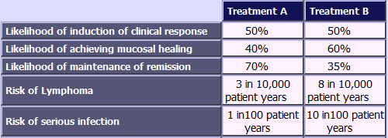

Which treatment would you choose?

1. Treatment A
2. Treatment B

Q2.

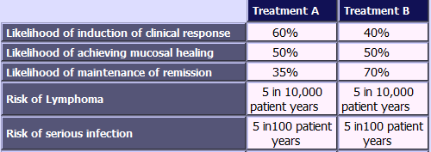

Which treatment would you choose?

1. Treatment A
2. Treatment B

Q3.

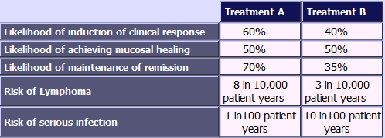

Which treatment would you choose?

1. Treatment A
2. Treatment B

Q4.

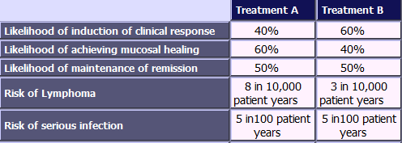

Which treatment would you choose?

1. Treatment A
2. Treatment B

Q5.

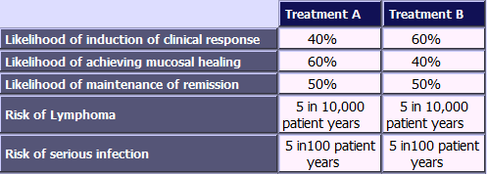

Which treatment would you choose?

1. Treatment A
2. Treatment B

Q6.

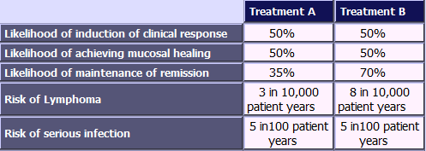

Which treatment would you choose?

1. Treatment A
2. Treatment B

Q7.

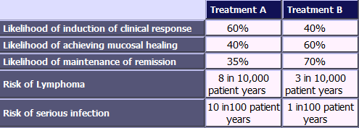

Which treatment would you choose?

1. Treatment A
2. Treatment B

Q8.

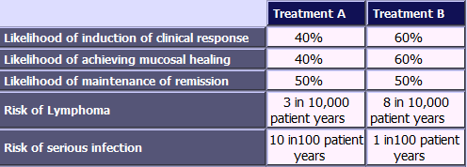

Which treatment would you choose?

1. Treatment A
2. Treatment B

Q9.

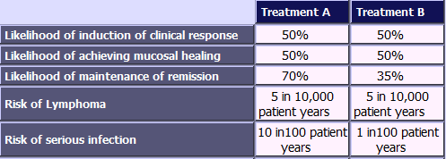

Which treatment would you choose?

1. Treatment A
2. Treatment B

Q10.

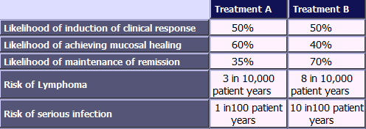

Which treatment would you choose?

1. Treatment A
2. Treatment B

Q11.

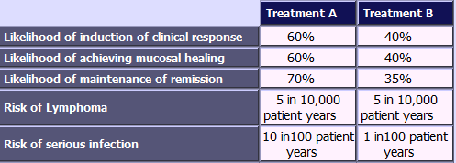

Which treatment would you choose?

1. Treatment A
2. Treatment B

Q12.

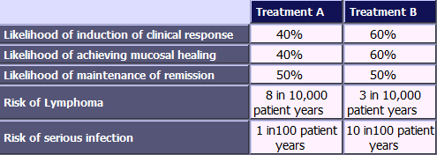

Which treatment would you choose?

1. Treatment A
2. Treatment B

Q13.

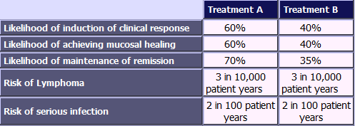

Which treatment would you choose?

1. Treatment A
2. Treatment B

What is your gender?

1. Male
2. Female
3. Prefer not to say

What is your age (in years)?

________________________________________________________________

What is your current job title?

1. Consultant IBD Specialist
2. Consultant Gastroenterologist with special interest in IBD
3. Consultant Gastroenterologist with special interest that is not IBD
4. IBD Specialist Nurse
5. Other ________________________________________________

In which year were you appointed as a Consultant or Specialist Nurse?

______________________________________________________________

Which of the following best describes IBD services in your centre?

1. Secondary referral service - from primary care/inpatient specialities
2. Tertiary referral service - from gastrointestinal/ surgery services outside of your hospital
3. Quaternary referral service - referrals from other specialist (tertiary) centres

In which region is your hospital situated?

1. North East
2. North West
3. Yorkshire and the Humber
4. East Midlands
5. West Midlands
6. East of England
7. London
8. South East
9. South West
10. Scotland
11. Northern Ireland
12. Wales

Thinking about the information and questions in this survey, please tell us how strongly you agree or disagree with each of the following statements.

|  |  |  |  |  |  |
| --- | --- | --- | --- | --- | --- |
|  | strongly disagree | disagree | uncertain | agree | strongly agree |
| I understood the questions about making choices between different pairs of treatment options |  |  |  |  |  |
| I found that the more questions I answered the easier it was to make a choice between the pairs of treatment options |  |  |  |  |  |
| When choosing between the pairs of treatment options I needed more information than was provided |  |  |  |  |  |
| I found making a choice between different pairs of treatment options confusing |  |  |  |  |  |

Do you have any comments you would like to make in connection with this questionnaire?

________________________________________________________________

________________________________________________________________

________________________________________________________________

________________________________________________________________

________________________________________________________________

We thank you for your time spent taking this survey.  
Your response has been recorded.

**Project document 2 – Supporting information for patient discrete choice experiment**

**PoPSTER: Patient preferences and current Practice for adults with STERoid resistance ulcerative colitis – Patient Discrete Choice Experiment**

**Name of lead researcher: Professor Alan Lobo (Chief Investigator)**

**IRAS Number: 255616**

Thank you for your interest in taking part in this online survey. The aim of this study is to explore patients’ preferences for the treatment of steroid resistant ulcerative colitis (UC). In particular, we are interested in finding how strongly patients feel about different treatment options. This will be done through the use of an online survey.  

**Before you decide if you would like to take part,** it is important for you to know why the research is being done and what it would involve for you. Please read the Plain Language Statement below. Then, if you are happy to proceed, please select the box at the bottom of the screen to confirm you have read and understood the Plain Language Statement and consent to the survey.

**Plain Language Statement**

**Why have I been invited to take part?**

This survey is open to any adult that has, or has previously had, a diagnosis of ulcerative colitis and is currently living in the UK. We are looking to recruit 300 patients and 100 healthcare professionals in this study.

**What would my participation involve?**

If you decide to take part after reading this information you can complete the survey online straight away. The survey will take around 20 minutes to complete. The online survey can be completed via a smart phone, tablet, or computer, however, a paper copy can be available upon request that can be returned via a freepost envelope. The survey has four parts. In the first part you will be asked to look at pairs of different treatments and asked which one you think is better. In the second part you will be asked to rank four treatments. In the third part, you will be asked questions about you and your health. In the final part you will be asked what you thought of the survey. Upon successful completion of the survey you will be returned to your panel platform where you can then close the survey window.

**Do I have to take part?**

There is no obligation to take part in the study. Participation is entirely voluntary and you are free to end your participation at any time before you complete the survey, without needing to give a reason. If you do take part, you are free to stop completing the survey at any time, however, your survey responses up until that point will be saved, and we will be unable to withdraw your data. This is because we do not collect any of your personal or identifying information so will not be able to identify and remove your data.

**What are the potential benefits and disadvantages of taking part?**

We hope that you will find the process beneficial as an opportunity to share your opinions and preferences in regards to potential treatment options for steroid resistant UC. By taking part you will be providing valuable information which will be used to inform clinicians and policy makers on the treatment for ulcerative colitis. There are no major disadvantages to the study, only the time it takes to complete the survey.

**What will happen to my information?**

This survey is hosted online by the University of Sheffield. Please note that any information you enter will be stored and processed using services provided by Qualtrics. These services have been the subject of independent assessment to ensure compliance with applicable data security standards. Further information can be found on the Qualtrics website (https://www.qualtrics.com/security-statement/).

Your personal and study data will be retained for a period of 5 years after the end of the project, following this it will be destroyed. After the project has ended, this information will be stored within the Clinical Trials Research Unit at the University of Sheffield, who are responsible for coordinating the PoPSTER research programme. Electronic data will be stored in an access restricted folder in the University’s Shared Network Filestore.

**Will my information be kept confidential?**

All of the information that is collected will be kept strictly confidential. The information you provide will not be used in any way that could identify you. We will not be collecting names or postal addresses. Only the project team will have access to the anonymised data and it will be used only for the purposes of this research.

**Use of my data**

Sheffield Teaching Hospital NHS Foundation Trust (STH NHSFT) is the sponsor for this study based in the United Kingdom and will act as the data controller for this study. This means that we are responsible for looking after your information and using it properly. At the end of the study, STH NHSFT will archive the study anonymously for a minimum of 5 years.

Your rights to access, change or move your information are limited, as we need to manage your information in specific ways in order for the research to be reliable and accurate. If you withdraw from the study, we will keep the information about you that we have already obtained. To safeguard your rights, we will use the minimum personally-identifiable information possible.   You can find out more about how we use your information at http://www.sth.nhs.uk/NHS/InformationGovernance/

All information collected during this study will be kept confidential. However, authorised representatives from the hospital research office or UK regulatory authorities might perform an audit of the study and review the study data.

This information will not identify you and will not be combined with other information in a way that could identify you. The information will only be used for the purpose of health and care research, and cannot be used to contact you or to affect your care. It will not be used to make decisions about future services available to you, such as insurance.

If you wish to raise a complaint on how we have handled your data, you can contact our Data Protection Officer who will investigate the matter. If you are not satisfied with our response or believe we are processing your personal data in a way that is not lawful you can complain to the Information Commissioner’s Office (ICO). Our Data Protection Officer is Peter Wilson and you can contact them by phone (0114 2265153) or email (Peter.Wilson@nhs.net).

**Who has reviewed this project?**

The study has been reviewed and approved by an independent NIHR Scientific Panel, the Health Research Authority (HRA) and the NHS Research Ethics Committee – East Midlands – Derby (19/EM/0011).

**Who can I contact about this study?**

If you have any questions about the research, please contact the research team, using the following details: Tara Wickramasekera, ScHARR, University of Sheffield, email or phone 0114 222 4349.

If you wish to contact the Chief Investigator of the study, please use these details: Professor Alan Lobo, Consultant Gastroenterologist, Gastroenterology and Liver Unit P Floor, Royal Hallamshire Hospital, Sheffield Teaching Hospitals NHS Foundation Trust, Glossop Road, Sheffield, S10 2JF, Email: alan.lobo@nhs.net

If you have any problems with the conduct of this research, please feel free to contact: Dipak Patel, Clinical Research and Innovation office, D floor, Royal Hallamshire Hospital, Sheffield Teaching Hospitals NHS Foundation Trust, Glossop Road, Sheffield, S10 2JF, Email: sthresearchadministration@nhs.net

**Before starting the survey, please confirm that you are aged over 18 years of age, have read all of information above and consent to take part in the survey.**

1. I consent, begin the survey
2. I do not consent, I do not wish to participate

**Please imagine this scenario:**

* You have had ulcerative colitis for three years.
* You have ongoing symptoms despite taking oral steroids (prednisolone) daily for 4 weeks.
* You have a stool frequency of six times per day, with blood and mucus and moderate abdominal pain.
* You are told that you need to start to reduce the steroids and go on to a different treatment option.

We would like to understand which factors would affect your decision to choose a treatment for the symptoms described above, and how important these factors are relative to each other. To help us do that, we are going to ask you to make a series of 13 choices. In each choice you will be asked to choose between two hypothetical treatments that you can take.   
   
The two treatments offered in each choice are drugs which differ with respect to the following characteristics:

1. **How effective the drug is at treating your symptoms:** The drugs may improve or settle your symptoms (for example in reducing stool frequency and bleeding, or returning these to normal), improve your quality of life and make you feel better. For example, a drug that is 60% effective means that if 100 people had the same drug for ulcerative colitis, for 60 people the treatment would be effective but for 40 people treatment would not be effective. Depending on the drug you take, the chance of it being effective may vary from:

* **40%**
* **50%**
* **60%**

1. **Speed of response to treatment:** Some drugs take longer than others to take effect. Depending on the drug you take, you may begin to feel better within:

* **6 weeks**
* **8 weeks**
* **14 weeks**

1. **Chance of your symptoms remaining improved after 12 months:** After your initial symptoms improve, the drugs can help to control your symptoms over time. However, there is also a possibility that you may lose the improvement and develop a flare of your symptoms. For example, a 70% chance means that, if 100 people took the same drug for a year, for 70 people the symptoms will be controlled and 30 people would lose improvement and develop a flare. Depending on the drug you take, your symptoms remaining improved after 12 months can vary from:

* **35%**
* **50%**
* **70%**

1. **Route and frequency of administration:** How and where the medication would be taken is different according to which drug you take. The options are:

* **a pill taken daily at home**
* **a self-administered injection under the skin, administered every 2 weeks at home**
* **a self-administered injection under the skin, administered every 8 weeks at home**
* **an intravenous infusion (drip) administered every 8 weeks at hospital**

1. **Chance of experiencing side effects:** Drugs can cause unwanted side effects. Common side effects include nausea, headache, skin rashes and mild infections. These often settle without treatment, can be easily treated, or are reversed if the drug is stopped. In rare cases, the drugs may cause severe side effects over a longer period of time. These include more severe infections (including tuberculosis and viral infections including the shingles virus), some cancers including, lymphoma (lymph gland cancer), blood clots in the leg (deep vein thrombosis (DVT)) or lung (pulmonary embolism), and nervous system problems. The chance of experiencing severe side effects is very rare for all treatments. The chance of experiencing side effects can be:

* **very common (may affect more than 10 in 100 people)**
* **common (may affect up to 10 in 100 people)**
* **uncommon (may affect 1 in 100 people or fewer)**
* **Very rare (may affect up to 1 in 10,000 people)**

We will now move onto the questions where you have to make a treatment choice. In total there are 13 choice questions. 

Q1.

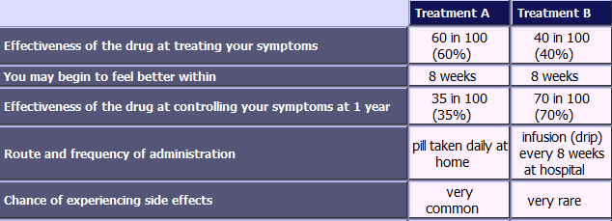  
     
  Which treatment would you choose?

1. Treatment A
2. Treatment B

Q2.

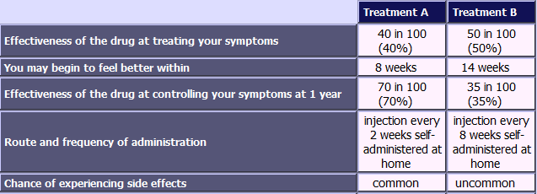  
    
  Which treatment would you choose?

1. Treatment A
2. Treatment B

Q3.

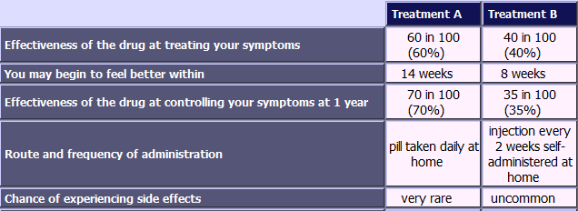

Which treatment would you choose?

1. Treatment A
2. Treatment B

Q4.

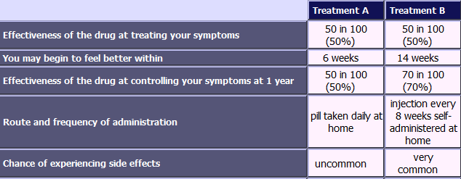

Which treatment would you choose?

1. Treatment A
2. Treatment B

Q5.

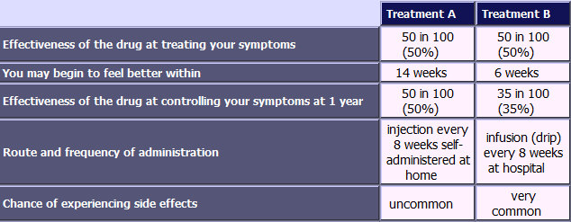    
Which treatment would you choose?

1. Treatment A
2. Treatment B

Q6.

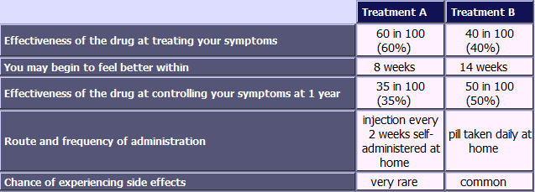  
     
Which treatment would you choose?

1. Treatment A
2. Treatment B

Q7.  
   
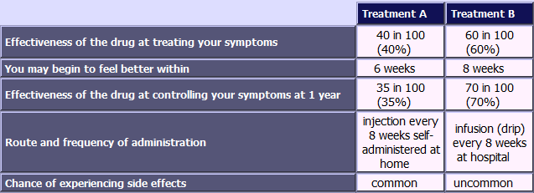  
  
Which treatment would you choose?

1. Treatment A
2. Treatment B

Q8.

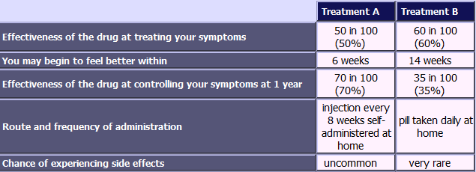  
      
Which treatment would you choose?

1. Treatment A
2. Treatment B

Q9.

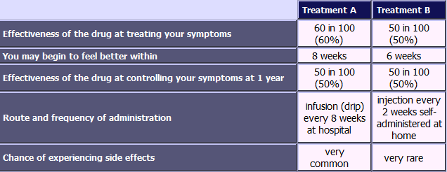  
     
Which treatment would you choose?

1. Treatment A
2. Treatment B

Q10

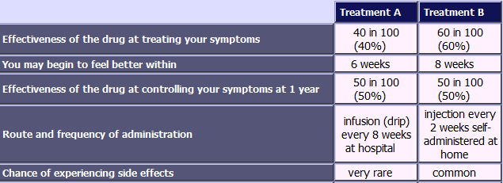  
     
Which treatment would you choose?

1. Treatment A
2. Treatment B

  Q11.

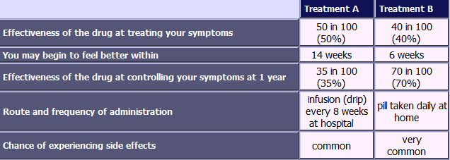  
     
Which treatment would you choose?

1. Treatment A
2. Treatment B

Q12.

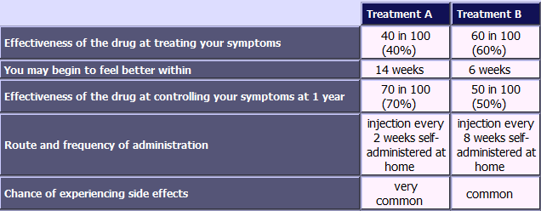  
     
Which treatment would you choose?

1. Treatment A
2. Treatment B

Q13.

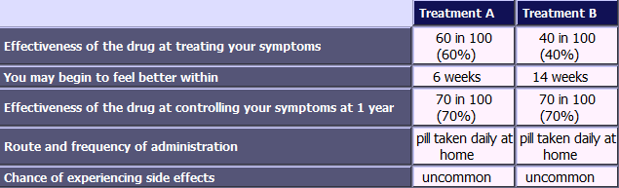  
     
Which treatment would you choose?

1. Treatment A
2. Treatment B

**Please continue to imagine the same scenario:**

* You have had ulcerative colitis for three years.
* You have ongoing symptoms despite taking oral steroids (prednisolone) daily for 4 weeks.
* You have a stool frequency of six times per day, with blood and mucus and a moderate amount of pain.

You and your consultant are discussing additional drug treatments with a view to reducing the steroids. The consultant presents you with four different treatment options. Please go to the next page to find out more information about the different treatment options. After reading the four treatments you will be asked to rank them in terms of preference, from most preferred to least preferred.

*Please read this carefully*

  **Infliximab**

* Infliximab is given by intravenous infusion (a drip) over one to two hours, either in hospital or at a day clinic. After the initial infusion, you will need further infusions at 2 weeks, 6 weeks, and then usually every 8 weeks after that.
* Studies have shown that Infliximab can be effective – with approximately 65% of people showing an improvement in symptoms and the appearances of the lining of the bowel. 34% of people go into remission: a more complete resolution of symptoms and the appearances of the bowel lining - after 1 year.
* Improvement may take up to 6 weeks following your first treatment.
* Common side effects occur in around 1 in 10 people, and include reactions to the infusion, greater susceptibility to infections (i.e. influenza), headache, and skin rashes.
* Rare side effects typically occur in no more than 1 in 10,000 people, and  include an increased risk of some severe infections such as tuberculosis (TB), an increased risk of some cancers including lymphoma, worsening of pre-existing heart failure and nervous system problems.
* With this medication, you may need to take other medication (azathioprine, mercaptopurine or methotrexate) to reduce antibody formation. These have side-effects of their own including infection risk and a very low risk of cancer.

*Please read this carefully*  
   
 **Adalimumab**

* Adalimumab is injected subcutaneously (under the skin). Usually the first 3 doses are given at a hospital under supervision. After that, the drug can be self-administered, thus avoiding the need for hospital attendance to administer the drug.
* Studies have shown that adalimumab can be effective - with approximately 54% of people showing an improvement in symptoms and the appearances of the lining of the bowel. 16% of people go into remission: a more complete resolution of symptoms and the appearances of the bowel lining - after 1 year.
* Improvement may take up to 12 weeks following your first treatment.
* Common side effects occur in around 1 in 10 people and  include pain at the injection site, sometimes with redness, itching and swelling, greater susceptibility to infections, and skin rashes.
* Rare side effects typically occur in no more than 1 in 10,000 people and include an increased risk of some severe infections such as tuberculosis (TB), an increased risk of some cancers including lymphoma, worsening of pre-existing heart failure and nervous system problems.
* With this medication, you may need to take other medication (azathioprine, mercaptopurine or methotrexate) to reduce antibody formation. These have side-effects of their own including infection risk and a very low risk of cancer.

*Please read this carefully*  
   
 **Vedolizumab**

* Vedolizumab is given by intravenous infusion (a drip), over one to two hours, usually in hospital or at a day clinic. After the initial infusion, you will need further infusions at 2 weeks, 6 weeks, and then usually every 8 weeks after that.
* Studies have shown that Vedolizumab can be effective - with approximately 53% of people showing an improvement in symptoms and the appearances of the lining of the bowel. 23% of people go into remission: a more complete resolution of symptoms and the appearances of the bowel lining - after 1 year.
* Improvement may take up to 14 weeks following your first treatment.
* Common side effect occur in around 1 in 10 people and include headache, susceptibility to infections, nausea, and joint pain.
* Rare side effects typically occur in no more than 1 in 10,000 people and include pneumonia, blurred vision and anaphylactic shock (sudden, severe allergic reaction).
* It is not always necessary to take other additional medication.

*Please read this carefully*  
   
 **Tofacitinib**

* Tofacitinib is taken orally (a pill) twice a day.
* Studies have shown that Tofacitinib can be effective - with approximately 64% of people showing an improvement in symptoms and the appearances of the lining of the bowel. 24% of people go into remission: a more complete resolution of symptoms and the appearances of the bowel lining - after 1 year.
* Improvement may take up to 8 weeks following your first treatment
* Common side effects occur in around 1 in 10 people and include headache, runny or stuffy nose and slight swelling at the back of the throat, nausea and joint pain.
* Rare side effects typically occur in no more than 1 in 10,000 people and include severe infections (e.g. tuberculosis (TB)), shingles, and potentially severe complications such as deep vein thrombosis (blood clot in the leg veins) and pulmonary embolism (blood clot in the lungs).
* It is not always necessary to take other additional medication.

**The following table is a summary of the 4 treatments.**  
   
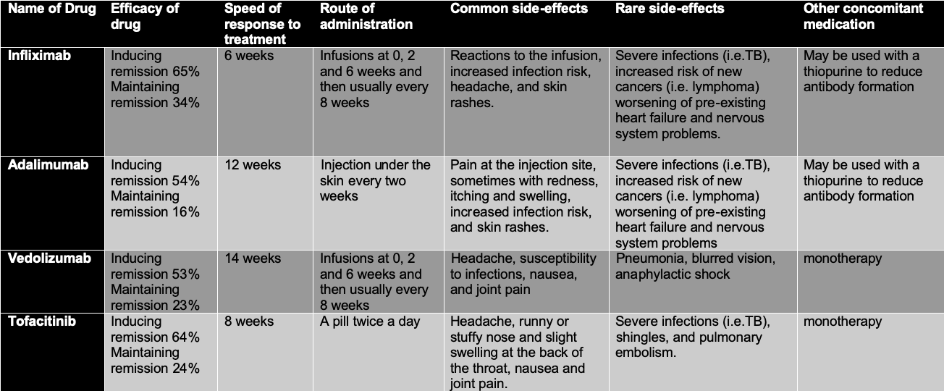

Now that you know more about the treatment options available to you, we would like you to consider which treatments you would prefer. Please rank these treatments in order of preference: 1= best preferred treatment and 4= least preferred treatment.

□ Infliximab

□ Adalimumab

□ Vedolizumab

□ Tofacitinib

Please could you state the reason why you ranked these treatments in this order?

________________________________________________________________

________________________________________________________________

___________________________________________________________

________________________________________________________________

________________________________________________________________

What is your gender?

1. Male
2. Female
3. Prefer not to say

What is your age (in years)?

________________________________________________________________

Which of the following best describes your main activity? Choose one, which is most applicable to you.

1. In employment or self-employment
2. Retired
3. Homemaker
4. Carer
5. Student
6. Unemployed/seeking work
7. Volunteer work
8. Prefer not to say

What ethnic group best describes you?

1. White
2. Black / African / Caribbean / Black British
3. Asian/Asian British
4. Mixed / Multiple ethnic groups
5. Prefer not to say

What is the highest level of education you have completed?

1. Primary
2. Secondary (GCSE/ O-Level)
3. Further education (A-Level, BTEC)
4. Bachelor's, Master's, Doctoral degree
5. Prefer not to say

What is your marital status?

1. Married/Partner
2. Widowed
3. Divorced /Separated
4. Single
5. Prefer not to say

When were you diagnosed with ulcerative colitis? (please state the year)

________________________________________________________________

Have you had any of these medications in the past? (please choose all that applies)

1. Infliximab
2. Adalimumab
3. Vedolizumab
4. Tofacitinib
5. Steroids
6. Azathioprine/Mercaptopurine/Methotrexate
7. Golimumab
8. Ustekinumab
9. Tacrolimus
10. None of the above

Please describe your current treatment for ulcerative colitis?

_____________________________________________________________

_____________________________________________________________

Do you believe that:

|  |  |  |  |
| --- | --- | --- | --- |
|  | Yes | No | Not Sure |
| Your IBD has been well controlled in the past two weeks? |  |  |  |
| Your current treatment is useful in controlling your IBD |  |  |  |

If you are not taking any treatment, please select this box

1. no treatment

In the past 2 weeks, did you:

|  |  |  |  |
| --- | --- | --- | --- |
|  | Yes | No | Not sure |
| Miss any planned activities because of IBD? (e.g. attending school/college, going to work or a social event) |  |  |  |
| Wake up at night because of symptoms of IBD? |  |  |  |
| Suffer from significant pain or discomfort? |  |  |  |
| Often feel lacking in energy (fatigued)? (by 'often' we mean more than half of the time) |  |  |  |
| Feel anxious or depressed because of your IBD? |  |  |  |
| Think you needed a change to your treatment? |  |  |  |

Now we would like to ask you 5 questions about your health in general. Under each heading, please tick the **ONE** box that best describes your health **TODAY**.

**MOBILITY**

1. I have no problems in walking about
2. I have slight problems in walking about
3. I have moderate problems in walking about
4. I have severe problems in walking about
5. I am unable to walk about

**SELF-CARE**

1. I have no problems washing or dressing myself
2. I have slight problems washing or dressing myself
3. I have moderate problems washing or dressing myself
4. I have severe problems washing or dressing myself
5. I am unable to wash or dress myself

**USUAL ACTIVITIES** *(e.g. work, study, housework, family or leisure activities)*

1. I have no problems doing my usual activities
2. I have slight problems doing my usual activities
3. I have moderate problems doing my usual activities
4. I have severe problems doing my usual activities
5. I am unable to do my usual activities

**PAIN/DISCOMFORT**

1. I have no pain or discomfort
2. I have slight pain or discomfort
3. I have moderate pain or discomfort
4. I have severe pain or discomfort
5. I have extreme pain or discomfort

**ANXIETY/DEPRESSION**

1. I am not anxious or depressed
2. I am slightly anxious or depressed
3. I am moderately anxious or depressed
4. I am severely anxious or depressed
5. I am extremely anxious or depressed

Thinking about the first part of the survey where you were asked to choose between pairs of different treatments, please tell us how strongly you agree or disagree with each of the following statements.

|  |  |  |  |  |  |
| --- | --- | --- | --- | --- | --- |
|  | strongly disagree | disagree | uncertain | agree | strongly agree |
| I understood the questions about making choices between different pairs of treatment options |  |  |  |  |  |
| I found that the more questions I answered the easier it was to make a choice between the pairs of treatment options |  |  |  |  |  |
| When choosing between the pairs of treatment options I needed more information than was provided |  |  |  |  |  |
| I found making a choice between different pairs of treatment options confusing |  |  |  |  |  |

Thinking about the second part of the survey where you were asked to rank 4 treatments, please tell us how strongly you agree or disagree with each of the following statements.

|  |  |  |  |  |  |
| --- | --- | --- | --- | --- | --- |
|  | strongly disagree | disagree | uncertain | agree | strongly agree |
| I found the ranking question made sense |  |  |  |  |  |
| I found the ranking questions difficult |  |  |  |  |  |

Do you have any comments you would like to make in connection with this questionnaire?

________________________________________________________________

________________________________________________________________

________________________________________________________________

________________________________________________________________

________________________________________________________________

We thank you for your time spent taking this survey.  
Your response has been recorded.

