**Supplementary Figure 1**

Standard Operating Procedure (SOP) (treatment guideline) for subthreshold micropulse laser (SML)

|  |  |  |
| --- | --- | --- |
| **Contact Lens Used** | Area Centralis or Mainster Focal/Grid (or any other macular lens with laser spot magnification of 1.05-1.06x) | *Represents single spot*  *Image 2*    **2**    *Image 1*  *Image 5*  **8**        *Image 6*  *Represents pattern mode*  **3**  **5**  **7**  **6**  *Image 3*    *Image 4* |
| **Spot size on**  **the Slit Lamp Adapter** | 200 µm*.* Use for both continuous-wave test spot and MicroPulse laser therapy |
| **Turn off Voice Prompts** | 1. Select Options (1) *(Image 1)* 2. In the Options Menu *(Image 2)*, select Voice Prompts until “Off” is displayed (2) 3. Select OK (3) |
| **Test Spot** | 1. Select Presets (4) *(Image 1)*   2. From the Preset Menu *(Image 3)*, select “DIAMONDS TEST SPOT” (5)  *Preset = continuous-wave mode*, 200 ms, 50 mW, *single spot (as displayed in Image 1)*  3. In the mildly oedematous macula > 2 DD from foveal center, titrate power upwards in 10 mW increments - moving to a new area each time - until a barely visible tissue reaction is seen.  If a reaction is evident with 50 mW, do not increase the power.  4. Note the threshold power. |
| **MicroPulse Laser Therapy** | 1. Select Presets (4) *(Image 1)*   2. From the Preset Menu *(Image 3)*, select “DIAMONDS MP” (6) *Preset = MicroPulse mode, 5% duty cycle, 200 ms*, *single spot (as displayed in image 4)*  3. Adjust power to 4x threshold power achieved in test spot. Example 100 mW threshold power = 400 mW MicroPulse power *(as displayed in Image 4)*  4. Deliver a single spot outside the macula to confirm system is in MicroPulse mode.  5. Select Pattern (7). Adjust grid to 7x7 by rotating the center knob, adjust spacing to 0.00 by rotating the right knob.  6. Select OK (8) *(Image 5)*  7. User interface will be displayed as in *Image 6*, with variable mW powers based on test spot (400 mW is shown as per example above). Deliver high-density applications as indicated in image 7: three 7x7 grids above and below the fovea (500 µm from its centre) and one 7x7 grid at each side (temporal and nasal) of the fovea (500 µm from its centre); if oedema is present outside this area, treat it too. |
| **Retreatments** | Retreatments are allowed as per the investigator discretion but should not be given earlier than every three months, with no limit on the number of retreatments applied. Retreatment **must be given** on the month 4 follow-up visit if insufficient response has been observed, as judged by the treating ophthalmologist.  In retreatments, treatment between 300 and 500 microns of the centre of the macula is allowed if centre-involving DMO persists after initial treatment. At other time points (scheduled follow-up visits after month 4) re-treatments are allowed at the discretion of the investigator.  ***All retreatments should be done with the same laser as that used on the initial treatment.***  ***If both eyes are eligible for treatment the same laser should be used in both eyes.*** |

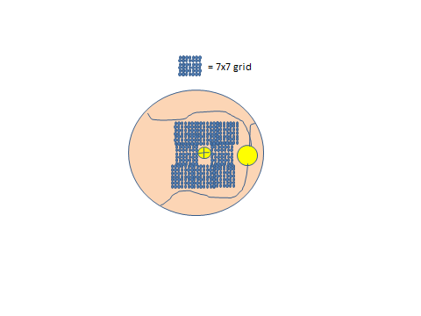

*Image 7*