Supplementary Figure 2

Standard Operating Procedure (SOP) (treatment guideline) for standard threshold laser
Laser Used | Argon (514 nm), frequency-doubled Nd:YAG (532 nm), diode [561 nm or IQ 577 (577 nm)] laser.
Contact Lens Used | Area Centralis or Mainster Focal/Grid (or any other macular lens with magnification of 1.05-1.06x)
Spot Size on the Slit Lamp Adapter | 50 - 200 µm | 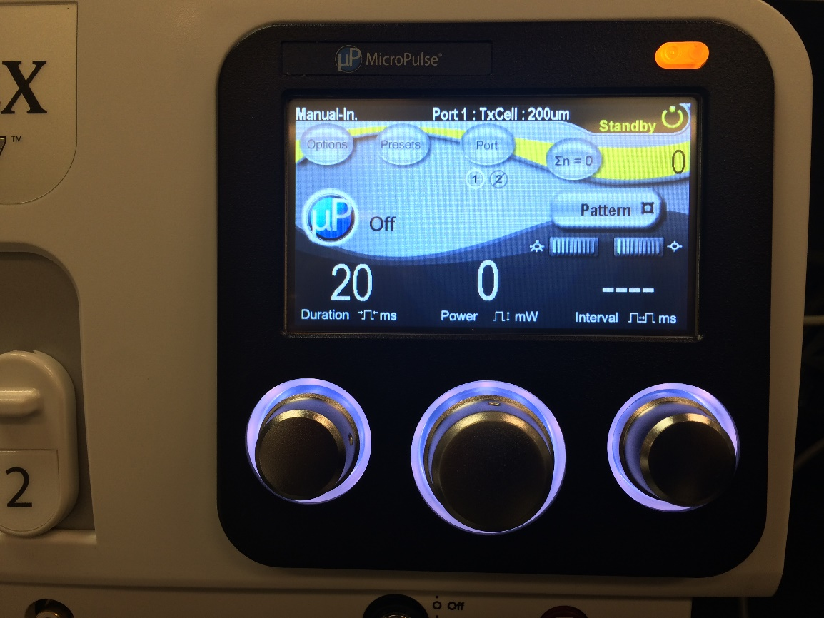  Represents single-spot  Example Shown: IQ 577 laser with TxCell Scanning Delivery Device  MicroPulse Mode is Off  Spot Size: 200 µm  Duration: 20 ms  Power: To obtain a mild grey-white burn  Interval: Single-spot
Duration | 50 - 100 ms for Argon  10 - 20 msec for 532 nm, 561 nm laser or 577 nm laser
Power | To obtain a mild grey-white burn
Technique | Modified ETDRS technique. Treatment should be applied to obtain a mild grey-white burn evident beneath leaking microaneurysms and in other areas of leakage/non perfusion not affecting the perifoveal capillaries based on FFA, if FFA has been obtained, and/or to cover areas of thickening if treatment is given based on OCT findings. Treatment should spare the central 500 µm and the area within 500 µm from the optic nerve head.
Retreatments | Retreatments are allowed as per the investigator discretion but should not be given earlier than every three months, with no limit on the number of treatments applied.  Retreatment must be given on follow up visits if there is an insufficient response to the first laser as judged by the treating ophthalmologist.  In retreatments, treatment between 300 and 500 µm of the centre of the macula is allowed if centre-involving DMO persists after initial treatment.  At other time points (scheduled follow-up visits after month 4) re-treatments are allowed at the discretion of the investigator.  All retreatments should be done with the same laser as that used on the initial treatment.  If both eyes are eligible for treatment the same laser should be used in both eyes.

