**Supplementary File 3: Meeting observation template**

**NON-PARTICIPANT OBSERVATION TOPIC GUIDE FOR STAKEHOLDER MEETINGS**

**Core evaluation questions as set out in study protocol:**

**RQ1:** What are the drivers and rationale for acute hospitals taking over the management and governance of general practices? What does this type of vertical integration aim to achieve?

**RQ2:** What models/arrangements exist for acute hospital organisations to manage general practices (including different contractual/legal/organisational arrangements across primary, secondary and community health services)?

**RQ3:** What is the experience of implementing this model of vertical integration, including barriers and enablers and lessons learnt?

**RQ4:** In what ways, if any, has this model of vertical integration influenced the extent and type of health service provision delivered in primary care? Have there been any unintended consequences of hospitals running general practice?

**RQ5:** What are the views of the primary and secondary care workforces about working together in this way across the care interface?

**RQ6**: In what ways, if any, has this model of vertical integration had impact so far? What are the expected longer-term impacts? How is progress being measured?

**Before the meeting begins**

* Reiterate the purpose and approach of the study, and who is funding it and why, and the current stage of the research.
* Ensure the participant has read the information leaflet.
* Ensure the participants feel able to ask any questions about the evaluation including issues about confidentiality, the findings and/or dissemination before giving written consent.
* Ensure those participants who do not give consent are informed that no notes will be taken of their contribution.
* Ensure you are seated where you can hear and observe discussions taking place without causing distraction.
* Start making notes.
* At the end of the meeting, reiterate purpose of the study and what happens next, and thank all present for letting us observe.

**Sociogram (including meeting room layout)**

A sociogram is an illustrative representation of social relationships. It is a diagram that details the structure of interpersonal relations in a group situation.

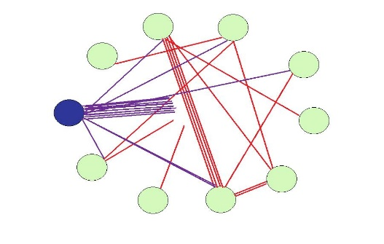

**Themes/content discussed during observation:**

|  |  |  |  |
| --- | --- | --- | --- |
| **Site location:** | **Date:** | **Start time:** | **End time:** |
| **Non-participant observation notes**   1. **Note taking will be content-focused, on what is being said by attendees** 2. **One row of this form should be used for each item on the agenda** 3. **Include identifiers (i.e. initials) within notes to distinguish between attendees** | | | |
| **Agenda item being discussion** | **Time** | **Notes** | **Further Questions/Areas to investigate** |
| **1. Meeting information:**   * **Name/Purpose of meeting** * **Number of attendees** * **Role of each attendee** * **What is covered on the agenda?** |  |  |  |
|  |  |  |  |
|  |  |  |  |

**Reflexive note taking post non-participant observation (notes should be specific to content discussed within meetings as opposed to researcher interpretations)**

|  |  |
| --- | --- |
| **Theme** | **Comments** |
| Rationale: are there clear drivers/resistance for VI? |  |
| Arrangements (contractual/legal/organisational arrangements across primary, secondary and community health services) discussed during the meeting? |  |
| Which attendees were impacting upon decision making actions? |  |
| Were some speaking more than others?  Why might that be? |  |
| If this is a follow up meeting, how have contributions from different attendees changed since the previous meeting? |  |
| Was discussion centred on intended and unintended consequences of VI? |  |
| How were challenges to discussions manifested by attendees?  And what was the nature of any responses to such challenges? |  |
| How was the meeting chaired? What was effective/ineffective with regard to how the discussions were facilitated? |  |
| Is there evidence of attendees discussing impact upon NHS workforce? |  |
| Was strategic direction of VI clear among discussion?  Was there clarification and evidence to support discussion?  Which outcome measures is VI being measured against? |  |
| Were there attendees who were silent or contributed little to discussions?  What may explain their lack of contribution? |  |
| Did the meeting keep to time? If not, why?  Did the meeting achieve its main objectives? |  |
| Any other comments? |  |