# Supplementary file 3. Quality of reporting of economic studies (CHEERS Checklist)

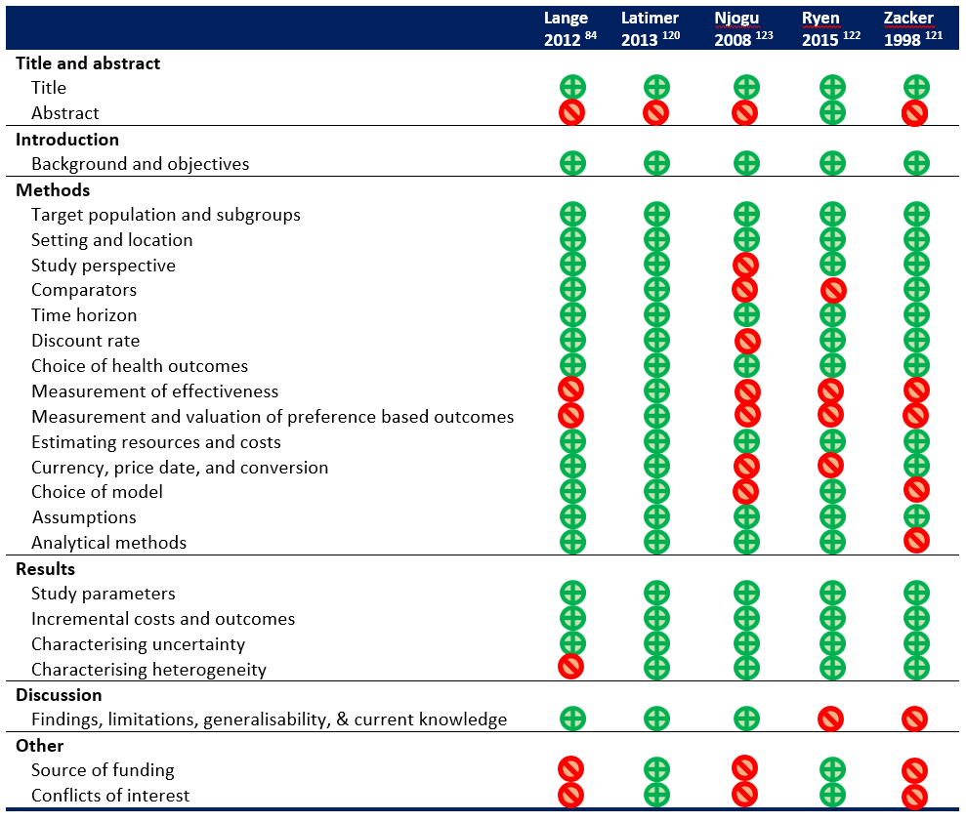

Items from the CHEERS (Consolidated Health Economic Evaluation Reporting Standards) checklist are marked as done (green ‘plus’ circle) or not done (red ‘backslash’ circle) for each of the five included economic studies.