Supplementary file 2 Consent forms

**CONSENT FORM – OBSERVATION OF ACTIVITY PATIENTS**

**Title of Project: Collaborative Rehabilitation Environments in Acute sTrokE (CREATE)**

NHS REC Committee and reference number:

Staff and clinical area identification number for this study:

Name of Chief Investigator: Prof Fiona Jones

Please initial boxes to confirm agreement:

I confirm that I have read and understand the information sheet dated 11.8.2017 version 0.3 for the above study. I have had the opportunity to consider the information, ask questions and have had these answered satisfactorily.

I understand that my participation is voluntary and that I am free to withdraw at any time.

I understand that any decision to withdraw or not to participate will remain confidential.

I understand that the researcher will record my activity and that all patient details will remain confidential and will be anonymised.

I understand that data collected during the study may be looked at by individuals from the study team, from regulatory authorities or from the NHS Trust. I give permission for these individuals to have access to my anonymised data.

I agree to non-participant observations of one-to-one interactions with the healthcare team involved in my care.

________________ ________________ ___________________

Name of Participant Date Signature

_________________ ________________ ___________________

Name of Person Date Signature

taking consent

**Accessible Consent form for observation of activities**  
  
STUDY TITLE: Collaborative Rehabilitation Environments in Acute sTrokE (CREATE)

**CONSENT FORM- OBSERVATION OF ACTIVITY PATIENTS**

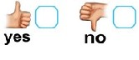

**Please initial if possible (or tick)**



I have **read** the

**information** about the

**research**

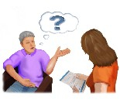

I have had the **chance**

to **ask questions** about

the research

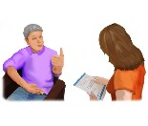

I am **happy** with the

**answers** to my questions

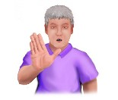

I understand that **I can**

**stop being in the research at any time**

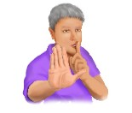

**If I stop I do not** have to **give a reason**…and I will **still get my** **normal care**



I **agree** to **being observed** by a **researcher**



I understand that the researcher will **make** **notes** about my **usual activities** whilst I am on the ward

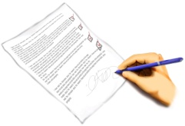

I understand that

**information** about me will be **kept safe**

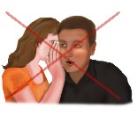

It will **not** be **shared** with **anyone** **outside the research team**

**Data collected** during the study may be looked at by **regulatory authorities** or the **NHS trust** but this data will not include my **name**







I **agree** to take part

in this **research**

**Name _______________________________________**

**Signature ___________________ Date _________**

**Witness Name (if applicable) _______________________________________**

**Signature ___________________ Date _________**

**Researcher’s Name _______________________________________**

**Signature ___________________ Date _________**

**CONSENT FORM – AUDIO-RECORDED INTERVIEW**

**Title of Project: Collaborative Rehabilitation Environments in Acute sTrokE (CREATE)**

NHS REC Committee and reference number:

Participant identification number for this study:

Name of Chief Investigator: Prof Fiona Jones

Please initial boxes to confirm agreement:

I confirm that I have read and understand the information sheet dated 11.8.2017 (version number 0.3.) for the above study. I have had the opportunity to consider the information and ask questions and I am satisfied with the answers I have received.

I understand that my participation in this interview is voluntary and that I am free to withdraw at any time without giving any reason.

I understand that this interview will be audio-recorded.

I understand that if I would like to withdraw from the study that any interview data will not be shared with anyone outside of the study team, sponsor or regulatory authority.

I understand that my comments may be used in different formats, and that any of my comments may be edited and may appear anonymously in written form.

I agree to take part in the above study.

________________ ________________ ___________________

Name of Participant Date Signature

_________________ ________________ ___________________

Name of Person Date Signature

taking consent