File 12: Economic model 3: Project local site data (before and after, probabilistic sensitivity analysis): Bootstrap scatter plot and Cost effectiveness acceptability curve

 |  | Bootstrap scatter plot | Cost effectiveness acceptability curve
Conf.2 | NHS perspective | 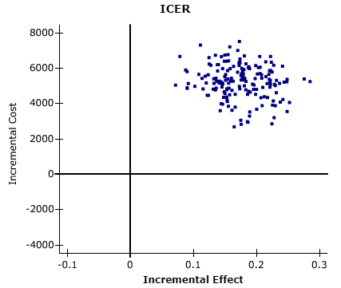 | 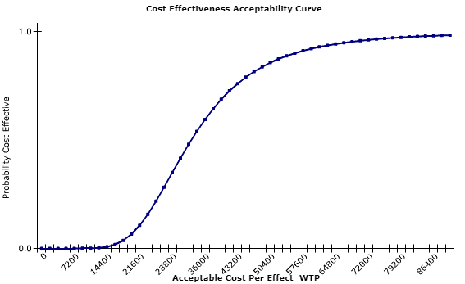
Conf.2 | Public sector perspective | 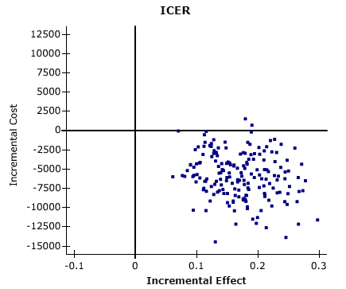 | 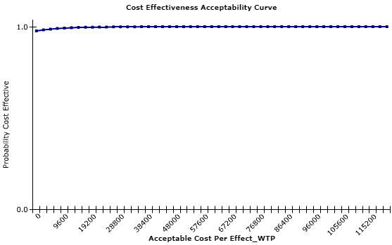
Conf.3 | NHS perspective | 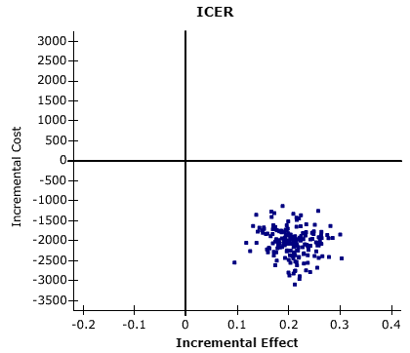 | 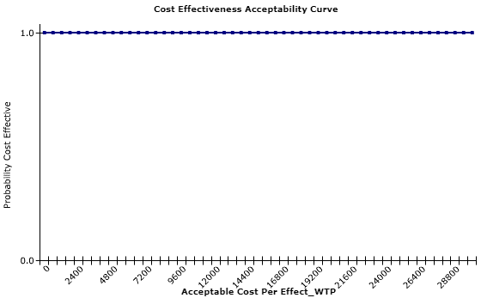
Conf.3 | Public sector perspective | 