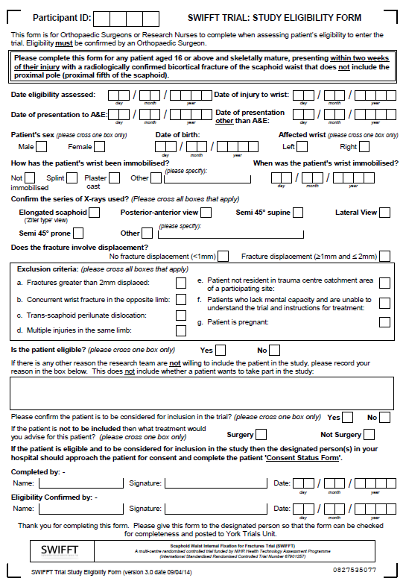 **Supplementary File 9: Study Eligibility Form**