## FEEDS Report Supplementary Material File 3

## Round 2 questionnaire for Delphi survey

**FEEDS Delphi Survey - Round 2**

Thank you for taking part in the first round of the FEEDS Delphi survey.

The FEEDS study aims to find out about strategies that parents of young children with developmental difficulties can use at home to help improve children's eating, drinking and swallowing difficulties.

As a reminder, in our study eating, drinking and swallowing difficulties are referred to as "eating and drinking difficulties".  The term "strategy" or "strategies" is used to describe what some people might call intervention, therapy, treatment, advice or things that help including self-help.  The potential benefits of the strategies are referred to as "outcomes".

This is the **second** round of the survey.

A Delphi survey is a way to seek agreement between different groups of people.  It's like having a discussion but through a survey instead of face to face. The Delphi survey will help us to reach conclusions about which outcomes and strategies should be examined in future research.

In this survey, you will be shown how parents and professionals rated items in the first round.  As you will see from the graphs, there are high levels of agreement between people for some items and for others there is not agreement.  We are asking you to re-rate each outcome and strategy in light of this information and we will see if there is more agreement this time.

​Like last time, the survey is divided into 2 sections:

* In part A, we show you how parents and professionals rated a list of **outcomes** related to improved eating and drinking.​ ​​
* In part B, we show you how parents and professionals rated a list of **strategies** to improve eating and drinking.

**Part A: Outcomes**

For each outcome, you will be shown graphs of how parents and professionals rated that outcome in the previous round.  You will then be asked to **re-rate how important you think the outcome is**.

If you feel unable to comment based on your knowledge and / or experience or feel the item is not relevant or not applicable to you, please select 'Not applicable / Not relevant'.

If you would like to add any additional outcomes or comment further on those listed, please do so in the text boxes.  If you made comments in the previous round, we will take account of these so you do not need to repeat these comments again on this survey. Thank you.

**General Health**

The graphs below show how important parents and professionals rated 'General Health' as an outcome.

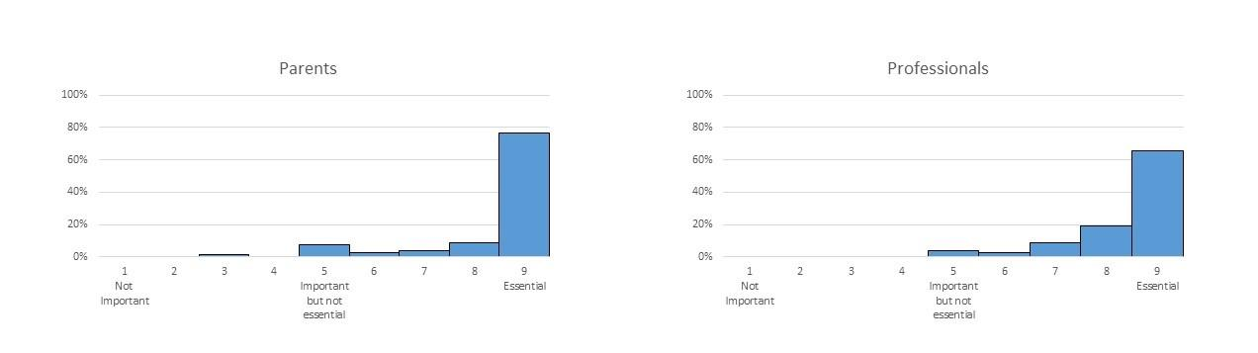

Q1_1 Now that you know this, please re-rate how important you think this outcome is.

|  |  |  |  |  |  |  |  |  |  |  |
| --- | --- | --- | --- | --- | --- | --- | --- | --- | --- | --- |
|  | Not important  1 | 2 | 3 | 4 | Important but not essential  5 | 6 | 7 | 8 | Essential  9 | Not applicable / Not relevant |
| **General health** ​A child's overall health |  |  |  |  |  |  |  |  |  |  |

Q1_2 Please provide any additional comments you have about this outcome here:

**Weight**

The graphs below show how important parents and professionals rated 'Weight' as an outcome.

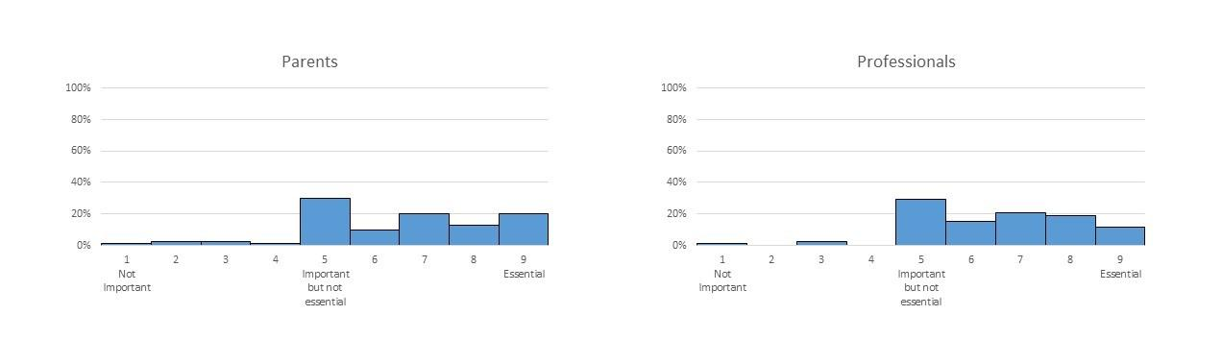

Q2_1 Now that you know this, please re-rate how important you think this outcome is.

|  |  |  |  |  |  |  |  |  |  |  |
| --- | --- | --- | --- | --- | --- | --- | --- | --- | --- | --- |
|  | Not important   1 | 2 | 3 | 4 | Important but not essential  5 | 6 | 7 | 8 | Essential  9 | Not applicable / Not relevant |
| **Weight ​**​How much a child weighs |  |  |  |  |  |  |  |  |  |  |

Q2_2 Please provide any additional comments you have about this outcome here:

________________________________________________________________

**Height**

The graphs below show how important parents and professionals rated 'Height' as an outcome.

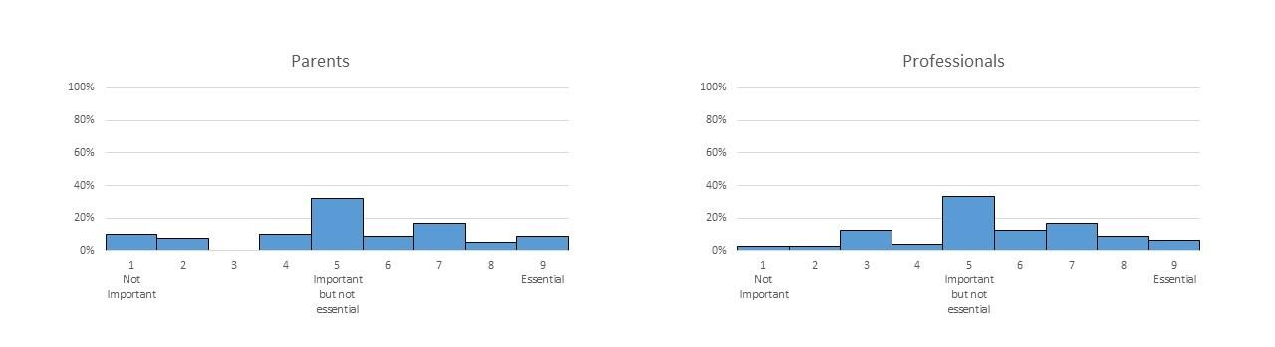

Q3_1 Now that you know this, please re-rate how important you think this outcome is.

|  |  |  |  |  |  |  |  |  |  |  |
| --- | --- | --- | --- | --- | --- | --- | --- | --- | --- | --- |
|  | Not important  1 | 2 | 3 | 4 | Important but not essential  5 | 6 | 7 | 8 | Essential  9 | Not applicable / Not relevant |
| **Height** ​How tall a child is |  |  |  |  |  |  |  |  |  |  |

Q3_2 Please provide any additional comments you have about this outcome here:

________________________________________________________________

**Growth**

The graphs below show how important parents and professionals rated 'Growth' as an outcome.

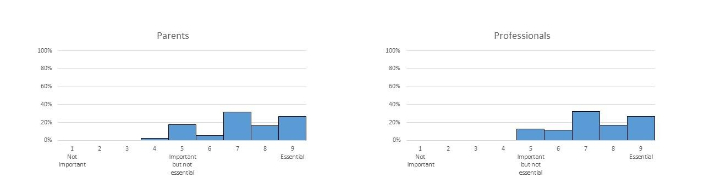

Q4_1 Now that you know this, please re-rate how important you think this outcome is.

|  |  |  |  |  |  |  |  |  |  |  |
| --- | --- | --- | --- | --- | --- | --- | --- | --- | --- | --- |
|  | Not important  1 | 2 | 3 | 4 | Important but not essential  5 | 6 | 7 | 8 | Essential  9 | Not applicable / Not relevant |
| **Growth** A change in a child's growth, including height and weight |  |  |  |  |  |  |  |  |  |  |

Q4_2 Please provide any additional comments you have about this outcome here:

________________________________________________________________

**Nutrition**

The graphs below show how important parents and professionals rated 'Nutrition' as an outcome.

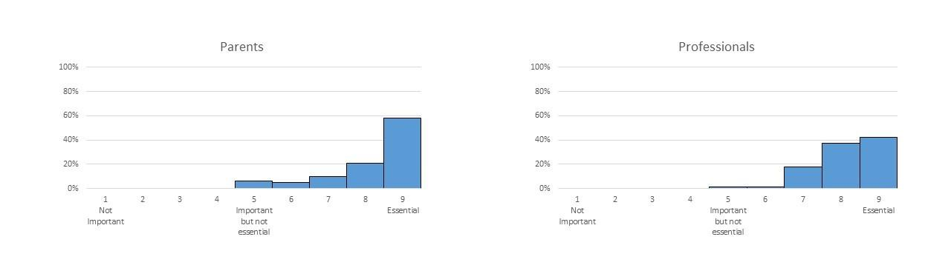

Q5_1 Now that you know this, please re-rate how important you think this outcome is.

|  |  |  |  |  |  |  |  |  |  |  |
| --- | --- | --- | --- | --- | --- | --- | --- | --- | --- | --- |
|  | Not important  1 | 2 | 3 | 4 | Important but not essential  5 | 6 | 7 | 8 | Essential  9 | Not applicable / Not relevant |
| **Nutrition** A child's level of energy and nutrients for healthy growth |  |  |  |  |  |  |  |  |  |  |

Q5_2 Please provide any additional comments you have about this outcome here:

________________________________________________________________

**Child's Enjoyment of Mealtimes**

The graphs below show how important parents and professionals rated 'Child's Enjoyment of Mealtimes' as an outcome.

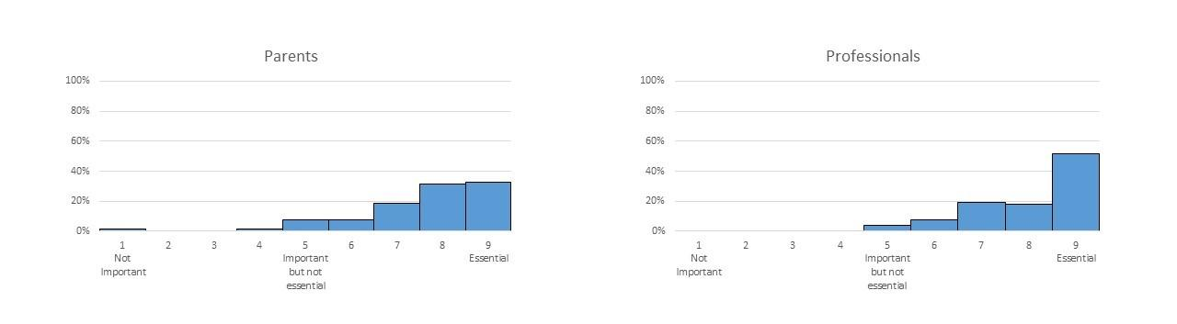

Q6_1 Now that you know this, please re-rate how important you think this outcome is.

|  |  |  |  |  |  |  |  |  |  |  |
| --- | --- | --- | --- | --- | --- | --- | --- | --- | --- | --- |
|  | Not important  1 | 2 | 3 | 4 | Important but not essential  5 | 6 | 7 | 8 | Essential  9 | Not applicable / Not relevant |
| **Child's enjoyment of mealtimes** |  |  |  |  |  |  |  |  |  |  |

Q6_2 Please provide any additional comments you have about this outcome here:

________________________________________________________________

**Parent or Caregiver's Enjoyment of Mealtimes**

The graphs below show how important parents and professionals rated 'Parent or Caregiver's Enjoyment of Mealtimes' as an outcome.

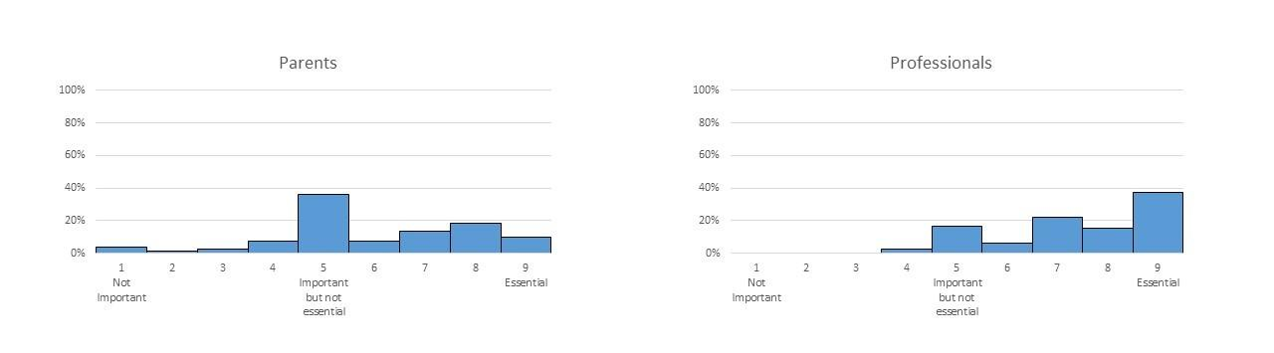

Q7_1 Now that you know this, please re-rate how important you think this outcome is.

|  |  |  |  |  |  |  |  |  |  |  |
| --- | --- | --- | --- | --- | --- | --- | --- | --- | --- | --- |
|  | Not important  1 | 2 | 3 | 4 | Important but not essential  5 | 6 | 7 | 8 | Essential  9 | Not applicable / Not relevant |
| **Parent or caregiver's enjoyment of mealtimes** |  |  |  |  |  |  |  |  |  |  |

Q7_2 Please provide any additional comments you have about this outcome here:

________________________________________________________________

**Quality of Life of Child**

The graphs below show how important parents and professionals rated 'Quality of Life of Child' as an outcome.

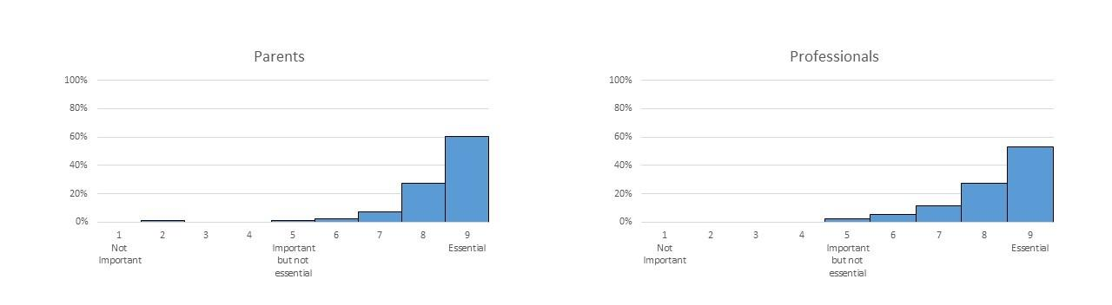

Q8_1 Now that you know this, please re-rate how important you think this outcome is.

|  |  |  |  |  |  |  |  |  |  |  |
| --- | --- | --- | --- | --- | --- | --- | --- | --- | --- | --- |
|  | Not important  1 | 2 | 3 | 4 | Important but not essential  5 | 6 | 7 | 8 | Essential  9 | Not applicable / Not relevant |
| **Quality of life of child** ​How satisfied a child feels about their life |  |  |  |  |  |  |  |  |  |  |

Q8_2 Please provide any additional comments you have about this outcome here:

________________________________________________________________

**Quality of Life of Family**

The graphs below show how important parents and professionals rated 'Quality of Life of Family' as an outcome.

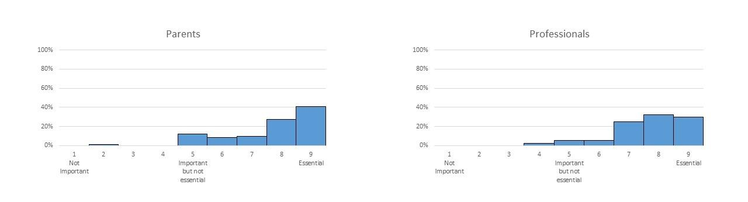

Q9_1 Now that you know this, please re-rate how important you think this outcome is.

|  |  |  |  |  |  |  |  |  |  |  |
| --- | --- | --- | --- | --- | --- | --- | --- | --- | --- | --- |
|  | Not important  1 | 2 | 3 | 4 | Important but not essential  5 | 6 | 7 | 8 | Essential  9 | Not applicable / Not relevant |
| **Quality of life of family** ​How satisfied other family members feel about their (own) lives |  |  |  |  |  |  |  |  |  |  |

Q9_2 Please provide any additional comments you have about this outcome here:

________________________________________________________________

**Mental Health of Parent or Caregiver**

The graphs below show how important parents and professionals rated 'Mental Health of Parent or Caregiver' as an outcome.

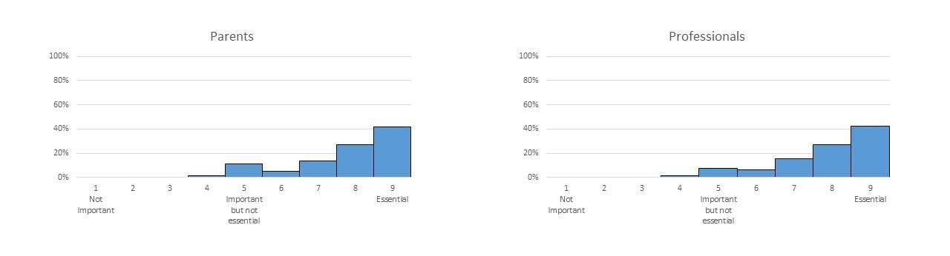

Q10_1 Now that you know this, please re-rate how important you think this outcome is.

|  |  |  |  |  |  |  |  |  |  |  |
| --- | --- | --- | --- | --- | --- | --- | --- | --- | --- | --- |
|  | Not important  1 | 2 | 3 | 4 | Important but not essential  5 | 6 | 7 | 8 | Essential  9 | Not applicable / Not relevant |
| **Mental health of parent or caregiver** ​A parent / caregiver's mood and emotional wellbeing |  |  |  |  |  |  |  |  |  |  |

Q10_2 Please provide any additional comments you have about this outcome here:

________________________________________________________________

**Safety**

The graphs below show how important parents and professionals rated 'Safety' as an outcome.

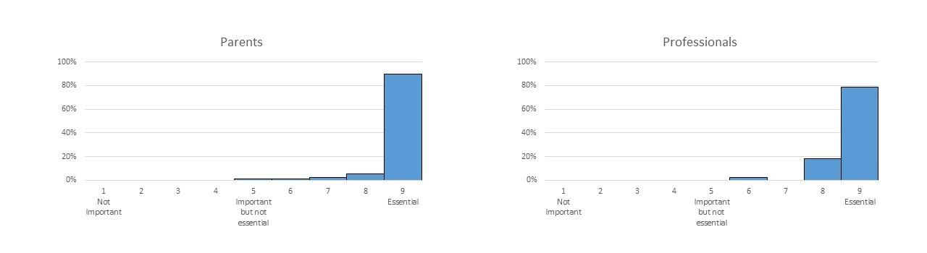

Q11_1 Now that you know this, please re-rate how important you think this outcome is.

|  |  |  |  |  |  |  |  |  |  |  |
| --- | --- | --- | --- | --- | --- | --- | --- | --- | --- | --- |
|  | Not important  1 | 2 (2) | 3 (3) | 4 (4) | Important but not essential  5 (5) | 6 (6) | 7 (7) | 8 (8) | Essential  9 (9) | Not applicable / Not relevant (10) |
| **Safety**  ​A child's ability to eat and drink safely without choking or aspirating |  |  |  |  |  |  |  |  |  |  |

Q11_2 Please provide any additional comments you have about this outcome here:

________________________________________________________________

**Oral Motor Control**

The graphs below show how important parents and professionals rated 'Oral Motor Control' as an outcome.

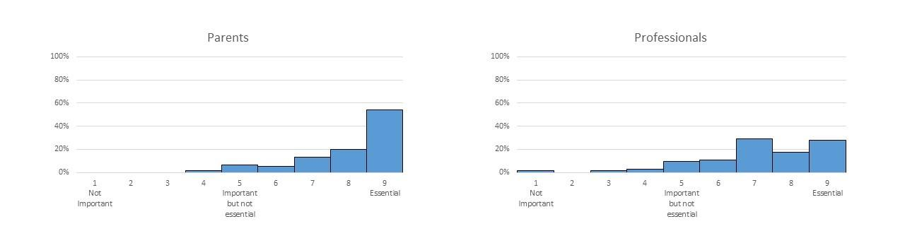

Q12_1 Now that you know this, please re-rate how important you think this outcome is.

|  |  |  |  |  |  |  |  |  |  |  |
| --- | --- | --- | --- | --- | --- | --- | --- | --- | --- | --- |
|  | Not important  1 | 2 | 3 | 4 | Important but not essential  5 | 6 | 7 | 8 | Essential  9 | Not applicable / Not relevant |
| **Oral motor control**  ​A child's ability to control the movement of their mouth, jaw, tongue or lips and swallow |  |  |  |  |  |  |  |  |  |  |

Q12_2 Please provide any additional comments you have about this outcome here:

________________________________________________________________

**Efficiency**

The graphs below show how important parents and professionals rated 'Efficiency' as an outcome.

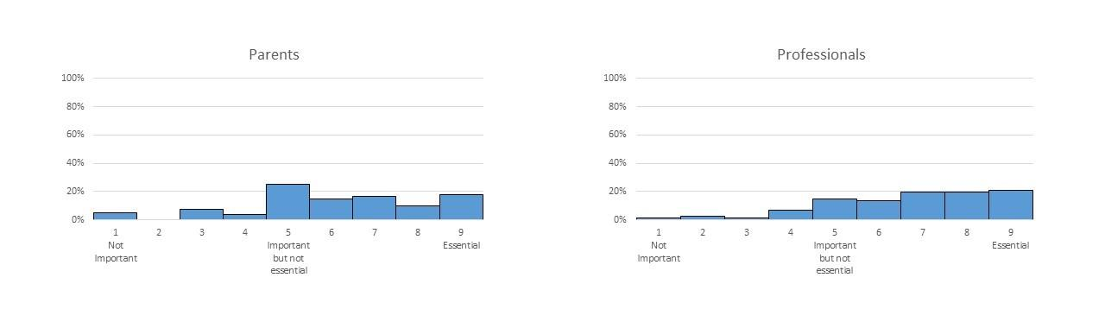

Q13_1 Now that you know this, please re-rate how important you think this outcome is.

|  |  |  |  |  |  |  |  |  |  |  |
| --- | --- | --- | --- | --- | --- | --- | --- | --- | --- | --- |
|  | Not important  1 | 2 | 3 | 4 | Important but not essential  5 | 6 | 7 | 8 | Essential  9 | Not applicable / Not relevant |
| **Efficiency** ​A child's ability to eat and drink at a reasonable pace |  |  |  |  |  |  |  |  |  |  |

Q13_2 Please provide any additional comments you have about this outcome here:

________________________________________________________________

**Independence**

The graphs below show how important parents and professionals rated 'Independence' as an outcome.

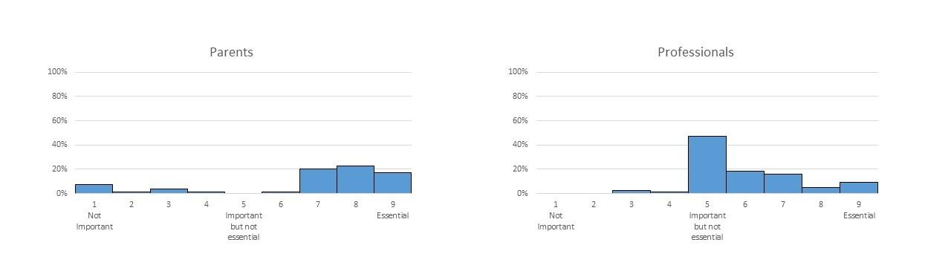

Q14_1 Now that you know this, please re-rate how important you think this outcome is.

|  |  |  |  |  |  |  |  |  |  |  |
| --- | --- | --- | --- | --- | --- | --- | --- | --- | --- | --- |
|  | Not important  1 | 2 | 3 | 4 | Important but not essential  5 | 6 | 7 | 8 | Essential  9 | Not applicable / Not relevant |
| **Independence** ​A child's ability to feed themselves |  |  |  |  |  |  |  |  |  |  |

Q14_2 Please provide any additional comments you have about this outcome here:

________________________________________________________________

**Variety**

The graphs below show how important parents and professionals rated 'Variety' as an outcome.

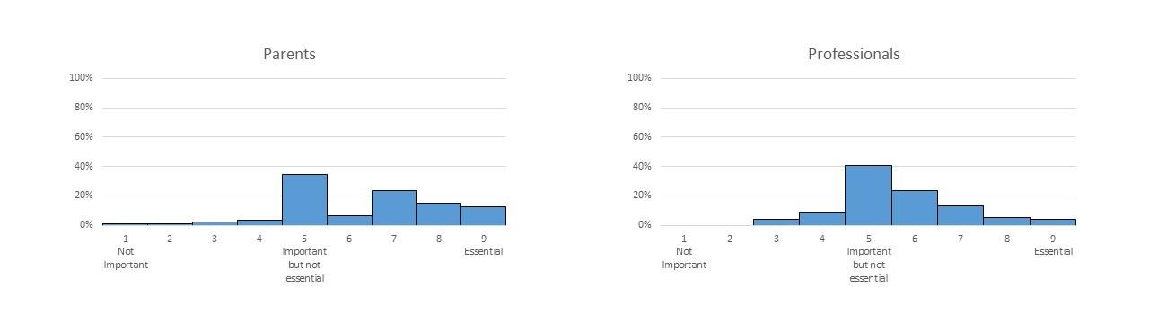

Q15_1 Now that you know this, please re-rate how important you think this outcome is.

|  |  |  |  |  |  |  |  |  |  |  |
| --- | --- | --- | --- | --- | --- | --- | --- | --- | --- | --- |
|  | Not important  1 | 2 | 3 | 4 | Important but not essential  5 | 6 | 7 | 8 | Essential  9 | Not applicable / Not relevant |
| **Variety** The range of foods or liquids a child eats or drinks |  |  |  |  |  |  |  |  |  |  |

Q15_2 Please provide any additional comments you have about this outcome here:

________________________________________________________________

**Amount**

The graphs below show how important parents and professionals rated 'Amount' as an outcome.

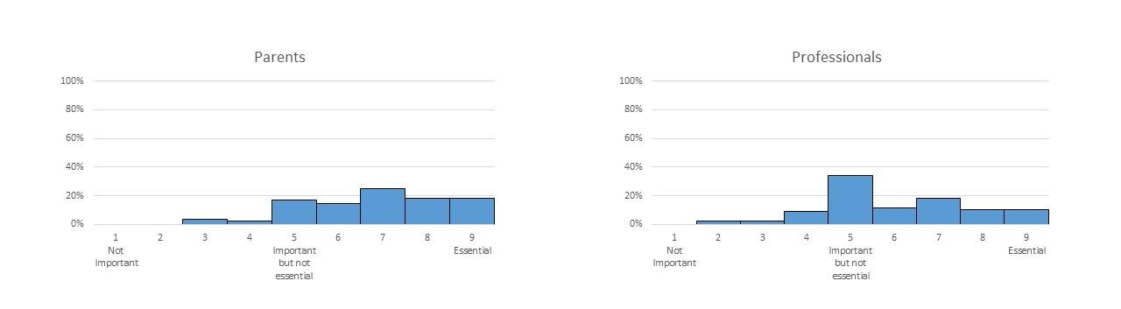

Q16_1 Now that you know this, please re-rate how important you think this outcome is.

|  |  |  |  |  |  |  |  |  |  |  |
| --- | --- | --- | --- | --- | --- | --- | --- | --- | --- | --- |
|  | Not important  1 | 2 | 3 | 4 | Important but not essential  5 | 6 | 7 | 8 | Essential  9 | Not applicable / Not relevant |
| **Amount** The amount of food or liquid a child eats or drinks per day |  |  |  |  |  |  |  |  |  |  |

Q16_2 Please provide any additional comments you have about this outcome here:

________________________________________________________________

**Appetite**

The graphs below show how important parents and professionals rated 'Appetite' as an outcome.

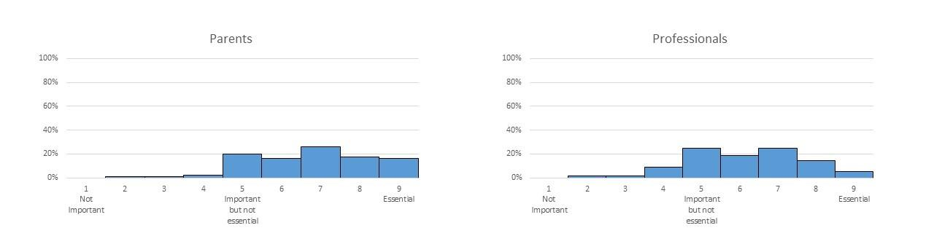

Q17_1 Now that you know this, please re-rate how important you think this outcome is.

|  |  |  |  |  |  |  |  |  |  |  |
| --- | --- | --- | --- | --- | --- | --- | --- | --- | --- | --- |
|  | Not important  1 | 2 | 3 | 4 | Important but not essential  5 | 6 | 7 | 8 | Essential  9 | Not applicable / Not relevant |
| **Appetite** A child's level of hunger and desire for food or drink |  |  |  |  |  |  |  |  |  |  |

Q17_2 Please provide any additional comments you have about this outcome here:

________________________________________________________________

**Mealtime Behaviour**

The graphs below show how important parents and professionals rated 'Mealtime Behaviour' as an outcome.

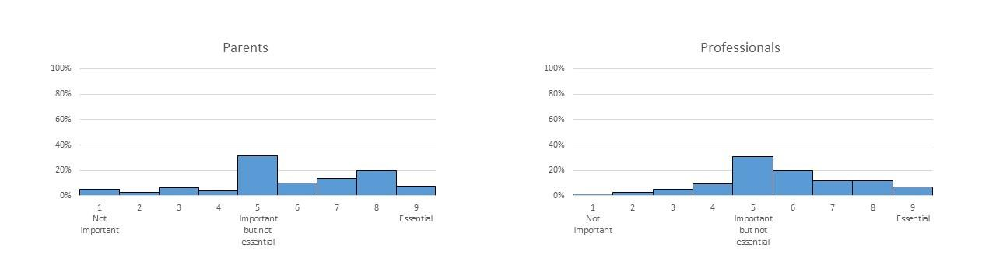

Q18_1 Now that you know this, please re-rate how important you think this outcome is.

|  |  |  |  |  |  |  |  |  |  |  |
| --- | --- | --- | --- | --- | --- | --- | --- | --- | --- | --- |
|  | Not important  1 | 2 | 3 | 4 | Important but not essential  5 | 6 | 7 | 8 | Essential  9 | Not applicable / Not relevant |
| **Mealtime behaviour**  A child behaving appropriately during meals |  |  |  |  |  |  |  |  |  |  |

Q18_2 Please provide any additional comments you have about this outcome here:

________________________________________________________________

**Mealtime Interaction**

The graphs below show how important parents and professionals rated 'Mealtime Interaction' as an outcome.

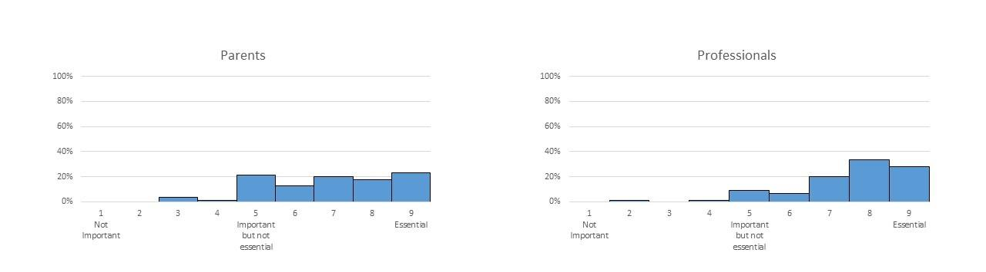

Q19_1 Now that you know this, please re-rate how important you think this outcome is.

|  |  |  |  |  |  |  |  |  |  |  |
| --- | --- | --- | --- | --- | --- | --- | --- | --- | --- | --- |
|  | Not important  1 | 2 | 3 | 4 | Important but not essential  5 | 6 | 7 | 8 | Essential  9 | Not applicable / Not relevant |
| **Mealtime interaction** The interaction between a child and the person feeding them at mealtimes |  |  |  |  |  |  |  |  |  |  |

Q19_2 Please provide any additional comments you have about this outcome here:

________________________________________________________________

**​Social Participation**

The graphs below show how important parents and professionals rated 'Social Participation' as an outcome.

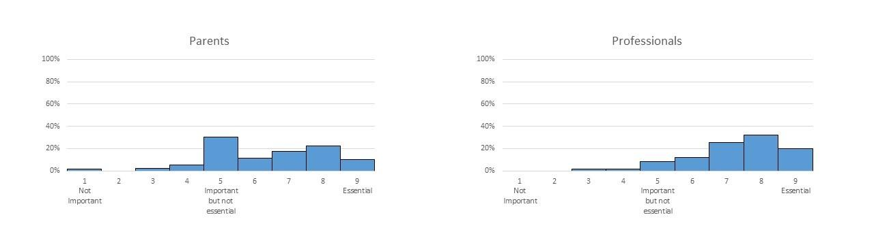

Q20_1 Now that you know this, please re-rate how important you think this outcome is.

|  |  |  |  |  |  |  |  |  |  |  |
| --- | --- | --- | --- | --- | --- | --- | --- | --- | --- | --- |
|  | Not important  1 | 2 | 3 | 4 | Important but not essential  5 | 6 | 7 | 8 | Essential  9 | Not applicable / Not relevant |
| **Social participation**  A child's involvement in social activities around eating and drinking |  |  |  |  |  |  |  |  |  |  |

Q20_2 Please provide any additional comments you have about this outcome here:

________________________________________________________________

**Child's Understanding**

The graphs below show how important parents and professionals rated 'Child's Understanding' as an outcome.

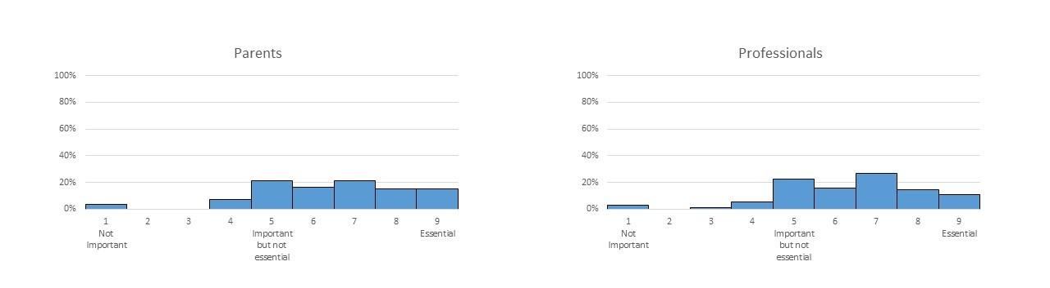

Q21_1 Now that you know this, please re-rate how important you think this outcome is.

|  |  |  |  |  |  |  |  |  |  |  |
| --- | --- | --- | --- | --- | --- | --- | --- | --- | --- | --- |
|  | Not important  1 | 2 | 3 | 4 | Important but not essential  5 | 6 | 7 | 8 | Essential  9 | Not applicable / Not relevant |
| **Child's understanding** ​A child's understanding of mealtime activities and routines |  |  |  |  |  |  |  |  |  |  |

Q21_2 Please provide any additional comments you have about this outcome here:

________________________________________________________________

**Parent or Caregiver's Understanding**

The graphs below show how important parents and professionals rated 'Parent or Caregiver's Understanding' as an outcome.

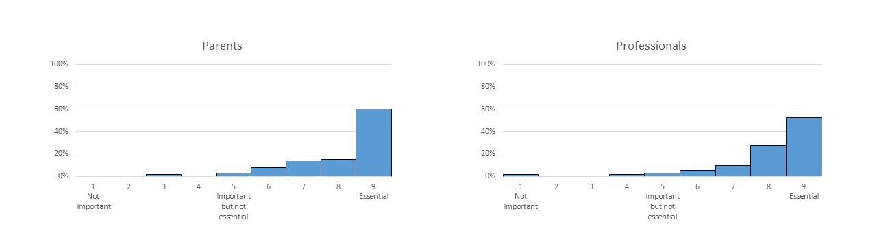

Q22_1 Now that you know this, please re-rate how important you think this outcome is.

|  |  |  |  |  |  |  |  |  |  |  |
| --- | --- | --- | --- | --- | --- | --- | --- | --- | --- | --- |
|  | Not important  1 | 2 | 3 | 4 | Important but not essential  5 | 6 | 7 | 8 | Essential  9 | Not applicable / Not relevant |
| **Parent or caregiver's understanding** ​A parent or caregiver's insight into their child's eating and drinking difficulties |  |  |  |  |  |  |  |  |  |  |

Q22_2 Please provide any additional comments you have about this outcome here:

________________________________________________________________

Q23   
Please provide any additional outcomes you think are important or essential here:   
    
If you provided any additional outcomes in the previous round, we will take account of these so you do not need to repeat these comments again on this survey. Thank you.

________________________________________________________________

**Part B: Strategies**

For each strategy, you will be shown graphs of how parents and professionals rated that strategy in the previous round.  You will then be asked to **re-rate how important you think it is that the strategy is included in an 'intervention package' for children with eating and drinking difficulties**.

If you feel unable to comment based on your knowledge and / or experience or feel the item is not relevant or not applicable to you, please select 'Not applicable / Not relevant'.

If you would like to add any additional strategies or comment further on those listed, please do so in the text boxes.  If you made comments in the previous round, we will take account of these so you do not need to repeat these comments again on this survey. Thank you.

**Modifying Environment**

The graphs below show how important parents and professionals rated 'Modifying Environment' as a strategy to be included as part of an 'intervention package' for children with eating and drinking difficulties.

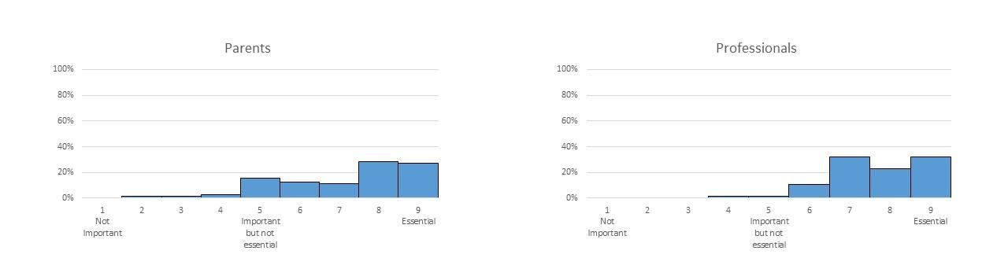

Q24_1 Now that you know this, please re-rate how important you think it is that this strategy is included in an 'intervention package' for children with eating and drinking difficulties.

|  |  |  |  |  |  |  |  |  |  |  |
| --- | --- | --- | --- | --- | --- | --- | --- | --- | --- | --- |
|  | Not important  1 | 2 | 3 | 4 | Important but not essential  5 | 6 | 7 | 8 | Essential | Not applicable / Not relevant |
| **Modifying environment** ​Changing the physical or social setting at mealtimes (e.g. reducing distractions such as levels of noise; using distractions to reduce a child's attention on their food) |  |  |  |  |  |  |  |  |  |  |

Q24_2 Please provide any additional comments you have about this strategy here:

________________________________________________________________

**Positioning**

The graphs below show how important parents and professionals rated 'Positioning' as a strategy to be included as part of an 'intervention package' for children with eating and drinking difficulties.

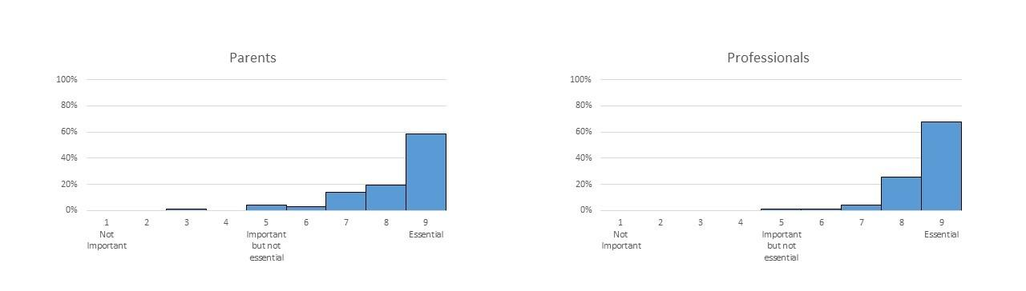

Q25_1 Now that you know this, please re-rate how important you think this strategy is.

|  |  |  |  |  |  |  |  |  |  |  |
| --- | --- | --- | --- | --- | --- | --- | --- | --- | --- | --- |
|  | Not important  1 | 2 | 3 | 4 | Important but not essential  5 | 6 | 7 | 8 | Essential  9 | Not applicable / Not relevant |
| **Positioning** ​Ensuring a child is in the best position to eat and drink food safely and efficiently (e.g. a child sitting upright; providing support for head control) |  |  |  |  |  |  |  |  |  |  |

Q25_2 Please provide any additional comments you have about this strategy here:

________________________________________________________________

**Modifying Equipment**

The graphs below show how important parents and professionals rated 'Modifying Equipment' as a strategy to be included as part of an 'intervention package' for children with eating and drinking difficulties.

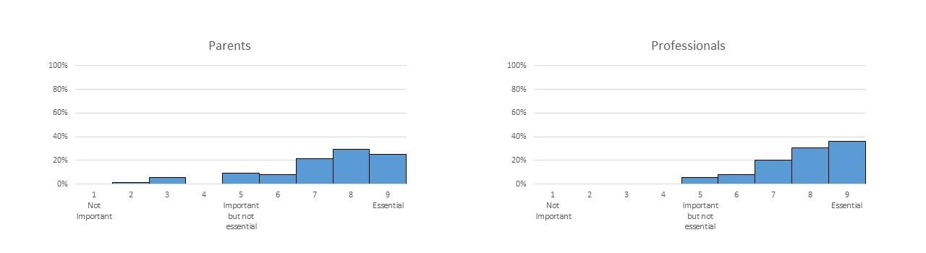

Q26_1 Now that you know this, please re-rate how important you think this strategy is.

|  |  |  |  |  |  |  |  |  |  |  |
| --- | --- | --- | --- | --- | --- | --- | --- | --- | --- | --- |
|  | Not important  1 | 2 | 3 | 4 | Important but not essential  5 | 6 | 7 | 8 | Essential  9 | Not applicable / Not relevant |
| **Modifying equipment** ​Using different spoons, forks, plates, cups, bottles etc (e.g. doidy cup; plastic spoon) |  |  |  |  |  |  |  |  |  |  |

Q26_2 Please provide any additional comments you have about this strategy here:

________________________________________________________________

**Scheduling of meals**

The graphs below show how important parents and professionals rated 'Scheduling of Meals' as a strategy to be included as part of an 'intervention package' for children with eating and drinking difficulties.

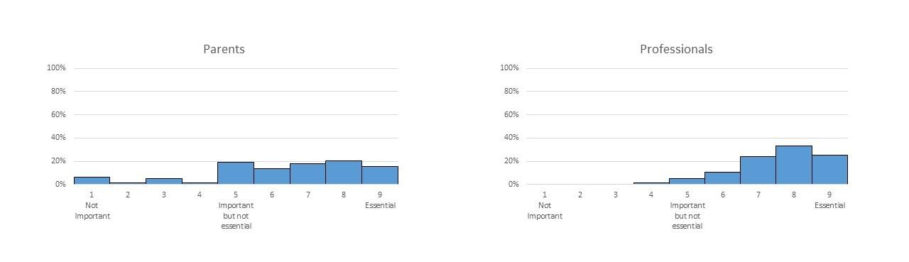

Q27_1 Now that you know this, please re-rate how important you think this strategy is.

|  |  |  |  |  |  |  |  |  |  |  |
| --- | --- | --- | --- | --- | --- | --- | --- | --- | --- | --- |
|  | Not important  1 | 2 | 3 | 4 | Important but not essential  5 | 6 | 7 | 8 | Essential  9 | Not applicable / Not relevant |
| **Scheduling of meals** ​Setting the timing of mealtimes to encourage a child's appetite and establish a mealtime routine (e.g. spreading meals / snacks throughout the day; setting a 30 minute limit for mealtimes) |  |  |  |  |  |  |  |  |  |  |

Q27_2 Please provide any additional comments you have about this strategy here:

________________________________________________________________

**Modifying Consistency of Food or Drink**

The graphs below show how important parents and professionals rated 'Modifying Consistency of Food or Drink' as a strategy to be included as part of an 'intervention package' for children with eating and drinking difficulties.

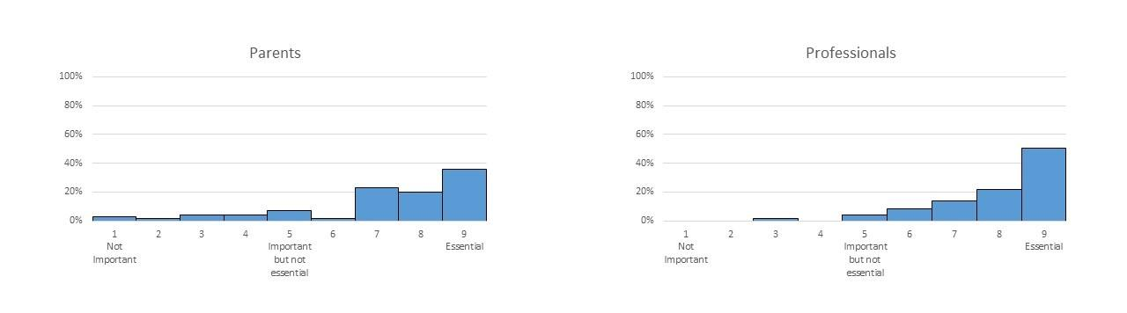

Q28_1 Now that you know this, please re-rate how important you think this strategy is.

|  |  |  |  |  |  |  |  |  |  |  |
| --- | --- | --- | --- | --- | --- | --- | --- | --- | --- | --- |
|  | Not important  1 | 2 | 3 | 4 | Important but not essential  5 | 6 | 7 | 8 | Essential  9 | Not applicable / Not relevant |
| **Modifying consistency of food or drink** ​Changing the consistency of a child's food or drink (e.g. pureeing food; thickening food or drink) |  |  |  |  |  |  |  |  |  |  |

Q28_2 Please provide any additional comments you have about this strategy here:

________________________________________________________________

**Modifying Other Aspects of Food or Drink**

The graphs below show how important parents and professionals rated 'Modifying Other Aspects of Food or Drink' as a strategy to be included as part of an 'intervention package' for children with eating and drinking difficulties.

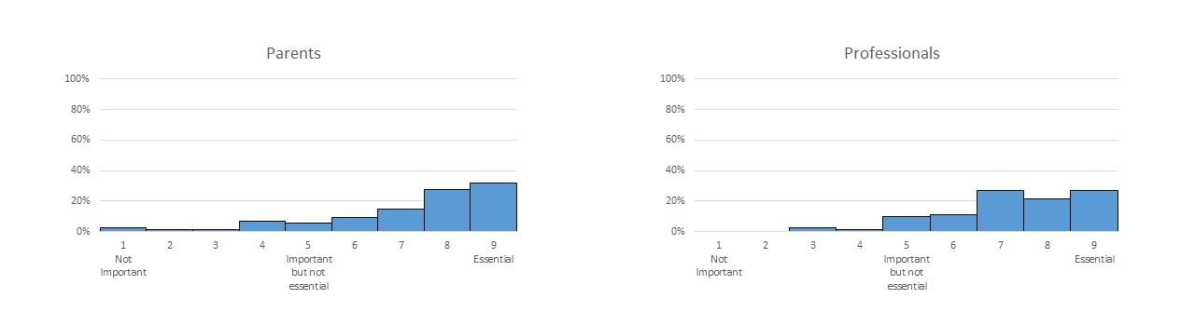

Q29_1 Now that you know this, please re-rate how important you think this strategy is.

|  |  |  |  |  |  |  |  |  |  |  |
| --- | --- | --- | --- | --- | --- | --- | --- | --- | --- | --- |
|  | Not important  1 | 2 | 3 | 4 | Important but not essential  5 | 6 | 7 | 8 | Essential  9 | Not applicable / Not relevant |
| **Modifying other aspects of food or drink** ​Changing the temperature, taste, amount or presentation of a child's food or drink (e.g. presenting different foods so they do not touch each other; mixing liked foods with disliked foods) |  |  |  |  |  |  |  |  |  |  |

Q29_2 Please provide any additional comments you have about this strategy here:

________________________________________________________________

**Modifying Placement of Food**

The graphs below show how important parents and professionals rated 'Modifying Placement of Food' as a strategy to be included as part of an 'intervention package' for children with eating and drinking difficulties.

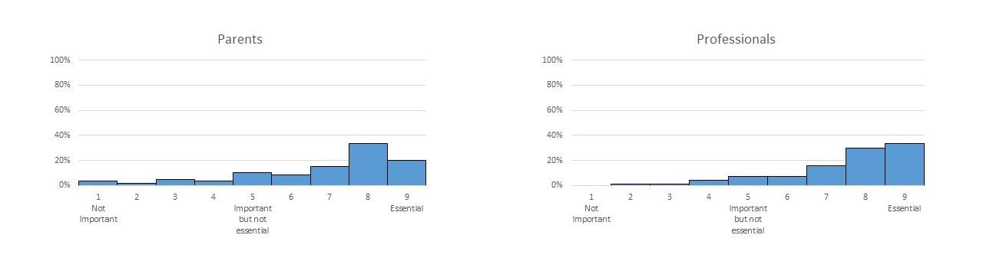

Q30_1 Now that you know this, please re-rate how important you think this strategy is.

|  |  |  |  |  |  |  |  |  |  |  |
| --- | --- | --- | --- | --- | --- | --- | --- | --- | --- | --- |
|  | Not important  1 | 2 | 3 | 4 | Important but not essential  5 | 6 | 7 | 8 | Essential  9 | Not applicable / Not relevant |
| **Modifying placement of food** ​Changing where the food is placed in a child's mouth to help chewing or swallowing (e.g. placing food to the side of the mouth) |  |  |  |  |  |  |  |  |  |  |

Q30_2 Please provide any additional comments you have about this strategy here:

________________________________________________________________

**Enhancing Communication**

The graphs below show how important parents and professionals rated 'Enhancing Communication' as a strategy to be included as part of an 'intervention package' for children with eating and drinking difficulties.

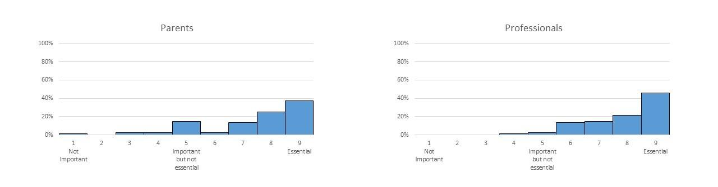

Q31_1 Now that you know this, please re-rate how important you think this strategy is.

|  |  |  |  |  |  |  |  |  |  |  |
| --- | --- | --- | --- | --- | --- | --- | --- | --- | --- | --- |
|  | Not important  1 | 2 | 3 | 4 | Important but not essential  5 | 6 | 7 | 8 | Essential  9 | Not applicable / Not relevant |
| **Enhancing communication** ​Improving communication between a child and the person feeding them during mealtimes (e.g. offering choices of food to a child; a child using eye pointing or signs or symbols to ask for specific food or drink) |  |  |  |  |  |  |  |  |  |  |

Q31_2 Please provide any additional comments you have about this strategy here:

________________________________________________________________

**Visual supports**

The graphs below show how important parents and professionals rated 'Visual Supports' as a strategy to be included as part of an 'intervention package' for children with eating and drinking difficulties.

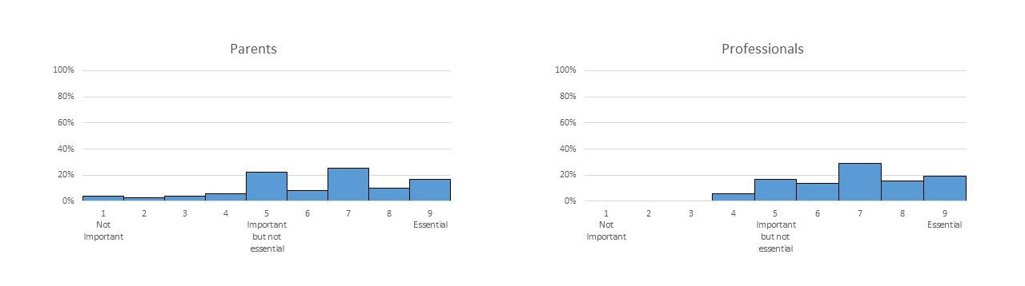

Q32_1 Now that you know this, please re-rate how important you think this strategy is.

|  |  |  |  |  |  |  |  |  |  |  |
| --- | --- | --- | --- | --- | --- | --- | --- | --- | --- | --- |
|  | Not important  1 | 2 | 3 | 4 | Important but not essential  5 | 6 | 7 | 8 | Essential  9 | Not applicable / Not relevant |
| **Visual supports** ​  Use of pictures, a "countdown clock", or social stories to increase a child's understanding of what happens during mealtimes (e.g. showing a child pictures of what food will be on their plate; showing a child a story to explain what will happen during a mealtime) |  |  |  |  |  |  |  |  |  |  |

Q32_2 Please provide any additional comments you have about this strategy here: ________________________________________________________________

**Responding to a Child's Cues for Feeding**

The graphs below show how important parents and professionals rated 'Responding to a Child's Cues for Feeding' as a strategy to be included as part of an 'intervention package' for children with eating and drinking difficulties.

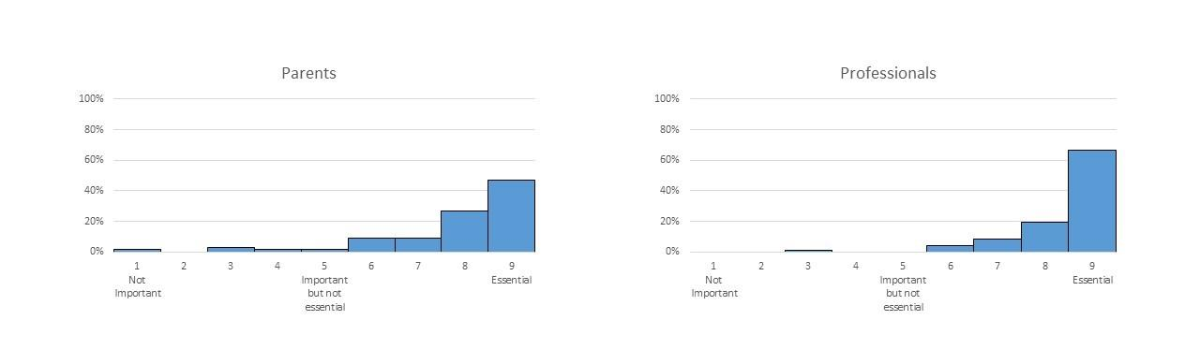

Q33_1 Now that you know this, please re-rate how important you think this strategy is.

|  |  |  |  |  |  |  |  |  |  |  |
| --- | --- | --- | --- | --- | --- | --- | --- | --- | --- | --- |
|  | Not important  1 | 2 | 3 | 4 | Important but not essential  5 | 6 | 7 | 8 | Essential  9 | Not applicable / Not relevant |
| **Responding to a child's cues for feeding** ​Helping people to recognise the signs that a child is ready to take another mouthful of food or drink (e.g. looking for breath alterations or repeated swallows from a child to indicate a lack of readiness) |  |  |  |  |  |  |  |  |  |  |

Q33_2 Please provide any additional comments you have about this strategy here:

________________________________________________________________

**​Pace of** **Feeding**

The graphs below show how important parents and professionals rated 'Pace of Feeding' as a strategy to be included as part of an 'intervention package' for children with eating and drinking difficulties.

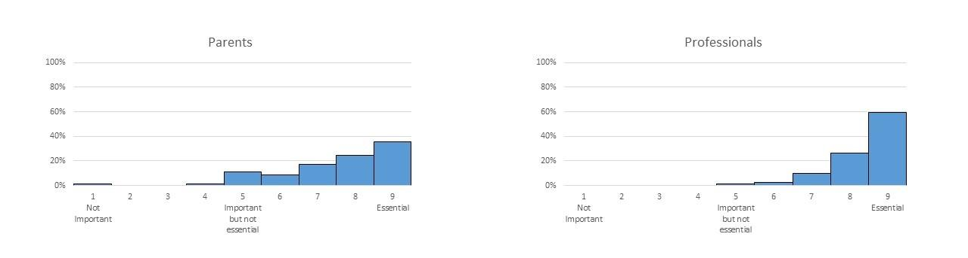

Q34_1 Now that you know this, please re-rate how important you think this strategy is.

|  |  |  |  |  |  |  |  |  |  |  |
| --- | --- | --- | --- | --- | --- | --- | --- | --- | --- | --- |
|  | Not important  1 | 2 | 3 | 4 | Important but not essential  5 | 6 | 7 | 8 | Essential  9 | Not applicable / Not relevant |
| **Pace of feeding** ​Changing the speed at which each mouthful of food or drink is taken by a child (e.g. slowing pace down to prevent overfilling of a child's mouth) |  |  |  |  |  |  |  |  |  |  |

Q34_2 Please provide any additional comments you have about this strategy here:

________________________________________________________________

**​Medication**

The graphs below show how important parents and professionals rated 'Medication' as a strategy to be included as part of an 'intervention package' for children with eating and drinking difficulties.

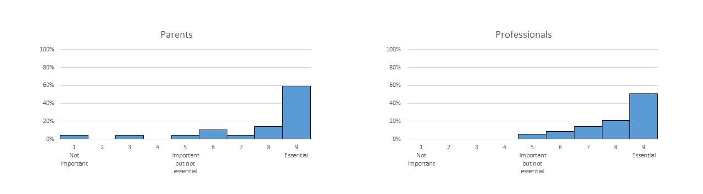

Q35_1 Now that you know this, please re-rate how important you think this strategy is.

|  |  |  |  |  |  |  |  |  |  |  |
| --- | --- | --- | --- | --- | --- | --- | --- | --- | --- | --- |
|  | Not important  1 | 2 | 3 | 4 | Important but not essential  5 | 6 | 7 | 8 | Essential  9 | Not applicable / Not relevan |
| **Medication** ​Any medication (e.g. for epilepsy, pain, drooling, tone, gastroesophageal reflux) |  |  |  |  |  |  |  |  |  |  |

Q35_2 Please provide any additional comments you have about this strategy here:

________________________________________________________________

**​Energy Supplements**

The graphs below show how important parents and professionals rated 'Energy Supplements' as a strategy to be included as part of an 'intervention package' for children with eating and drinking difficulties.

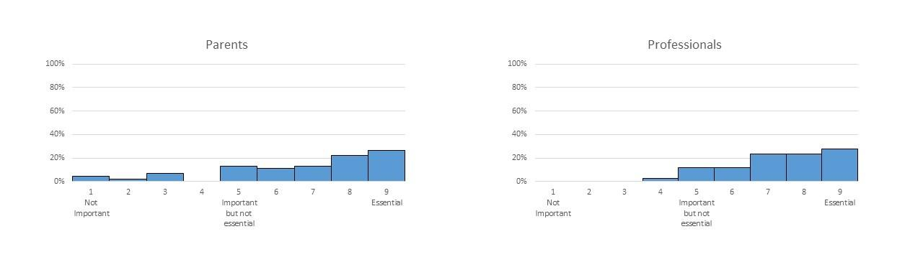

Q36_1 Now that you know this, please re-rate how important you think this strategy is.

|  |  |  |  |  |  |  |  |  |  |  |
| --- | --- | --- | --- | --- | --- | --- | --- | --- | --- | --- |
|  | Not important  1 | 2 | 3 | 4 | Important but not essential  5 | 6 | 7 | 8 | Essential  9 | Not applicable / Not relevant |
| **Energy supplements** ​Any energy or calorie supplement given orally or via feeding tube |  |  |  |  |  |  |  |  |  |  |

Q36_2 Please provide any additional comments you have about this strategy here:

________________________________________________________________

**​Vitamin or Nutritional Supplements**

The graphs below show how important parents and professionals rated 'Vitamin or Nutritional Supplements' as a strategy to be included as part of an 'intervention package' for children with eating and drinking difficulties.

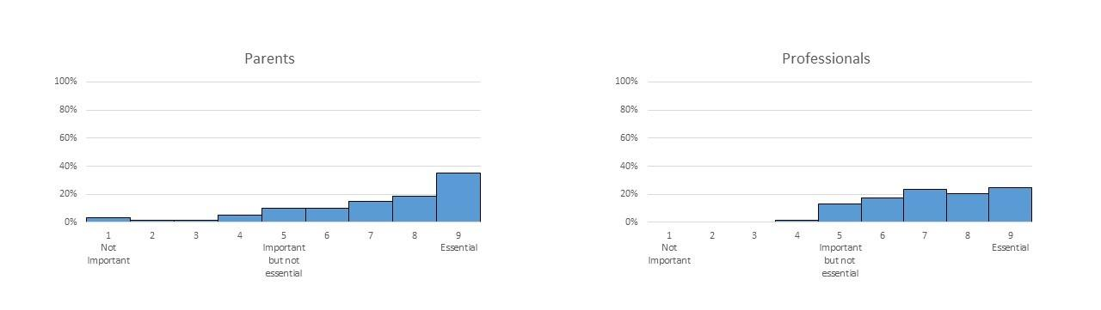

Q37_1 Now that you know this, please re-rate how important you think this strategy is.

|  |  |  |  |  |  |  |  |  |  |  |
| --- | --- | --- | --- | --- | --- | --- | --- | --- | --- | --- |
|  | Not important  1 | 2 | 3 | 4 | Important but not essential  5 | 6 | 7 | 8 | Essential  9 | Not applicable / Not relevant |
| **Vitamin or nutritional supplements** ​Any supplements given or changes to a child's diet to increase the vitamins or nutrients in their diet |  |  |  |  |  |  |  |  |  |  |

Q37_2 Please provide any additional comments you have about this strategy here:

________________________________________________________________

**​Physical Support**

The graphs below show how important parents and professionals rated 'Physical Support' as a strategy to be included as part of an 'intervention package' for children with eating and drinking difficulties.

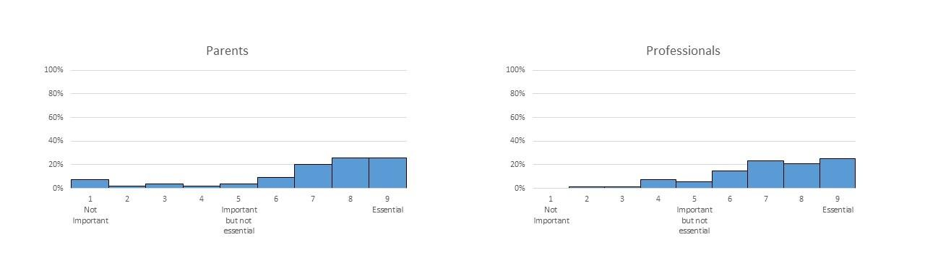

Q38_1 Now that you know this, please re-rate how important you think this strategy is.

|  |  |  |  |  |  |  |  |  |  |  |
| --- | --- | --- | --- | --- | --- | --- | --- | --- | --- | --- |
|  | Not important  1 | 2 | 3 | 4 | Important but not essential  5 | 6 | 7 | 8 | Essential  9 | Not applicable / Not relevant |
| **Physical support** ​Giving direct physical support to a child when eating or drinking to improve the movements needed to bite, chew and swallow (e.g. placing a thumb underneath the chin to help a child close their mouth) |  |  |  |  |  |  |  |  |  |  |

Q38_2 Please provide any additional comments you have about this strategy here:

________________________________________________________________

**​**

**Oral and Sensory Desensitisation**

The graphs below show how important parents and professionals rated 'Oral and Sensory Desensitisation' as a strategy to be included as part of an 'intervention package' for children with eating and drinking difficulties.

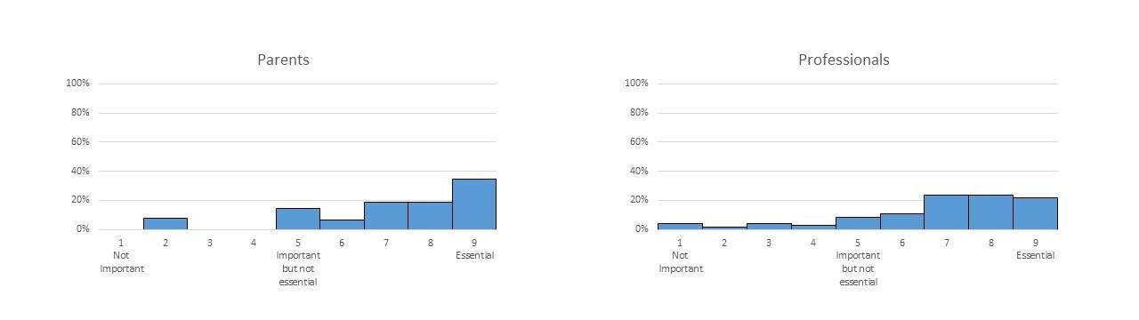

Q39_1 Now that you know this, please re-rate how important you think this strategy is.

|  |  |  |  |  |  |  |  |  |  |  |
| --- | --- | --- | --- | --- | --- | --- | --- | --- | --- | --- |
|  | Not important  1 | 2 | 3 | 4 | Important but not essential  5 | 6 | 7 | 8 | Essential  9 | Not applicable / Not relevant |
| **​**​**Oral and sensory desentisation** ​Activities aimed at reducing a child's adverse reactions to different sensory experiences linked to eating and drinking (e.g. face massage; chewing non-food items such as a chewy 'toothbrush') |  |  |  |  |  |  |  |  |  |  |

Q39_2 Please provide any additional comments you have about this strategy here:

________________________________________________________________

**​Oral Motor Exercises**

The graphs below show how important parents and professionals rated 'Oral Motor Exercises' as a strategy to be included as part of an 'intervention package' for children with eating and drinking difficulties.

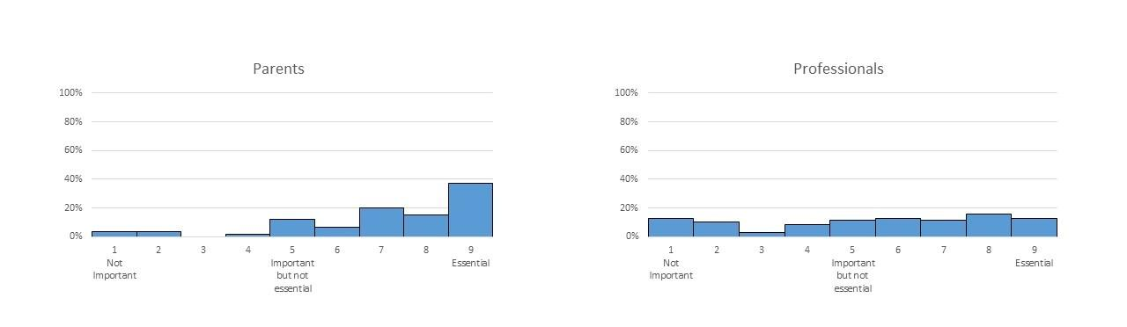

Q40_1 Now that you know this, please re-rate how important you think this strategy is.

|  |  |  |  |  |  |  |  |  |  |  |
| --- | --- | --- | --- | --- | --- | --- | --- | --- | --- | --- |
|  | Not important  1 | 2 | 3 | 4 | Important but not essential  5 | 6 | 7 | 8 | Essential  9 | Not applicable / Not relevant |
| **​**​**Oral motor exercises** ​Exercises done with a child to improve the control of their mouth, jaw, tongue or lips (e.g. a child moving a non-food item with their tongue; a child sucking through a straw) |  |  |  |  |  |  |  |  |  |  |

Q40_2 Please provide any additional comments you have about this strategy here:

________________________________________________________________

**​**

**Graded Exposure to New Food**

The graphs below show how important parents and professionals rated 'Graded Exposure to New Food' as a strategy to be included as part of an 'intervention package' for children with eating and drinking difficulties.

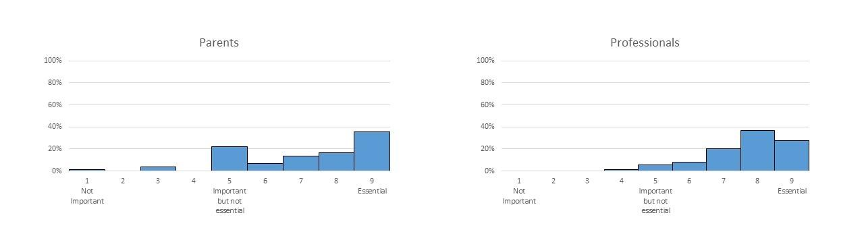

Q41_1 Now that you know this, please re-rate how important you think this strategy is.

|  |  |  |  |  |  |  |  |  |  |  |
| --- | --- | --- | --- | --- | --- | --- | --- | --- | --- | --- |
|  | Not important  1 | 2 | 3 | 4 | Important but not essential  5 | 6 | 7 | 8 | Essential  9 | Not applicable / Not relevant |
| **​**​**Graded exposure to new food** ​Activities aimed at gradually exposing a child to new or disliked foods and drinks (e.g. messy play activities involving a child; touching new or disliked foods; using small steps towards a child accepting new or disliked foods such as licking the food or putting it in their mouth with no expectation to swallow |  |  |  |  |  |  |  |  |  |  |

Q41_2 Please provide any additional comments you have about this strategy here:

________________________________________________________________

**Graded Exposure to New Textures**

The graphs below show how important parents and professionals rated 'Graded Exposure to New Textures' as a strategy to be included as part of an 'intervention package' for children with eating and drinking difficulties.

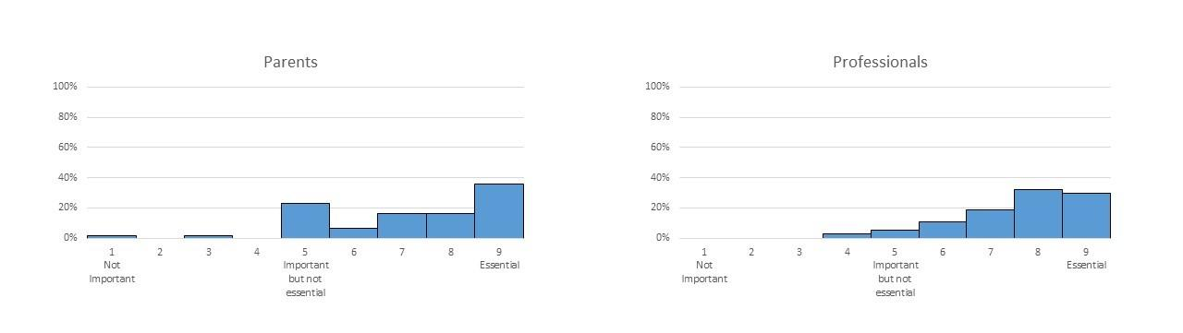

Q42_1 Now that you know this, please re-rate how important you think this strategy is.

|  |  |  |  |  |  |  |  |  |  |  |
| --- | --- | --- | --- | --- | --- | --- | --- | --- | --- | --- |
|  | Not important  1 | 2 | 3 | 4 | Important but not essential  5 | 6 | 7 | 8 | Essential  9 | Not applicable / Not relevant |
| **​**​**Graded exposure to new textures** ​Activities aimed at gradually introducing a child to more challenging food textures and fluid consistencies (e.g. messy play activities involving a child touching new or disliked textures; using small steps to introduce a child to lumpy food or foods that require chewing) |  |  |  |  |  |  |  |  |  |  |

Q42_2 Please provide any additional comments you have about this strategy here:

________________________________________________________________

**Changing Behaviour at Mealtimes**

The graphs below show how important parents and professionals rated 'Changing Behaviour at Mealtimes' as a strategy to be included as part of an 'intervention package' for children with eating and drinking difficulties.

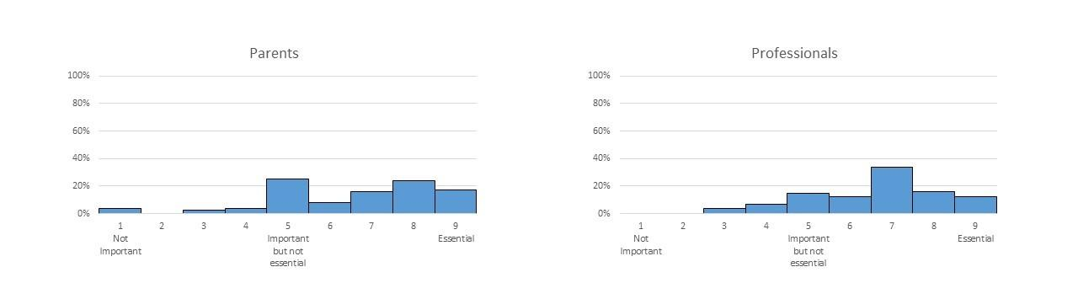

Q43_1 Now that you know this, please re-rate how important you think this strategy is.

|  |  |  |  |  |  |  |  |  |  |  |
| --- | --- | --- | --- | --- | --- | --- | --- | --- | --- | --- |
|  | Not important  1 | 2 | 3 | 4 | Important but not essential  5 | 6 | 7 | 8 | Essential  9 | Not applicable / Not relevant |
| **​**​**Changing behaviour at mealtimes** ​Strategies to encourage a child to behave appropriately at mealtimes (e.g. a child sitting down ready to eat; a child staying seated for the meal) |  |  |  |  |  |  |  |  |  |  |

Q43_2 Please provide any additional comments you have about this strategy here:

________________________________________________________________

**​**

**Modelling**

The graphs below show how important parents and professionals rated 'Modelling' as a strategy to be included as part of an 'intervention package' for children with eating and drinking difficulties.

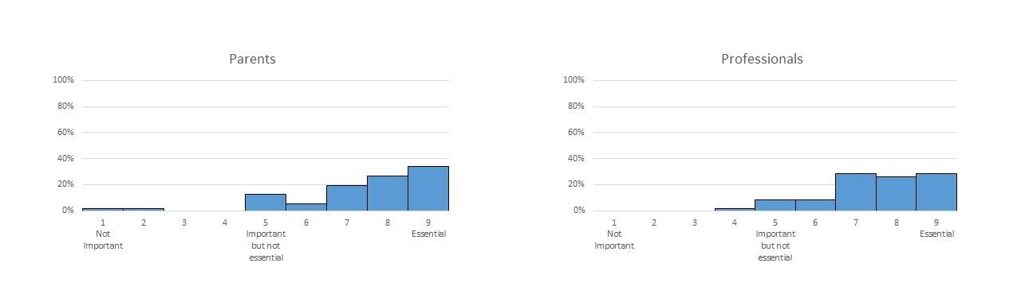

Q44_1 Now that you know this, please re-rate how important you think this strategy is.

|  |  |  |  |  |  |  |  |  |  |  |
| --- | --- | --- | --- | --- | --- | --- | --- | --- | --- | --- |
|  | Not important  1 | 2 | 3 | 4 | Important but not essential  5 | 6 | 7 | 8 | Essential  9 | Not applicable / Not relevant |
| **​**​**Modelling** ​Giving a child the opportunity to learn from others by eating and drinking with them (e.g. sitting a child with other children or family members at mealtimes) |  |  |  |  |  |  |  |  |  |  |

Q44_2 Please provide any additional comments you have about this strategy here:

________________________________________________________________

**​Training to Self-Feed**

The graphs below show how important parents and professionals rated 'Training to Self-Feed' as a strategy to be included as part of an 'intervention package' for children with eating and drinking difficulties.

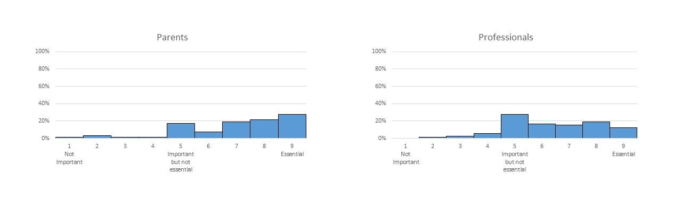

Q45_1 Now that you know this, please re-rate how important you think this strategy is.

|  |  |  |  |  |  |  |  |  |  |  |
| --- | --- | --- | --- | --- | --- | --- | --- | --- | --- | --- |
|  | Not important  1 | 2 | 3 | 4 | Important but not essential  5 | 6 | 7 | 8 | Essential  9 | Not applicable / Not relevant |
| **​**​**Training to self feed** ​Teaching a child to feed themselves (e.g. placing a hand over a child's hand to help guide the food into their mouth) |  |  |  |  |  |  |  |  |  |  |

Q45_2 Please provide any additional comments you have about this strategy here:

________________________________________________________________

**​Support for Parents**

The graphs below show how important parents and professionals rated 'Support for Parents' as a strategy to be included as part of an 'intervention package' for children with eating and drinking difficulties.

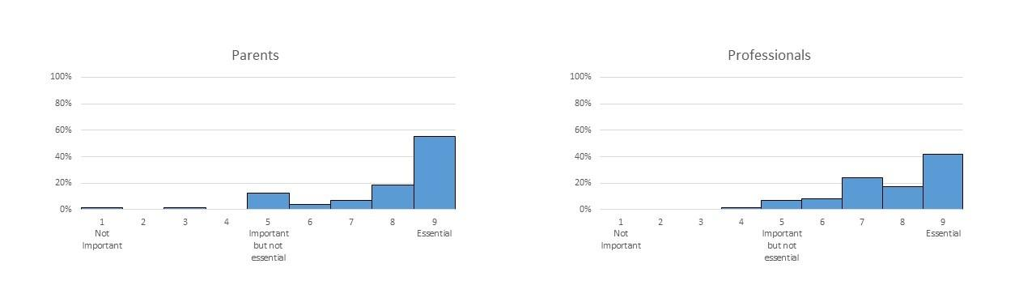

Q46_1 Now that you know this, please re-rate how important you think this strategy is.

|  |  |  |  |  |  |  |  |  |  |  |
| --- | --- | --- | --- | --- | --- | --- | --- | --- | --- | --- |
|  | Not important  1 | 2 | 3 | 4 | Important but not essential  5 | 6 | 7 | 8 | Essential  9 | Not applicable / Not relevant |
| **​**​**Support for parents** ​  Help for parents around their child's eating and drinking difficulties (e.g. counselling; parent support groups) |  |  |  |  |  |  |  |  |  |  |

Q46_2 Please provide any additional comments you have about this strategy here:

________________________________________________________________

**​Sharing Information**

The graphs below show how important parents and professionals rated 'Sharing Information' as a strategy to be included as part of an 'intervention package' for children with eating and drinking difficulties.

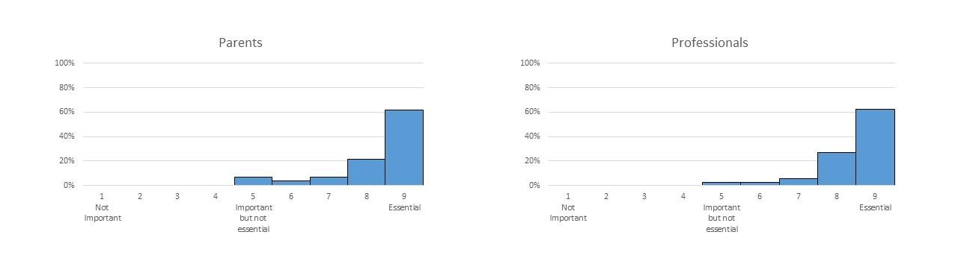

Q47_1 Now that you know this, please re-rate how important you think this strategy is.

|  |  |  |  |  |  |  |  |  |  |  |
| --- | --- | --- | --- | --- | --- | --- | --- | --- | --- | --- |
|  | Not important  1 | 2 | 3 | 4 | Important but not essential  5 | 6 | 7 | 8 | Essential  9 | Not applicable / Not relevant |
| **​**​**Sharing Information** ​Any information shared to help parents and professionals understand a child's difficulties with eating and drinking (e.g. professionals teaching parents and school staff about a child's physical or sensory difficulties; parents helping professionals understand what's important about mealtimes in their family) |  |  |  |  |  |  |  |  |  |  |

Q47_2 Please provide any additional comments you have about this strategy here:

________________________________________________________________

**Psychological Support for Children**

The graphs below show how important parents and professionals rated 'Psychological Support for Children' as a strategy to be included as part of an 'intervention package' for children with eating and drinking difficulties.

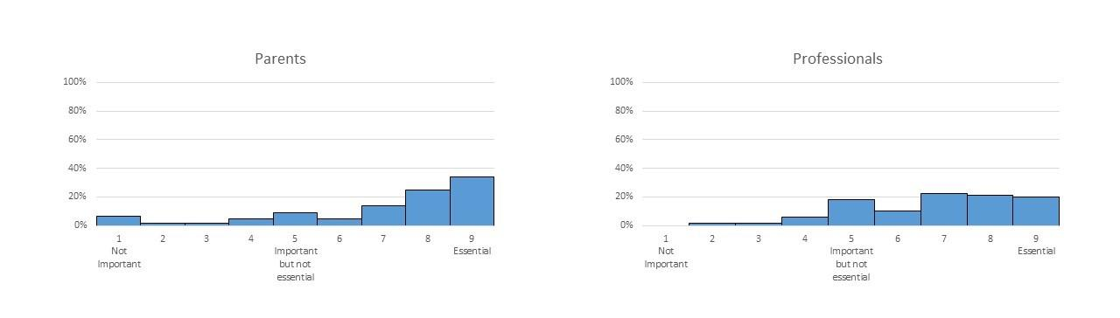

Q48_1 Now that you know this, please re-rate how important you think this strategy is.

|  |  |  |  |  |  |  |  |  |  |  |
| --- | --- | --- | --- | --- | --- | --- | --- | --- | --- | --- |
|  | Not important  1 | 2 | 3 | 4 | Important but not essential  5 | 6 | 7 | 8 | Essential  9 | Not applicable / Not relevant |
| **​**​**Psychological support for children** ​Psychological help for a child (e.g. counselling or cognitive behavioural therapy) |  |  |  |  |  |  |  |  |  |  |

Q48_2 Please provide any additional comments you have about this strategy here:

________________________________________________________________

Q49 Please provide any additional strategies you think are important or essential here:

If you provided any additional strategies in the previous round, we will take account of these so you do not need to repeat these comments again on this survey. Thank you.