# **Supplementary Material 2: Ethics approval for Phase 1**

Evidence of Research Ethics Committee approval

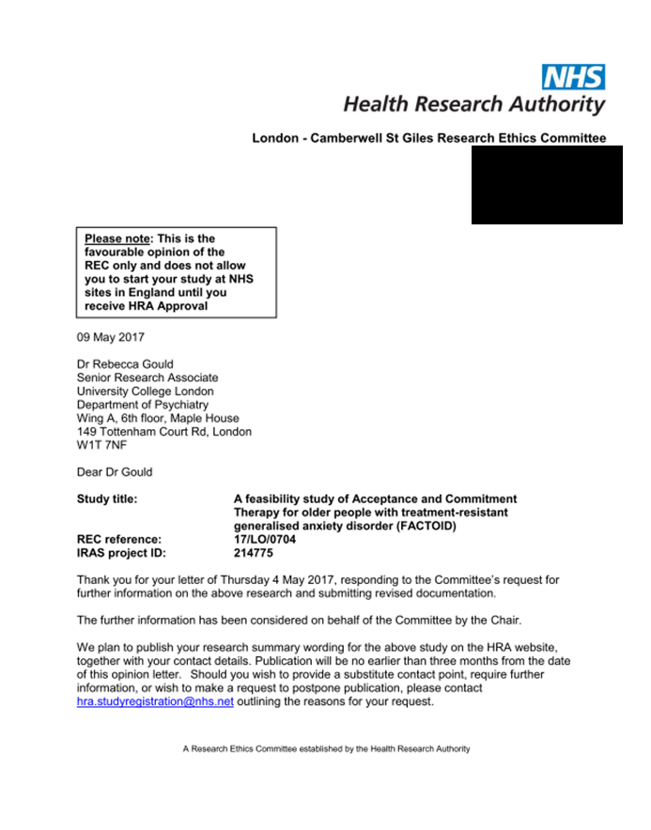

Evidence of Health Research Authority approval

