# **Supplementary Material 5: Ethics approval for Phase 2**

Evidence of Research Ethics Committee approval

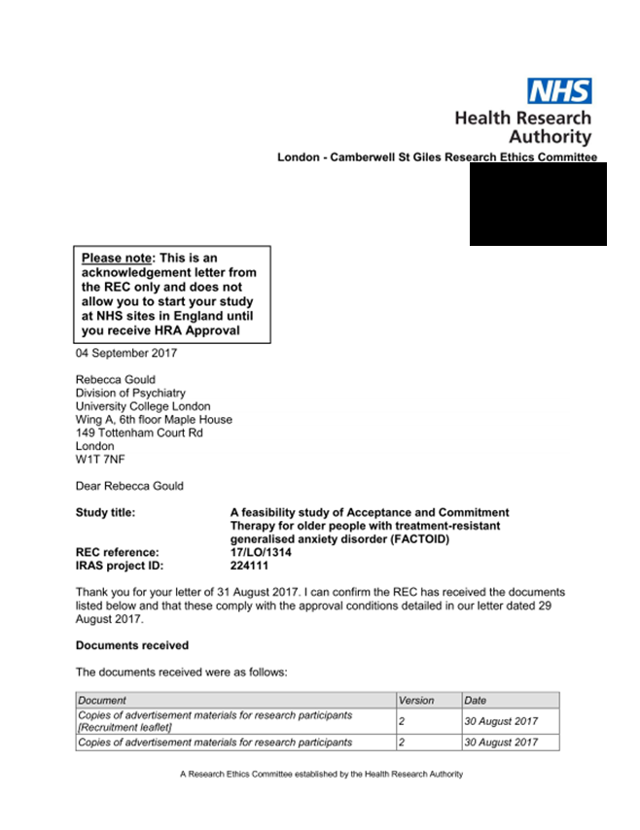

Evidence of Health Research Authority approval

