Supplementary Material 3

Screenshots of participant advertisements (reproduced with permission from Bliss and Tommy’s, personal communication, 2021).

Tommy’s 20th November 2018

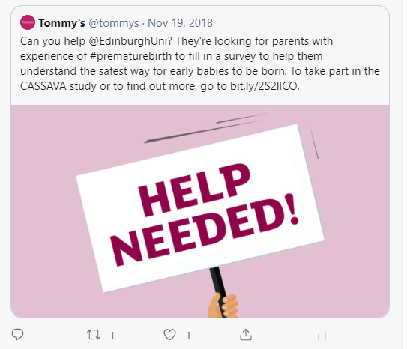

Tommy’s centre in Edinburgh advertised the survey on their own Facebook page on 13th November 2018

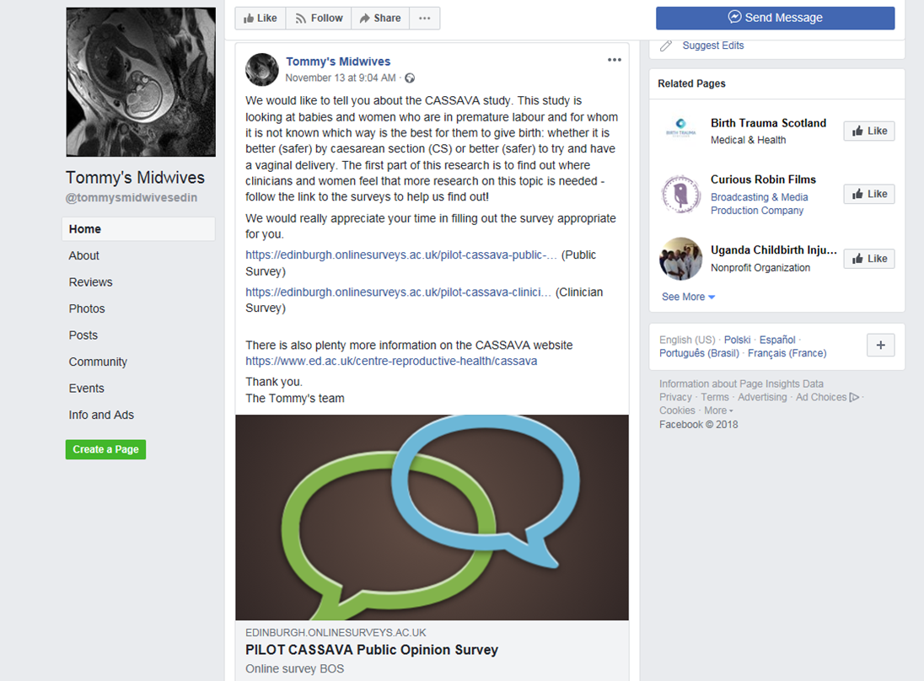

Bliss advertised on Facebook, Twitter and Instagram on 7th December 2018

