**Report Supplementary Materials 4**

**METHODS FOR IDENTIFYING COMORBIDITIES FOR CASE-MIX ADJUSTMENT IN VOLUME-OUTCOME ANALYSIS FOR AAA**

## AIM

The aim of this document is to describe methods used to identify comorbidities for case-mix adjustment in volume-outcome analyses of patients who received an aneurysm repair in the index admission. We started with an existing list of important comorbidities (based on ICD10) that are commonly used in analysing routine hospital data: The Charlson comorbidity categories. We then investigated the use of this list in our data, and worked together with our clinical advisers to refine the list for our analytical purpose. The final list for comorbidities was used for case-mix adjustment between vascular centres in our volume-outcome analysis.

## IDENTIFICATION OF COMORBIDITY CATEGORIES

This section describes the list of categories identified as potential comorbidities to be included for case-mix adjustment. Charlson comorbidity categories were used as the starting list, with modifications (i.e. exclusion of some categories and inclusion of new categories) suggested by the clinical experts.

Charlson comorbidity categories have been used to describe patient comorbidities in routine data. There are 17 categories defined by the ICD-10 codes (either full codes or 3-digit blocks). Table 1 briefly presents these 17 categories (Quan et al.,2005).

Table 1: Charlson comorbidity categories by ICD-10 (Quan et al., 2005)

|  |  |  |
| --- | --- | --- |
| **Number** | **Charlson Comorbidity Category** | **ICD-10 codes/blocks** |
| 1 | Myocardial Infarction | I21.x, I22.x, I25.2 |
| 2 | Congestive Heart Failure | I09.9, I11.0, I13.0, I13.2, I25.5, I42.0,I42.5–I42.9, I43.x, I50.x, P29.0 |
| 3 | Peripheral Vascular Disease | I70.x, I71.x, I73.1, I73.8, I73.9, I77.1,I79.0, I79.2, K55.1, K55.8, K55.9,Z95.8, Z95.9 |
| 4 | Cerebrovascular Disease | G45.x, G46.x, H34.0, I60.x–I69.x |
| 5 | Dementia | F00.x–F03.x, F05.1, G30.x, G31.1 |
| 6 | Chronic Pulmonary Disease | I27.8, I27.9, J40.x–J47.x, J60.x–J67.x,J68.4, J70.1, J70.3 |
| 7 | Connective Tissue Disease-Rheumatic Disease | M05.x, M06.x, M31.5, M32.x–M34.x,M35.1, M35.3, M36.0 |
| 8 | Peptic Ulcer Disease | K25.x–K28.x |
| 9 | Mild Liver Disease | B18.x, K70.0–K70.3, K70.9,K71.3–K71.5, K71.7, K73.x, K74.x,K76.0, K76.2–K76.4, K76.8, K76.9,Z94.4 |
| 10 | Diabetes without chronic complications | E10.0, E10.1, E10.6, E10.8, E10.9,E11.0, E11.1, E11.6, E11.8, E11.9,E12.0, E12.1, E12.6, E12.8, E12.9,E13.0, E13.1, E13.6, E13.8, E13.9,E14.0, E14.1, E14.6, E14.8, E14.9 |
| 11 | Diabetes with chronic complications | E10.2–E10.5, E10.7, E11.2–E11.5,E11.7, E12.2–E12.5, E12.7, E13.2–E13.5, E13.7, E14.2–E14.5, E14.7 |
| 12 | Paraplegia and Hemiplegia | G04.1, G11.4, G80.1, G80.2, G81.x,G82.x, G83.0–G83.4, G83.9 |
| 13 | Renal Disease | I12.0, I13.1, N03.2–N03.7, N05.2–N05.7, N18.x, N19.x, N25.0, Z49.0–Z49.2, Z94.0, Z99.2 |
| 14 | Any maglinancy, including lymphoma and leukemia, except malignant neoplasm of skin | C00.x–C26.x, C30.x–C34.x, C37.x–C41.x, C43.x, C45.x–C58.x, C60.x–C76.x, C81.x–C85.x, C88.x,C90.x–C97.x |
| 15 | Moderate or Severe Liver Disease | I85.0, I85.9, I86.4, I98.2, K70.4,K71.1, K72.1, K72.9, K76.5, K76.6,K76.7 |
| 16 | Metastatic Carcinoma | C77.x–C80.x |
| 17 | AIDS/HIV | B20.x–B22.x, B24.x |

After examining the clinical validity as well as the frequency and the impacts of each Charlson category on in-hospital mortality and length of stay in the index admissions in our data, our clinical advisors (three vascular surgeons and one vascular radiologist) agreed on following:

* The following comorbidity categories are not relevant and should be excluded:
  + Number 3 (Peripheral Vascular Disease): This overlaps with our vascular conditions so it should not be considered as a comorbidity. Indeed, our data show that 97% of our patients would be categorised into this group of ‘comorbidity’.
  + Number 5 (Dementia) (553 cases – 0.7% of total patients). This comorbidity is not common and its effect is negligible.
  + Number 7 (Connective Tissue Disease-Rheumatic Disease) (1432 cases – 1.7% of total patients). It does not have an effect on mortality or length of stay as shown in our data and clinical opinion.
  + Number 17 (AIDS/HIV) (12 cases – 0.01% of total patients). This comorbidity is not common.
* The following comorbidity categories should be merged together:
  + Number 11 with number 10 (diabetes)
  + Number 16 with number 14 (cancer)
* The following comorbidity categories need to be distinguished between whether it is a comorbidity or a complication by looking at its presence in previous admissions before the index admissions. The categories are only counted as comorbidities if they appear in pre-index admissions, this is because if they only appear in the index admission, they are likely to be complication rather than comorbidity.
  + Number 1 (Acute MI)
  + Number 2 (Congestive Heart Failure)
  + Number 4 (Cerebro vascular disease)
  + Number 8 (Peptic Ulcer Disease)
  + Number 12 (Paraplegia and Hemiplegia)
  + Number 13 (Renal disease)
* With the cancer comorbidity category, we noted the following points:
  + Cancer is a contra-indication for elective surgery
  + However, it can be relevant for emergency cases or cancer could be diagnosed in the index admission.
* We also checked whether we should add the following comorbidity categories to the current Charlson list:
  + Smoking: 'Z720','F171','F172','F173','F174','F175','F176','F177','F178','F179'
  + Obesity: 'E660','E661','E662','E668','E669'
  + Primary hypertension: 'I10X'
  + Dyslipidemia: 'E780','E782','E784','E785'

A further clinical examination of the ICD-10 codes mentioned in Charlson categories led us to propose the following changes in terms of ICD-10 codes used:

* The Charlson group for ‘Myocardial Infarction’ was updated and changed to ‘Coronary Artery Disease’ with the additional ICD10 codes for angina and ischaemic heart disease (see Table 2).
* The Charlson group for ‘Congestive Heart Failure’ was updated to ‘Heart Failure’. Some of the old ICD10 codes were dropped because they were not relevant for our vascular conditions. Some new ICD10 codes were added (see Table 2).

A modified list of Charlson comorbidity categories was proposed for describing comorbidities in patients with aneurysm as presented in Table 2. When checking the presence of the comorbidities in pre-index admissions, we limit the time period to one year prior to the index admission. This is because of a potential bias with counting all pre-index admissions: those who had their index admissions towards the end of our data (near to 2018) would be more likely to have pre-index admissions compared to those at the beginning of our data.

Table 2: proposed comorbidity categories for further investigation (Sheffield AAA modified Charlson Comorbidities)

|  |  |  |  |
| --- | --- | --- | --- |
| **No** | **Comorbidity Category** | **ICD-10 codes/blocks** | **Note** |
| 1 | Coronary Artery Disease | I20.x, I21.x, I22.x, I23.x, I24.x, I25.x | Not count as a comorbidity if only present in the index admission |
| 2 | Heart Failure | I50.x, I43.x, I42.x,  I09.9, I11.0, I13.0, I13.2, I25.5, I51.7 | Not count as a comorbidity if only present in the index admission |
| 3 | Cerebrovascular Disease | G45.x, G46.x, H34.0, I60.x–I69.x | Not count as a comorbidity if only present in the index admission |
| 4 | Chronic Pulmonary Disease | I27.8, I27.9, J40.x–J47.x, J60.x–J67.x,J68.4, J70.1, J70.3 | Count in both index and pre-index admissions |
| 5 | Peptic Ulcer Disease | K25.x–K28.x | Not count as a comorbidity if only present in the index admission |
| 6 | Mild Liver Disease | B18.x, K70.0–K70.3, K70.9,K71.3–K71.5, K71.7, K73.x, K74.x,K76.0, K76.2–K76.4, K76.8, K76.9,Z94.4 | Count in both index and pre-index admissions |
| 7 | Diabetes | E10.0, E10.1, E10.6, E10.8, E10.9,E11.0, E11.1, E11.6, E11.8, E11.9,E12.0, E12.1, E12.6, E12.8, E12.9,E13.0, E13.1, E13.6, E13.8, E13.9,E14.0, E14.1, E14.6, E14.8, E14.9,E10.2–E10.5, E10.7, E11.2–E11.5,E11.7, E12.2–E12.5, E12.7, E13.2–E13.5, E13.7, E14.2–E14.5, E14.7 | Count in both index and pre-index admissions |
| 8 | Paraplegia and Hemiplegia | G04.1, G11.4, G80.1, G80.2, G81.x,G82.x, G83.0–G83.4, G83.9 | Not count as a comorbidity if only present in the index admission |
| 9 | Renal Disease | I12.0, I13.1, N03.2–N03.7, N05.2–N05.7, N18.x, N19.x, N25.0, Z49.0–Z49.2, Z94.0, Z99.2 | Not count as a comorbidity if only present in the index admission |
| 10 | Cancer | C00.x–C26.x, C30.x–C34.x, C37.x–C41.x, C43.x, C45.x–C58.x, C60.x–C76.x, C81.x–C85.x, C88.x,C90.x–C97.x,C77.x–C80.x | Relevant for emergency or when cancer is diagnosed in the index admission |
| 11 | Moderate or Severe Liver Disease | I85.0, I85.9, I86.4, I98.2, K70.4,K71.1, K72.1, K72.9, K76.5, K76.6,K76.7 | Count in both index and pre-index admissions |
| 12 | Smoking | Z720','F171','F172','F173','F174','F175','F176','F177','F178','F179' | New group, investigate |
| 13 | Obesity | E660','E661','E662','E668','E669' | New group, investigate |
| 14 | Primary hypertension | I10X | New group, investigate |
| 15 | Dyslipidemia | E780','E782','E784','E785' | New group, investigate |

## DESCRIPTIVE ANALYSES

### Patient pathways

There are 83964 AAA patients who had an aneurysm repair (83964 index admissions). Among them, 62507 (74.4%) had admissions which are prior to the index admission (no time limit); and 41500 (49%) had prior admissions within 1 year before the index admission (within our HES period between 1st Apr 2002 and 15 Feb 2015). Within the index admissions, 69% of them had only one episode; 12% had two episodes; 13% had three episodes; and 6% had more than three episodes.

### Descriptive summaries of the comorbidities in the index admissions

Table 3 presents the descriptive summaries of the comorbidities in the index admissions. We looked at how frequently a comorbidity appears in the index admissions and what would be the impact of its presence on in-hospital mortality and length of stay. We looked at elective admissions and emergency admissions separately. (Note that our rules for distinguishing between comorbidity and complication for the categories 1,2,3,5,8, and 9 above – to reduce bias, we only considered pre-index admissions within 1 year before the index admissions).

We observed four distinctive patterns for the comorbidity categories:

* the presence of the comorbidity increases the in-hospital mortality in both elective and emergency cases (green rows). The categories fall into this pattern are: 2,3,4,6,8,9, and 11. Especially the category 11 (moderate or severe liver disease) shows a substantially high in-mortality rate when it was present.
* the presence of the comorbidity increases the in-hospital mortality in elective cases but not in emergency cases (yellow rows). The categories that fall into this pattern are: 1 and 5.
* the presence of the comorbidity increases the in-hospital mortality in emergency cases but not in elective cases (orange rows). The categories that fall into this pattern are 7 and 13.
* the presence of the comorbidity lowers the in-hospital mortality in both emergency cases and elective cases (white rows). The categories that fall into this pattern are 10 (cancer), 12 (smoker), 14 (hypertension) and 15 (dyslipidemia).

The most common comorbidity is hypertension (54% of total patients), followed by dyslipidemia (22%), chronic pulmonary disease (18%), smoking (16%), Coronary Artery Disease (16%), and Diabetes (11%).

The following sections report further investigations performed for several comorbidity categories.

Table 3: Summaries of comorbidities in the index admissions in our data and their impacts on mortality and length of stay

|  |  |  |  |  |  |  |  |  |  |  |  |  |  |  |
| --- | --- | --- | --- | --- | --- | --- | --- | --- | --- | --- | --- | --- | --- | --- |
| **Comorbidity Category** | Code | Total cases | % of total patients | Elective cases | Emergency cases | % elective | **Elective** | | | | **Emergency** | | | |
| In_hosp death | | LOS (days) | | In_hosp death | | LOS (days) | |
| Present | Absent | Present | Absent | Present | Absent | Present | Absent |
| Coronary Artery Disease | 1 | 12984 | 15% | 10284 | 2699 | 79% | 5.6% | 4.7% | 11.3 | 11.4 | 28.9% | 29.7% | 21.8 | 21.6 |
| Heart Failure | 2 | 2468 | 3% | 1817 | 651 | 74% | 6.2% | 4.8% | 11.9 | 11.3 | 33.6% | 29.6% | 23.8 | 21.5 |
| Cerebrovascular Disease | 3 | 1935 | 2% | 1439 | 496 | 74% | 5.1% | 4.9% | 12.2 | 11.3 | 34.3% | 29.6% | 24.2 | 21.5 |
| Chronic Pulmonary Disease | 4 | 15382 | 18% | 10454 | 4927 | 68% | 5.6% | 4.7% | 11.7 | 11.3 | 32.3% | 29.1% | 21.4 | 21.6 |
| Peptic Ulcer Disease | 5 | 669 | 1% | 526 | 143 | 79% | 6.1% | 4.9% | 11.7 | 11.3 | 28.7% | 29.7% | 25.8 | 21.6 |
| Mild Liver Disease | 6 | 975 | 1% | 636 | 338 | 65% | 7.7% | 4.8% | 12.3 | 11.3 | 30.5% | 29.6% | 23.9 | 21.6 |
| Diabetes | 7 | 9557 | 11% | 6899 | 2658 | 72% | 4.7% | 4.9% | 10.7 | 11.4 | 31.0% | 29.5% | 21.5 | 21.6 |
| Paraplegia and Hemiplegia | 8 | 262 | 0% | 183 | 79 | 70% | 6.0% | 4.9% | 12.3 | 11.3 | 30.4% | 29.7% | 26.7 | 21.6 |
| Renal Disease | 9 | 3060 | 4% | 2343 | 717 | 77% | 6.6% | 4.8% | 12.0 | 11.3 | 40.0% | 29.4% | 22.4 | 21.6 |
| Cancer | 10 | 5684 | 7% | 4522 | 1162 | 80% | 4.87% | 4.88% | 10.3 | 11.4 | 28.7% | 29.7% | 22.2 | 21.6 |
| Moderate or Severe Liver D | 11 | 390 | 0% | 134 | 256 | 34% | 47.8% | 4.8% | 11.7 | 11.3 | 85.5% | 29.1% | 16.7 | 21.6 |
| Smoker | 12 | 13023 | 16% | 8920 | 4103 | 68% | 4.4% | 5.0% | 10.9 | 11.4 | 21.8% | 31.0% | 19.7 | 21.9 |
| Obesity | 13 | 2138 | 3% | 1580 | 558 | 74% | 4.5% | 4.9% | 10.3 | 11.4 | 34.4% | 29.6% | 21.2 | 21.6 |
| Hypertension | 14 | 44923 | 54% | 31765 | 13155 | 71% | 4.7% | 5.1% | 10.9 | 11.9 | 26.8% | 32.2% | 21.2 | 21.9 |
| Dyslipidemia | 15 | 18114 | 22% | 14082 | 4031 | 78% | 3.8% | 5.2% | 10.3 | 11.7 | 21.7% | 31.0% | 19.9 | 21.9 |

### Investigation for the cancer group

5684 (6.8% of total patients) cases were identified as having at least an ICD10 code identified as cancer in their index admissions or one-year pre-index admissions: 1778 (31%) only had cancer recorded in the index admissions; 2202 (39%) had cancer recorded in only pre-index admissions; and 1704 (30%) had cancer recorded in both index and pre-index admissions.

Table 4: In-hospital mortality and length of stay for those who had a cancer comorbidity in index and pre-index admissions

|  |  |  |  |  |  |
| --- | --- | --- | --- | --- | --- |
| Elective | Cancer in index | Cancer in pre-index | n_cases | in_hosp_death | Los (days) |
| El | 0 | 0 | 51443 | 5% | 11.4 |
| El | 0 | 1 | 1852 | 4% | 9.4 |
| El | 1 | 0 | 1276 | 8% | 11.8 |
| El | 1 | 1 | 1394 | 4% | 10.1 |
| Em | 0 | 0 | 26825 | 30% | 21.6 |
| Em | 0 | 1 | 350 | 28% | 22.7 |
| Em | 1 | 0 | 502 | 30% | 22.7 |
| Em | 1 | 1 | 310 | 27% | 20.7 |

As observed, the cases where cancer would increase in-hospital mortality are when it was present in the index episode.

### Investigation for the newly proposed categories

#### Smoking

13023 cases (15.5% of total patients) had an ICD10 code in their index admissions or pre-index admissions identified them as smoker or ex-smoker. These ICD10 codes for identifying smokers include:

* Z720: Tobacco use
* F17 block: Mental and behavioural disorders due to use of tobacco

The initial analysis in our data (Table 3) shows that those who had been identified as smokers had a lower in-hospital mortality for both elective cases and emergency cases.

In order to understand the nature of the problem, we investigated the following characteristics between those identified as smokers/ex-smokers and those not: presence of other comorbidities, age, gender and % EVAR cases (separately for elective cases and emergency cases). For elective cases, the findings are as follows.

Table 5: Characteristics of smokers vs non-smokers in elective and emergency cases

|  |  |  |  |  |
| --- | --- | --- | --- | --- |
|  | Elective cases | | Emergency cases | |
| Factors | smoker/ex-smokers | Non-smokers | smoker/ex-smokers | Non-smokers |
| Coronary Artery Disease | 23.9% | 17.3% | 13% | 9% |
| Heart Failure | 4.2% | 3.1% | 3% | 2% |
| Cerebrovascular Disease | 3.9% | 2.3% | 3% | 2% |
| Chronic Pulmonary Disease | 28.7% | 16.8% | 29% | 16% |
| Peptic Ulcer Disease | 1.3% | 0.9% | 1% | 0% |
| Mild Liver Disease | 1.5% | 1.1% | 2% | 1% |
| Diabetes | 11.8% | 12.4% | 10% | 9% |
| Paraplegia and Hemiplegia | 0.5% | 0.3% | 1% | 0% |
| Renal Disease | 4.9% | 4.0% | 4% | 2% |
| Cancer | 8.8% | 7.9% | 4% | 4% |
| Moderate/Severe Liver Disease | 0.3% | 0.2% | 1% | 1% |
| Smoker | 100.0% | 0.0% | 100% | 0% |
| Obesity | 3.9% | 2.6% | 3% | 2% |
| Hypertension | 62.6% | 55.7% | 56% | 45% |
| Dyslipidemia | 34.8% | 23.3% | 23% | 13% |
| Age | 70.22 | 73.56 | 69.4 | 73.77 |
| % Male | 83.88% | 86.16% | 79.6% | 81.6% |
| % Evar | 42.16% | 38.99% | 20.1% | 16.6% |

We can see that the smoker group has higher prevalence of Chronic Pulmonary Disease. However, the smoker group is younger; the proportion of male is lower; and the proportion of EVAR cases is higher.

#### Obesity

2138 cases (2.5% of total cases) had an ICD10 code in their index admissions or pre-index admissions identified them as obesity. These ICD10 codes for identifying obesity include:

* E66 block
  + E660: Obesity due to excess calories
  + E661: Drug-induced obesity
  + E662: Extreme obesity with alveolar hypoventilation
  + E668: Other obesity
  + E669: Obesity, unspecified

The initial analysis in our data (Table 3) shows that those who had been identified as obesity had a higher rate in-hospital mortality in emergency cases but not in elective cases.

Further investigation for elective cases and emergency cases is as follows. For elective and emergency cases, the findings are as follows.

Table 6: Characteristics of obese vs non-obese patients in elective and emergency cases

|  |  |  |  |  |
| --- | --- | --- | --- | --- |
|  | Elective cases | | Emergency cases | |
| Factors | Obesity | No Obesity | Obesity | No Obesity |
| Coronary Artery Disease | 30% | 18% | 17% | 10% |
| Heart Failure | 7% | 3% | 7% | 2% |
| Cerebrovascular Disease | 3% | 3% | 4% | 2% |
| Chronic Pulmonary Disease | 28% | 18% | 27% | 17% |
| Peptic Ulcer Disease | 1% | 1% | 1% | 1% |
| Mild Liver Disease | 3% | 1% | 1% | 1% |
| Diabetes | 27% | 12% | 26% | 9% |
| Paraplegia and Hemiplegia | 0% | 0% | 1% | 0% |
| Renal Disease | 8% | 4% | 6% | 2% |
| Cancer | 9% | 8% | 5% | 4% |
| Moderate/Severe Liver Diseas | 1% | 0% | 1% | 1% |
| Smoker | 22% | 16% | 20% | 15% |
| Obesity | 100% | 0% | 100% | 0% |
| Hypertension | 75% | 56% | 66% | 47% |
| Dyslipidemia | 41% | 25% | 24% | 14% |
| Age | 69.63 | 73.1 | 69.97 | 73.19 |
| % Male | 88% | 86% | 82% | 81% |
| % Evar | 56% | 39% | 26% | 17% |

We can see that the obesity group has higher prevalence of other comorbidities. However, the obesity group is younger; and the proportion of EVAR cases is higher.

#### Hypertension

44923 cases (53.5% of total patients) had an ICD10 code in their index admissions or pre-index admissions identified them as having essential (primary) hypertension as a cormobidity. Only one ICD10 code was used for identifying essential (primary) hypertension: I10X.

The initial analysis in our data shows that those with a hypertension comorbidity had a lower in-hospital mortality for both elective and emergency cases. Further investigation is as follows.

For elective cases, the findings are as follows.

Table 7: Characteristics of patients with hypertension vs no-hypertension in elective and emergency cases

|  |  |  |  |  |
| --- | --- | --- | --- | --- |
|  | Elective cases | | Emergency cases | |
| Factors  (elective cases) | Hypertension | No-hypertension | Hypertension | No-hypertension |
| Coronary Artery Disease | 24% | 12% | 14% | 5% |
| Heart Failure | 4% | 2% | 3% | 1% |
| Cerebrovascular Disease | 3% | 1% | 3% | 1% |
| Chronic Pulmonary Disease | 20% | 17% | 20% | 16% |
| Peptic Ulcer Disease | 1% | 1% | 1% | 0% |
| Mild Liver Disease | 1% | 1% | 1% | 1% |
| Diabetes | 16% | 8% | 13% | 6% |
| Paraplegia and Hemiplegia | 0% | 0% | 0% | 0% |
| Renal Disease | 5% | 3% | 3% | 2% |
| Cancer | 8% | 8% | 5% | 4% |
| Moderate/Severe Liver Diseas | 0% | 0% | 1% | 1% |
| Smoker | 18% | 14% | 17% | 12% |
| Obesity | 4% | 2% | 3% | 1% |
| Hypertension | 100% | 0% | 100% | 0% |
| Dyslipidemia | 34% | 13% | 23% | 6% |
| Age | 73.27 | 72.7 | 73.73 | 72.58 |
| % Male | 85% | 87% | 79% | 83% |
| % Evar | 44% | 34% | 21% | 14% |

#### Dyslipidemia

24386 cases (29% of total cases) had an ICD10 code in their index admissions or pre-index admissions identified them as dyslipidemia. These ICD10 codes for identifying dyslipidemia include:

* E780: Pure hypercholesterolaemia
* E782: Mixed hyperlipidaemia
* E784: Other hyperlipidaemia
* E785: Hyperlipidaemia, unspecified

The initial analysis in our data shows that those with a hypertension comorbidity had a lower in-hospital mortality for both elective and emergency cases. Further investigation is as follows.

For elective cases, the findings are as follows.

Table 8: Patients with dyslipidemia vs no- dyslipidemia in elective and emergency cases

|  |  |  |  |  |
| --- | --- | --- | --- | --- |
|  | Elective cases | | Emergency cases | |
| Factors (elective cases) | dyslipidemia | No- dyslipidemia | dyslipidemia | No- dyslipidemia |
| Coronary Artery Disease | 32% | 14% | 23% | 7% |
| Heart Failure | 5% | 3% | 6% | 2% |
| Cerebrovascular Disease | 4% | 2% | 4% | 1% |
| Chronic Pulmonary Disease | 20% | 18% | 20% | 17% |
| Peptic Ulcer Disease | 1% | 1% | 1% | 0% |
| Mild Liver Disease | 1% | 1% | 1% | 1% |
| Diabetes | 16% | 11% | 16% | 8% |
| Paraplegia and Hemiplegia | 1% | 0% | 1% | 0% |
| Renal Disease | 6% | 3% | 5% | 2% |
| Cancer | 8% | 8% | 5% | 4% |
| Moderate/Severe Liver Diseas | 0% | 0% | 1% | 1% |
| Smoker | 22% | 14% | 23% | 13% |
| Obesity | 5% | 2% | 3% | 2% |
| Hypertension | 78% | 50% | 77% | 42% |
| Dyslipidemia | 100% | 0% | 100% | 0% |
| Age | 72.5 | 73.2022 | 72.592 | 73.2145 |
| % Male | 85% | 86% | 82% | 81% |
| % Evar | 47% | 37% | 25% | 16% |

### Comparing EVAR vs OPEN repair

Among 83964 AAA patients who had an aneurysm repair, 26889 (32%) patients received EVAR and 57075 (68%) patients received Open Repair (OPEN).

Our clinical advisers suggested that there could be a behavioural pattern of selecting patients with more comorbidities for EVAR. In addition, there could be some comorbidities that are more significant for OPEN than EVAR. Table 9 and Table 10 present the effects of having the comorbidities for EVAR cases and OPEN cases separately.

The effects of comorbidities are quite different for EVAR vs OPEN (see those with colours). Furthermore, the effects of comorbidities on length of stay are quite strange for EVAR. Thus, we separated those who survived the index admissions and look at length of stay outcome for them only. These results are presented in Tables 11 and 12.

Table 9: Summary of comorbidities for EVAR cases

|  |  |  |  |  |  |  |  |  |  |  |  |  |  |  |
| --- | --- | --- | --- | --- | --- | --- | --- | --- | --- | --- | --- | --- | --- | --- |
| **Comorbidity Category** | Code | Total cases | % of total patients | Elective cases | Emergency cases | % elective | **Elective** | | | | **Emergency** | | | |
| In_hosp death | | LOS (days) | | In_hosp death | | LOS (days) | |
| Present | Absent | Present | Absent | Present | Absent | Present | Absent |
| Coronary Artery Disease | 1 | 5582 | 20.8% | 4839 | 743 | 87% | 2.5% | 1.7% | 7.1 | 6.4 | 13.2% | 14.3% | 18.1 | 20.5 |
| Heart Failure | 2 | 1139 | 4.2% | 936 | 203 | 82% | 2.8% | 1.8% | 7.7 | 6.5 | 16.3% | 14.1% | 21.3 | 20.1 |
| Cerebrovascular Disease | 3 | 842 | 3.1% | 721 | 121 | 86% | 1.7% | 1.9% | 8.5 | 6.4 | 17.4% | 14.1% | 23.1 | 20.1 |
| Chronic Pulmonary Disease | 4 | 6382 | 23.7% | 5245 | 1137 | 82% | 2.4% | 1.7% | 7.3 | 6.3 | 14.9% | 13.9% | 18.8 | 20.6 |
| Peptic Ulcer Disease | 5 | 259 | 1.0% | 223 | 36 | 86% | 1.8% | 1.9% | 6.7 | 6.5 | 22.2% | 14.1% | 23.6 | 20.1 |
| Mild Liver Disease | 6 | 398 | 1.5% | 303 | 95 | 76% | 3.3% | 1.8% | 6.6 | 6.5 | 15.8% | 14.1% | 17.6 | 20.2 |
| Diabetes | 7 | 4057 | 15.1% | 3467 | 590 | 85% | 1.6% | 1.9% | 6.3 | 6.5 | 12.9% | 14.3% | 19.9 | 20.2 |
| Paraplegia and Hemiplegia | 8 | 105 | 0.4% | 90 | 15 | 86% | 3.3% | 1.9% | 8.2 | 6.5 | 20.0% | 14.1% | 17.8 | 20.2 |
| Renal Disease | 9 | 1617 | 6.0% | 1374 | 243 | 85% | 3.0% | 1.8% | 8.6 | 6.4 | 22.2% | 13.7% | 19.0 | 20.2 |
| Cancer | 10 | 2613 | 9.7% | 2299 | 314 | 88% | 1.61% | 1.89% | 6.5 | 6.5 | 13.1% | 14.2% | 18.6 | 20.3 |
| Moderate or Severe Liver D | 11 | 66 | 0.2% | 49 | 17 | 74% | 16.3% | 1.8% | 7.5 | 6.5 | 35.3% | 14.1% | 28.3 | 20.1 |
| Smoker | 12 | 4586 | 17.1% | 3761 | 825 | 82% | 2.0% | 1.8% | 6.8 | 6.5 | 11.3% | 14.8% | 17.9 | 20.6 |
| Obesity | 13 | 1007 | 3.7% | 892 | 115 | 89% | 2.0% | 1.9% | 6.6 | 6.5 | 19.1% | 14.0% | 19.7 | 20.2 |
| Hypertension | 14 | 16636 | 61.9% | 13905 | 2731 | 84% | 1.9% | 1.8% | 6.6 | 6.3 | 12.6% | 16.3% | 18.6 | 22.2 |
| Dyslipidemia | 15 | 7584 | 28.2% | 6571 | 1013 | 87% | 1.8% | 1.9% | 6.6 | 6.5 | 10.5% | 15.1% | 18.3 | 20.7 |

Table 10: Summary of comorbidities for OPEN cases

|  |  |  |  |  |  |  |  |  |  |  |  |  |  |  |
| --- | --- | --- | --- | --- | --- | --- | --- | --- | --- | --- | --- | --- | --- | --- |
| **Comorbidity Category** | Code | Total cases | % of total patients | Elective cases | Emergency cases | % elective | **Elective** | | | | **Emergency** | | | |
| In_hosp death | | LOS (days) | | In_hosp death | | LOS (days) | |
| Present | Absent | Present | Absent | Present | Absent | Present | Absent |
| Coronary Artery Disease | 1 | 7402 | 13.0% | 5445 | 1956 | 74% | 8.4% | 6.5% | 15.0 | 14.4 | 34.9% | 32.7% | 23.2 | 21.7 |
| Heart Failure | 2 | 1329 | 2.3% | 881 | 448 | 66% | 9.9% | 6.8% | 16.2 | 14.5 | 41.5% | 32.7% | 24.9 | 21.8 |
| Cerebrovascular Disease | 3 | 1093 | 1.9% | 718 | 375 | 66% | 8.6% | 6.8% | 16.0 | 14.5 | 39.7% | 32.7% | 24.5 | 21.8 |
| Chronic Pulmonary Disease | 4 | 9000 | 15.8% | 5209 | 3790 | 58% | 8.8% | 6.5% | 16.1 | 14.2 | 37.5% | 31.9% | 22.1 | 21.8 |
| Peptic Ulcer Disease | 5 | 410 | 0.7% | 303 | 107 | 74% | 9.2% | 6.8% | 15.4 | 14.5 | 30.8% | 32.9% | 26.6 | 21.8 |
| Mild Liver Disease | 6 | 577 | 1.0% | 333 | 243 | 58% | 11.7% | 6.8% | 17.6 | 14.5 | 36.2% | 32.8% | 26.4 | 21.8 |
| Diabetes | 7 | 5500 | 9.6% | 3432 | 2068 | 62% | 7.8% | 6.7% | 15.0 | 14.4 | 36.1% | 32.5% | 21.9 | 21.9 |
| Paraplegia and Hemiplegia | 8 | 157 | 0.3% | 93 | 64 | 59% | 8.6% | 6.8% | 16.3 | 14.5 | 32.8% | 32.8% | 28.8 | 21.9 |
| Renal Disease | 9 | 1443 | 2.5% | 969 | 474 | 67% | 11.7% | 6.7% | 16.8 | 14.4 | 49.2% | 32.5% | 24.2 | 21.8 |
| Cancer | 10 | 3071 | 5.4% | 2223 | 848 | 72% | 8.23% | 6.75% | 14.2 | 14.5 | 34.6% | 32.8% | 23.5 | 21.8 |
| Moderate or Severe Liver D | 11 | 324 | 0.6% | 85 | 239 | 26% | 65.9% | 6.7% | 14.2 | 14.5 | 89.1% | 32.3% | 15.9 | 21.9 |
| Smoker | 12 | 8437 | 14.8% | 5159 | 3278 | 61% | 6.2% | 7.0% | 14.0 | 14.6 | 24.5% | 34.2% | 20.1 | 22.2 |
| Obesity | 13 | 1131 | 2.0% | 688 | 443 | 61% | 7.7% | 6.8% | 15.2 | 14.5 | 38.4% | 32.7% | 21.5 | 21.9 |
| Hypertension | 14 | 28287 | 49.6% | 17860 | 10424 | 63% | 6.8% | 6.9% | 14.3 | 14.7 | 30.5% | 34.8% | 21.9 | 21.8 |
| Dyslipidemia | 15 | 10530 | 18.4% | 7511 | 3018 | 71% | 5.6% | 7.2% | 13.6 | 14.8 | 25.5% | 33.9% | 20.5 | 22.1 |

Table 11: Summary of comorbidities for EVAR cases in survivors

|  |  |  |  |  |  |  |  |  |  |  |
| --- | --- | --- | --- | --- | --- | --- | --- | --- | --- | --- |
| **Comorbidity Category** | Code | Total cases | % of total patients | Elective cases | Emergency cases | % elective | **Elective** | | **Emergency** | |
| LOS (days) | | LOS (days) | |
| Present | Absent | Present | Absent |
| Coronary Artery Disease | 1 | 5363 | 20.8% | 4718 | 645 | 88% | 6.8 | 6.1 | 18.2 | 21.0 |
| Heart Failure | 2 | 1080 | 4.2% | 910 | 170 | 84% | 7.2 | 6.2 | 23.7 | 20.4 |
| Cerebrovascular Disease | 3 | 809 | 3.1% | 709 | 100 | 88% | 8.4 | 6.2 | 24.4 | 20.5 |
| Chronic Pulmonary Disease | 4 | 6086 | 23.6% | 5118 | 968 | 84% | 6.9 | 6.1 | 19.4 | 20.9 |
| Peptic Ulcer Disease | 5 | 247 | 1.0% | 219 | 28 | 89% | 6.2 | 6.3 | 21.9 | 20.6 |
| Mild Liver Disease | 6 | 373 | 1.4% | 293 | 80 | 79% | 6.2 | 6.3 | 19.9 | 20.6 |
| Diabetes | 7 | 3925 | 15.2% | 3411 | 514 | 87% | 6.2 | 6.3 | 20.2 | 20.6 |
| Paraplegia and Hemiplegia | 8 | 99 | 0.4% | 87 | 12 | 88% | 8.4 | 6.3 | 21.7 | 20.6 |
| Renal Disease | 9 | 1522 | 5.9% | 1333 | 189 | 88% | 8.2 | 6.1 | 19.9 | 20.6 |
| Cancer | 10 | 2535 | 9.8% | 2262 | 273 | 89% | 6.3 | 6.3 | 18.9 | 20.7 |
| Moderate or Severe Liver D | 11 | 52 | 0.2% | 41 | 11 | 79% | 7.1 | 6.3 | 36.2 | 20.5 |
| Smoker | 12 | 4418 | 17.1% | 3686 | 732 | 83% | 6.5 | 6.2 | 18.0 | 21.1 |
| Obesity | 13 | 967 | 3.7% | 874 | 93 | 90% | 6.3 | 6.3 | 21.7 | 20.5 |
| Hypertension | 14 | 16029 | 62.1% | 13641 | 2388 | 85% | 6.4 | 6.1 | 18.9 | 22.9 |
| Dyslipidemia | 15 | 7358 | 28.5% | 6451 | 907 | 88% | 6.4 | 6.2 | 18.6 | 21.1 |

Table 12: Summary of comorbidities for OPEN cases in survivors

|  |  |  |  |  |  |  |  |  |  |  |
| --- | --- | --- | --- | --- | --- | --- | --- | --- | --- | --- |
| **Comorbidity Category** | Code | Total cases | % of total patients | Elective cases | Emergency cases | % elective | **Elective** | | **Emergency** | |
| LOS (days) | | LOS (days) | |
| Present | Absent | Present | Absent |
| Coronary Artery Disease | 1 | 6261 | 13.3% | 4987 | 1273 | 80% | 14.6 | 14.0 | 28.7 | 26.7 |
| Heart Failure | 2 | 1056 | 2.2% | 794 | 262 | 75% | 16.1 | 14.1 | 32.0 | 26.8 |
| Cerebrovascular Disease | 3 | 882 | 1.9% | 656 | 226 | 74% | 15.7 | 14.1 | 34.3 | 26.8 |
| Chronic Pulmonary Disease | 4 | 7119 | 15.1% | 4749 | 2369 | 67% | 15.7 | 13.8 | 27.2 | 26.8 |
| Peptic Ulcer Disease | 5 | 349 | 0.7% | 275 | 74 | 79% | 15.0 | 14.1 | 29.4 | 26.9 |
| Mild Liver Disease | 6 | 450 | 1.0% | 294 | 155 | 65% | 17.7 | 14.1 | 34.8 | 26.8 |
| Diabetes | 7 | 4487 | 9.5% | 3166 | 1321 | 71% | 14.8 | 14.0 | 27.7 | 26.8 |
| Paraplegia and Hemiplegia | 8 | 128 | 0.3% | 85 | 43 | 66% | 16.2 | 14.1 | 37.4 | 26.8 |
| Renal Disease | 9 | 1097 | 2.3% | 856 | 241 | 78% | 16.2 | 14.1 | 33.5 | 26.8 |
| Cancer | 10 | 2595 | 5.5% | 2040 | 555 | 79% | 13.7 | 14.1 | 27.3 | 26.9 |
| Moderate or Severe Liver D | 11 | 55 | 0.1% | 29 | 26 | 53% | 14.3 | 14.1 | 57.2 | 26.8 |
| Smoker | 12 | 7315 | 15.5% | 4840 | 2475 | 66% | 13.6 | 14.2 | 22.7 | 27.7 |
| Obesity | 13 | 908 | 1.9% | 635 | 273 | 70% | 14.8 | 14.1 | 28.1 | 26.8 |
| Hypertension | 14 | 23892 | 50.7% | 16641 | 7248 | 70% | 14.0 | 14.3 | 26.2 | 27.5 |
| Dyslipidemia | 15 | 9343 | 19.8% | 7094 | 2248 | 76% | 13.3 | 14.4 | 23.4 | 27.4 |

In terms of the distribution of comorbidities, age and gender for EVAR and OPEN cases, the findings are as presented in Table 13 for both elective and emergency cases. Patients receiving EVAR had more comorbidities and they were older than those receiving OPEN repair.

Table 13: Characteristics of EVAR vs OPEN patients in elective and emergency cases

|  |  |  |  |  |
| --- | --- | --- | --- | --- |
|  | Elective cases | | Emergency cases | |
| Factors | EVAR | OPEN | EVAR | OPEN |
| Coronary Artery Disease | 21.9% | 16.1% | 16% | 8% |
| Heart Failure | 4.2% | 2.6% | 4% | 2% |
| Cerebrovascular Disease | 3.3% | 2.1% | 3% | 2% |
| Chronic Pulmonary Disease | 23.7% | 15.4% | 24% | 16% |
| Peptic Ulcer Disease | 1.0% | 0.9% | 1% | 0% |
| Mild Liver Disease | 1.4% | 1.0% | 2% | 1% |
| Diabetes | 15.7% | 10.1% | 12% | 9% |
| Paraplegia and Hemiplegia | 0.4% | 0.3% | 0% | 0% |
| Renal Disease | 6.2% | 2.9% | 5% | 2% |
| Cancer | 10.4% | 6.6% | 7% | 4% |
| Moderate/Severe Liver Diseas | 0.2% | 0.3% | 0% | 1% |
| Smoker | 17.0% | 15.2% | 17% | 14% |
| Obesity | 4.0% | 2.0% | 2% | 2% |
| Hypertension | 62.9% | 52.7% | 57% | 44% |
| Dyslipidemia | 29.7% | 22.2% | 21% | 13% |
| Age | 75.1 | 71.7 | 73.86 | 72.97 |
| % Male | 88% | 85% | 80.1% | 81.6% |

## REGRESSION ANALYSIS FOR IN-HOSPITAL DEATH

Regression models were developed for four separate groups: EVAR elective, EVAR emergency, OPEN elective, and OPEN emergency. We divided the cases into four groups because descriptive analyses suggest potential interactions between admission method (elective vs emergency) and type of vascular repair (open vs evar) and other variables (age, gender, comorbidities).

The single effects were included for the following variables:

* Age, gender
* Comorbidity categories (see the rules in previous sections)
  + Co1, co2, co3, co5, co8, and co9: only in pre-index (within one year) admissions
  + The rest: either index or pre-index (within one year) admissions

The results are below.

**Note:** 0 means no effect. Positive coefficient means positive effect (higher mortality when present). Negative coefficient means negative effect (lower mortality when present).

### Elective EVAR repair

*Regression Model 1:* including all comorbidities

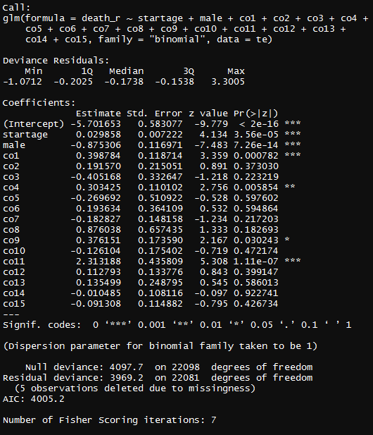

Comment: We need to take out the comorbidities with anomalous (negative) coefficients. Thus, we excluded comorbidities 3,5,7,10,14, and 15 and run the regression again.

*Regression model 2:* excluding comorbidities 3,5,7,10,14, and 15

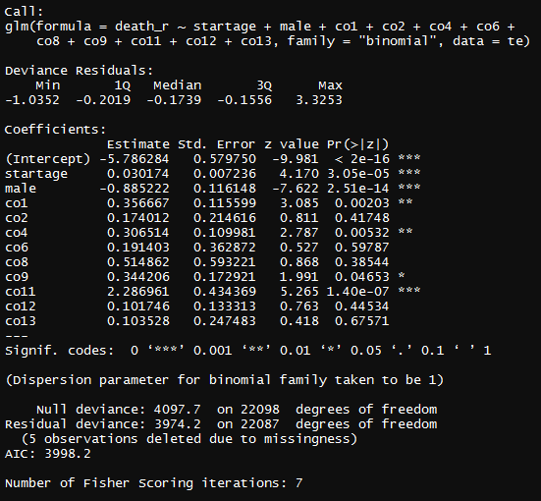

Comment: the results look sensible. List of included comorbidities: 1,2,4,6,8,9,11,12,13. We could use this list of comorbidities for case-mix adjustment for EVAR elective cases in volume-outcome analysis.

### Emergency EVAR repair

*Regression Model 1:* including all comorbidities

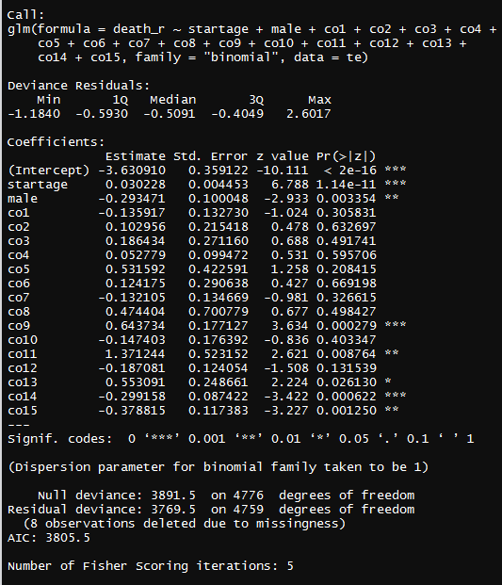

*Regression model 2:* Excluding comorbidities: 1,7,10,12,14,15

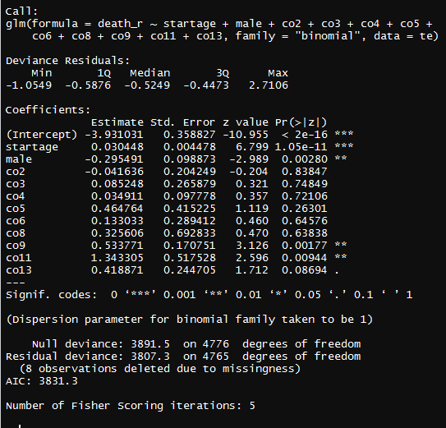

List of included comorbidities: 2,3,4,5,6,8,9,11,13

### Elective OPEN repair

*Regression Model 1:* including all comorbidities

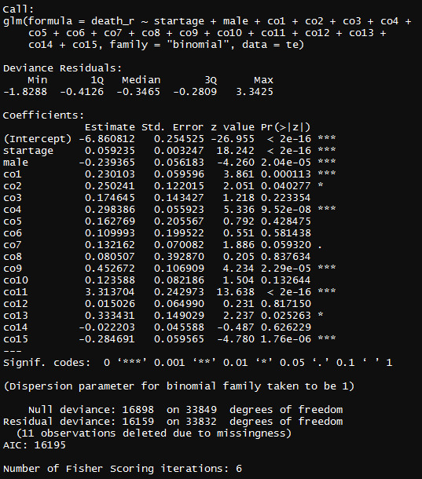

*Regression model 2:* Excluding comorbidities: co14, co15

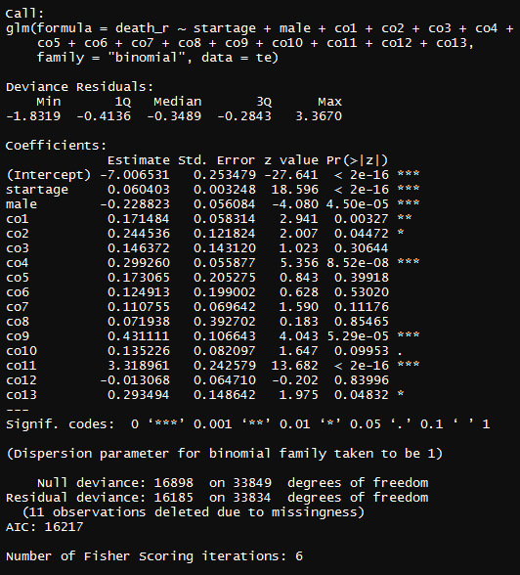

*Regression model 3:* Excluding co12

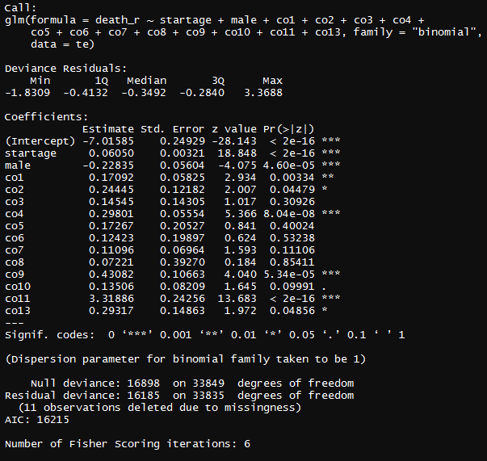

List of included comorbidities: 1,2,3,4,5,6,7,8,9,10,11,13

### Emergency OPEN repair

*Regression Model 1:* including all comorbidities

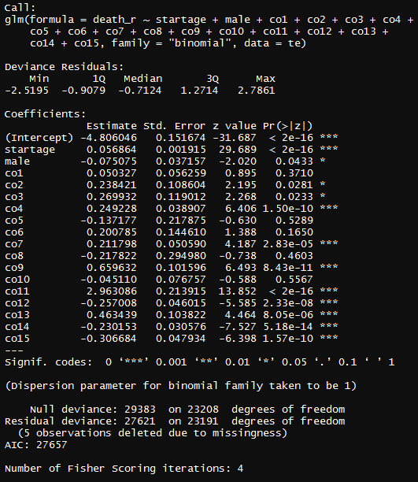

*Regression model 2:* Excluding 5,8,10,12,14,15

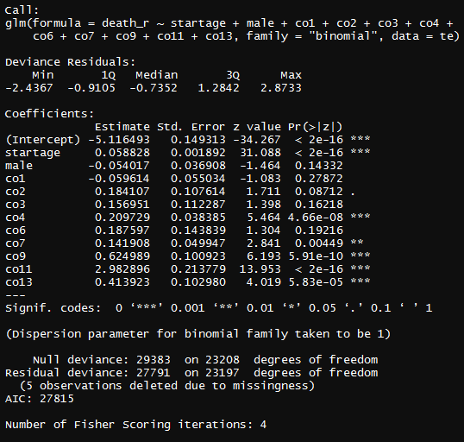

List of included comorbidities: 1,2,3,4,6,7,9,11,13

## FINAL LIST OF COMORBIDITY CATEGORIES FOR CASE-MIX ADJUSTMENT

After examining the Charlson list of 17 potential comorbidities, we selected a modified/improved list of comorbidities based on ICD10 which could be used for case-mix adjustment in volume-outcome analysis. Our proposed list includes 15 comorbidity groups: (1) Coronary Artery Disease, (2) Heart Failure, (3) Cerebrovascular Disease, (4) Chronic Pulmonary Disease, (5) Peptic Ulcer Disease, (6) Mild Liver Disease, (7) Diabetes, (8) Paraplegia and Hemiplegia, (9) Renal Disease, (10) Cancer, (11) Moderate or Severe Liver Disease, (12) Smoking, (13) Obesity, (14) Primary hypertension, and (15) Dyslipidemia.