## SUPPLEMENTARY MATERIAL 1: SYSTEMATIC REVIEWS

### Progression Of Erosive Damage

#### Literature Search

Publications were identified by searches of PubMed, Cochrane Library and Scopus. Additional lateral search techniques included checking reference lists, performing key word searches in Google Scholar and using the cited by option in PubMed. Databases were searched from 1 January 1975 to 31 February 2014. The search strategy used key words and MeSH terms on the title/abstract and full text as appropriate.

#### Inclusion/Exclusion Criteria

The inclusion criteria comprised: investigated the progression or predictive/prognostic markers of radiographic joint damage; patients had a diagnosis of RA, using validated classification criteria like the EULAR and/or the ACR criteria; baseline assessments occurred no later than 3 years from symptom onset; prospective cohort study design; radiographic follow-up data available for at least 5 years for progression rates, and 3 years for predictive markers; used Larsen or Sharp–van der Heijde (SvdH) method to score radiographic damage; and only publications in English.

#### Screening

One reviewer screened titles/abstracts identified in searches. A second reviewer independently screened the full text of 10% of all publications identified against agreed inclusion criteria.

#### Data Extraction

Two reviewers extracted data including cohort name, country of study population, scoring method used, number of patients included, years of recruitment, length of follow-up, sex, mean age, baseline DAS and HAQ scores, proportion of patients on DMARDs, proportion RF positive, number, mean/median and standard deviation/interquartile range of radiographic scores at each follow-up visit, analysis method used, significant and not-significant predictors identified and the effect estimate and 95% CIs. Where the raw data were not given in the published paper, the author was contacted to provide these (n = 21).

#### Studies Identified

The PRISMA flow diagram is shown in **Supplement 1 Figure 1**. Ten of the 28 studies identified provided data suitable for meta-analysis: these are shown in **Supplement 1** Table 1; there were reported in 9 publications.1-9 Patients were recruited from 1965 to 2000 and follow-up ranged from 5 to 20 years. The number of patients included with baseline radiographic data ranged from 73 to 1121. Four studies used Larsen; six used the SvdH scores. Five recruited patients from 1965 to 1989 and five from 1990 to 2000.

#### Quality Assessment

Studies were rated using the Downs and Blacks instrument for non-randomized studies of health care interventions.10 Most studies were of good quality. All studies reported clear aims, objectives and outcome measures and recruited representative patients. Only three studies (6%) reported on missing data and only seven (15%) reported on losses to follow-up.

**Supplement 1 Figure 1. PRISMA Flow Diagram Review Of Erosive Progression**

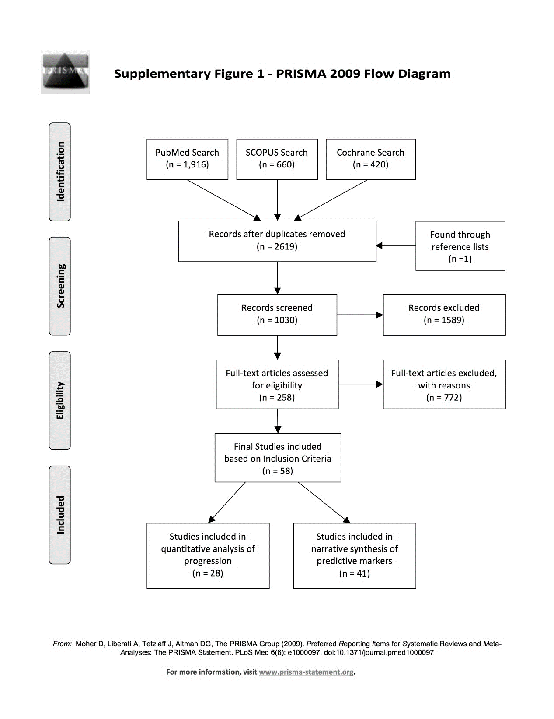

Reproduced from Carpenter *et al*.11 Have radiographic progression rates in early rheumatoid arthritis changed? A systematic review and meta-analysis of long-term cohorts., *Rheumatology*, 2016, **55** (6), pp. 1053–65, Supplementary Data, by permission of the British Society for Rheumatology.

**Supplement 1 Table 1. Studies Included in Systematic Review Of X-Ray Progression**

|  |  |  |  |  |  |  |  |  |  |  |  |
| --- | --- | --- | --- | --- | --- | --- | --- | --- | --- | --- | --- |
| **Lead Author** | **Cohort** | **Country** | **Scoring Method** | **Sample Size** | **Recruitment Year** | **Years Follow-Up** | **Female (%)** | **Mean Age** | **RF+Ve (%)** | **Radiographic Damage** | |
|  |  |  |  |  |  |  |  |  |  | *Mean Baseline (SD)* | *Annual Rate (SE)* |
| ***Post-1990*** | | | | | | | | | | | |
| Bridges1 | CLEAR I | USA | SvdH | 357 | 2000 | 5 | 82% | 50 | 80.1 | 2.9 (7.7) | 1.9 (0.7) |
| Tanaka8 | Japan | Japan | SvdH | 130 | 1995 | 10 | 69% | 54 | 54 | 5 (10.3) | 3 (0.2) |
| Courvoisier2 | French | France | SvdH | 117 | 1993 | 10 | 80% | 50 | 78.6 | 5.8 (9) | 3.1 (0.4) |
| Knevel5 | Leiden | Netherlands | SvdH | 678 | 1993 | 7 | 67% | 57 | 57.9 | 8.7 (10.7) | 4.3 (0.1) |
| Viatte9 | NOAR | UK | Larsen | 1446 | 1990 | 5 | 68% | 56 | 44 | 10.7 (13.9) | 0.8 (0.6) |
| ***Pre-1990*** | | | | | | | | | | | |
| James 3 | ERAS | UK | Larsen | 1465 | 1986 | 9 | 66% | 55 | 62.7 | 4.3 (10.1) | 2.4 (0.7) |
| Kuper 6 | Nijmegen | Netherlands | SvdH | 126 | 1985 | 6 | 64% | 50 | 83 | 1 (16.2) | 8 (0.1) |
| Kapetanovic7 | Lund | Sweden | Larsen | 135 | 1985 | 20 | 63% | 52 | 83 | 8.1 (1.5) | 3.4 (0.3) |
| Kaarela4 | Hienola | Finland | Larsen | 103 | 1973 | 20 | 68% | 45 | 100 | 4.3 (6.8) | 4.1 (0.5) |
| Kneve5 | Groningen | Netherlands | SvdH | 261 | 1965 | 25 | 68% | 45 | 93.2 | 3 (56.5) | 3.7 (0.5) |

RF=Rheumatoid Factor; +Ve = positive; SD= Standard Deviations; SE= Standard Errors

### Clinical Practice Guidelines For RA

#### Literature Search

We searched Medline and Embase databases using the terms ‘clinical practice guidelines’ and ‘rheumatoid arthritis’. The search was limited to articles published in English, from January 2000 to January 2017. We also searched for guidelines published by national and international bodies individually. Additional guidelines were found by carrying out secondary reference searches. Updates of prior guidelines were used when published after January 2017.

#### Eligibility Criteria

We evaluated guidelines that provided recommendations on the general management of RA and included a range of different treatments. They had to identify themselves as a guideline and be published in English. Guidelines and appraisals that dealt with specific areas of management, such as safety monitoring of drugs or appraisals of single drugs or technologies, were excluded. When there were several versions of guidelines from the same organisation, only the latest guideline was included.

#### Screening and Data Extraction

Two researchers independently assessed studies for eligibility and extracted data. The data included: year of publication; format (who was involved); quality method followed; systematic review of evidence, patient groups considered, and area of management included. Data was also extracted about composite activity assessments, treatment targets, and range of treatments considered. When there were differences between assessors, they reviewed the reports together and came to a joint conclusion.

#### Guidelines Identified

We identified 529 potential guidelines articles: 80 were assessed in detail; 22 guidelines12-33 selected because they met our inclusion criteria (**Supplement 1 Figure 2**). These included two European League Against Rheumatism (EULAR) guidelines, which provided general guidance and guidance of treat-to- target, and four different guidelines from the United Kingdom, which were produced by various groups at different times and worked from varying perspectives. The 59 excluded guidelines articles included 5 superseded guidelines and one separately published summary article, 32 guidelines that dealt with single drugs or drug classes, 18 that dealt with non-drug treatments and 3 patient-related articles. The guidelines evaluated are summarised in **Supplement 1** Table 2. Virtually all the guidelines were drawn up by groups of expert rheumatologists. There were variable levels of patient involvement and contributions from other experts, such as nurses, other allied health professionals, experts in systematic reviews and a range of other areas.

#### Quality Assessment

We sought evidence that individual guidelines had followed quality methods in their development. Firstly, we recorded who had been involved in developing the guideline, including the involvement of specialists, other experts and patients. Secondly, we evaluated whether they had used recognised quality methods such as Agree and Agree II34, Adapte35, Grade36, and National Institute for Health and Clinical Excellence(NICE)37 methods. Thirdly we sought evidence whether they had used systematic reviews of published evidence to develop their recommendations. We did not specifically examine the quality of individual guidelines because we anticipated this would be highly variable because some guidelines were developed by large organisations such as the American College of Rheumatology whilst others were developed by smaller groups with far less resources making substantial variations in the quality of the guidelines inevitable.

Analysis of the 22 guidelines (**Supplement 1** Table 2) showed 21 involved specialists, 12 involved other experts, 12 involved patients, 11 had systematic reviews in the guideline and 2 had separate systematic reviews, and 8 used specific quality methods (Grade 2, Agree 1, Agree II 3, Adapte 1, NICE 1).

**Supplement 1 Figure 2. PRISMA Flow Diagram for Systematic Review of Guidelines for RA**

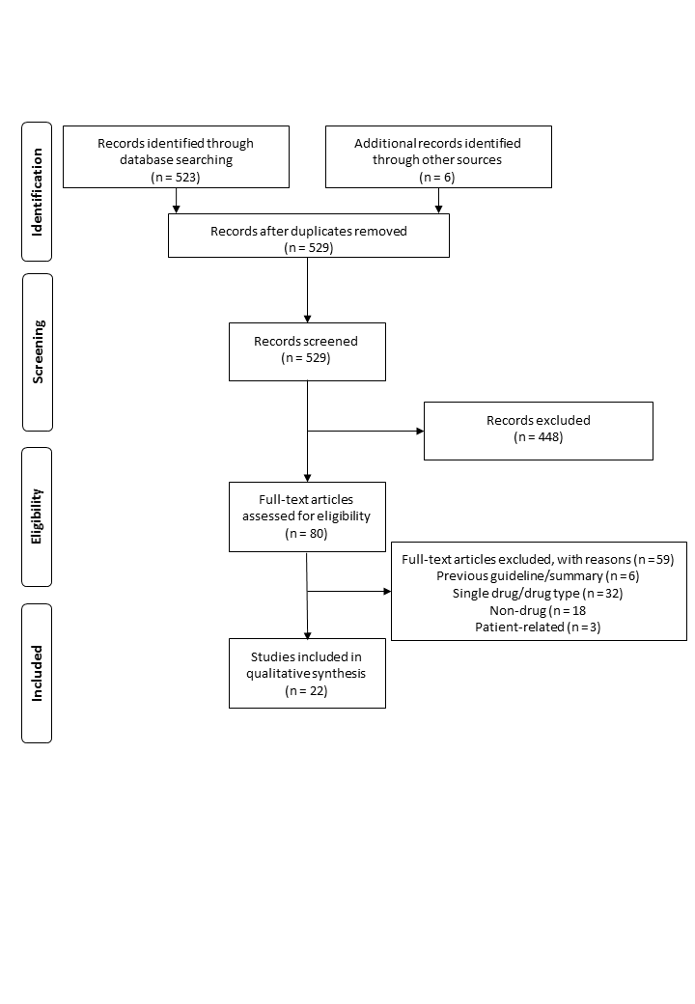

**Supplement 1 Table 2. Features of Clinical Guidelines Included in Review**

| **Guideline** | **Year** | **Format** | | | **Quality Method** | **Systematic Review of Evidence** | | **Patients** | **Areas Covered** | | |
| --- | --- | --- | --- | --- | --- | --- | --- | --- | --- | --- | --- |
|  |  | *Specialists* | *Other Experts* | *Patients* |  | *In Guideline* | *Separate* |  | *Diagnosis* | *Drugs* | *MDT* |
| 1. American30 | 2015 | Yes | Yes | Yes | Grade | Yes | - | All | - | Yes | - |
| 2. APLAR24 | 2015 | Yes | - | Yes | Agree II | Yes* | - | All | - | Yes | - |
| 3. Australian13 | 2009 | Yes | Yes | Yes | Agree | Yes* | - | <2 years | Yes | Yes | Yes |
| 4. Brazilian29 | 2012 | Yes | - | - | - | Yes | - | All | - | Yes | Yes |
| 5. British Columbia16 | 2012 | Not Specified | | | - | - | - | All | Yes | Yes | Some |
| 6. British Society For Rheumatology: Established25 | 2009 | Yes | Yes | Yes | - | - | - | >2 years | - | Yes | Yes |
| 7. British Society For Rheumatology: Early26 | 2010 | Yes | Yes | Yes | - | - | - | <2 years | Yes | Yes | Yes |
| 8. Canadian19 | 2011 | Yes | Yes | Yes | Adapte | Yes* |  | All | - | Yes | - |
| 9. EULAR32 | 2016 | Yes | Yes | Yes | Agree II | - | Yes | All | - | Yes | - |
| 10. French22 | 2014 | Yes | Yes | Yes | - | - | - | All | Yes | Yes | Some |
| 11. German17 | 2013 | Yes | - | Yes | - | Yes |  | All |  | Yes | - |
| 12. Hong Kong28 | 2010 | Yes | Not Specified | | - | - | - | All | Yes | Yes | - |
| 13. Indian27 | 2008 | Yes | Not Specified | | - | - | - | All | Yes | Yes | Yes |
| 14. Latin American 20 | 2006 | Yes | Not Specified | | - | - | - | All | Yes | Yes | Yes |
| 15. Mexican21 | 2014 | Yes | Not Specified | | Agree II | Yes* | - | All |  | Yes |  |
| 16. England12 | 2009 | Yes | Yes | Yes | NICE | Yes | - | All | Yes | Yes | Yes |
| 17. Scotland15 | 2011 | Yes | Yes | - | Grade | Yes** |  | <5 years | Yes | Yes | Yes |
| 18. South African23 | 2013 | Yes | Yes | Yes | - | - | - | All | Yes | Yes | Yes |
| 19. Spanish14 | 2007 | Yes | Yes | - | - | Yes |  | All | Yes | Yes | Yes |
| 20. Swedish33 | 2011 | Yes | Not Specified | | - | - | - | All | - | Yes | - |
| 21. Treat-to-target31 | 2010 | Yes | - | Yes | - |  | Yes | All | - | Yes | - |
| 22. Turkish18 | 2011 | Yes | Yes | - | - | Yes |  | All | - | Yes | Yes |

* Systematically reviewed other guidelines; ** used existing published systematic reviews

### Trial Evidence Supporting Intensive Treatment and Remissions

#### Literature Search

A systematic literature search was carried out using EMBASE, OVID Medline as well as hand searching the systematic reviews relevant to this topic found in the Cochrane library database. The key word search terms used were ‘arthritis, rheumatoid’ (MeSH), ‘clinical trial’ [Publication Type] (MeSH), randomised controlled trial [Publication Type] (MeSH), open label (free text) and ‘remission’ (free text). These were searched separately and in combination. The EMBASE search terms included'arthritis, rheumatoid' (MeSH) all subheadings and FOCUS function, clinical trial (MeSH) Explode function.

#### Inclusion and Exclusion Criteria

The inclusion criteria were: randomized controlled trials or open label non-randomised comparative studies with at least one intensive treatment arm and one control arm; adult patients with RA; studies of at least six months duration; studies enrolling at least 50 patients; studies reporting remissions; studies using treatments in their licensed indication for RA. The intensive treatment arms used drugs considered more intensive than DMARD monotherapy. These included combination DMARDs (which could involve using short-term regular doses of steroids to control synovitis), TNF inhibitors, non-TNF biologics (tocilizumab, abatacept and rituximab), and Janus Kinase (JAK) inhibitors. We also noted whether studies used a treat-to-target approach with intensive treatments. Studies either compared one intensive treatment strategy against standard care or two different intensive treatment strategies (such as combination DMARDs and TNF inhibitors with DMARDs). Foreign language papers and published conference abstracts were excluded. Trials comparing similar types of treatment, such as two intensive DMARD regimens, were also excluded. The search identified publications from 1st January 2000 to 30th April 2017.

#### Screening and Data Extraction

Two researchers independently assessed studies for eligibility and extracted data. This included year of publication, disease duration, number of treatment groups, study design, control and intensive treatment regimens, study size, remissions and study end-points. The numbers of patients achieving disease remission at the trial end-point was defined by Disease Activity Scores (DAS) <1.6, DAS28 < 2.6 or equivalent criteria. The trials were classified as early (generally with disease durations <1 year) or established (generally with disease durations >1 year) reflecting the trial investigators assessments. When there were differences between assessors, they reviewed the reports together and came to a joint conclusion.

#### Trials Identified

We identified 488 papers and included 5338-87 (**Supplement 1** Figure 2). They comprised 48 superiority trials (**Supplement 1** Table 3) and six head-to-head trials (**Supplement 1** Table 4). The BeST trial88 was in both groups. Some of the randomised controlled trials had more than two treatment arms: when there were two control groups the results were combined; when there were two or more intensive treatment groups only those reporting licensed dosage, regimens were included.

Twenty-two superiority trials evaluated early RA patients including four trials of patients with very early disease, less than 6 months from diagnosis. One trial had two different intensive treatment arms (combination DMARDs and biologics) which were both included. Six trials had two or three intensive treatment arms: in three trials biologic monotherapy treatment arms were omitted; in another three trials only, licensed combination regimens were included.

Twenty-six superiority trials evaluated patients with established RA. Six of these trials specified maximum disease durations (from 5 to 20 years). Mean or median disease durations, reported in all of these trials, ranged from 1 to 12 years (mean 8 years). One trial had two control groups (methotrexate or sulfasalazine monotherapy) and these were combined. Sixteen trials had two or more intensive treatment arms: three had two different licensed intensive treatments (biologics and JAK inhibitors) which were both included; in one trial the biologic monotherapy treatment arm was omitted; in a further 12 trials only licensed combination regimens were included.

#### Quality Assessment

A quality assessment was completed for each paper using the Cochrane Collaboration tool for assessing risk of bias.89 The types of bias assessed were: random sequence generation, selection bias, performance bias, detection bias, attrition bias, reporting bias and other bias (such as pharmaceutical funding). The risk was defined as low or high. We also used funnel plots to assess publication bias and associated issues.90 Overall quality was high with low risks of bias (**Supplement 1** Tables 3 and 4).

**Supplement 1 Figure 3. PRISMA Flow Diagram Systematic Review of Trials Of Intensive Treatment And Remissions**

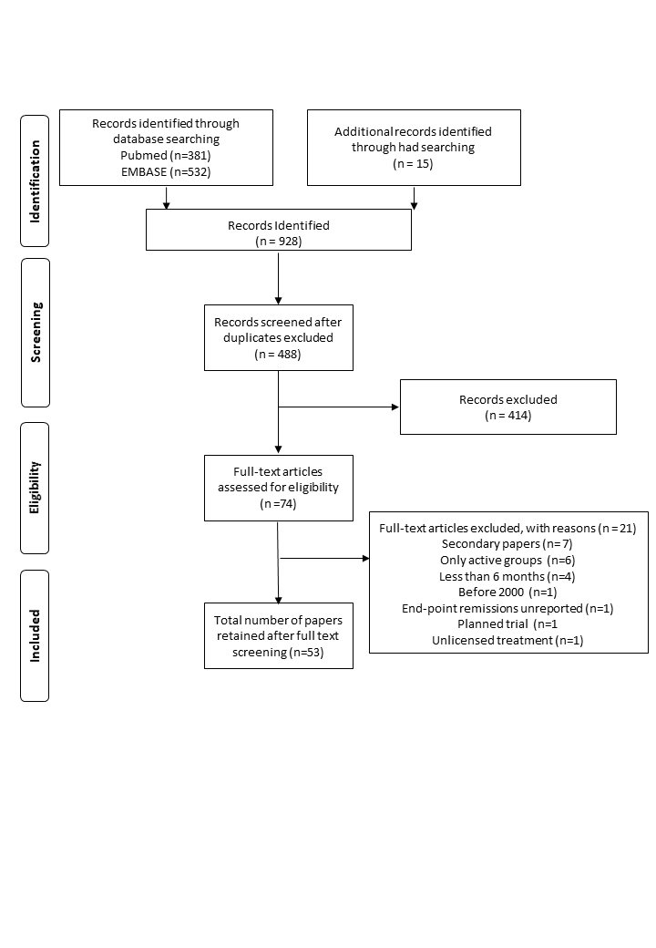

**Supplement 1 Table 3.** **Systematic Review of Trials Of Intensive Treatment and Remissions - Studies with Control Groups**

| **First Author** | **Study** | **Year** | **Design** | **Groups** | **Duration** | **Quality Assessments** | | | **Follow-up** | **Treatments** | |
| --- | --- | --- | --- | --- | --- | --- | --- | --- | --- | --- | --- |
|  |  |  |  |  |  | *Allocation* | *Blinding* | *Bias Analysis* |  | *Control* | *Intensive* |
| Atsumi 38 | C-Opera | 2016 | RCT | 2 | Early | Low risk | Low risk | Low risk | 12 mths | MTX | Certolizumab/MTX |
| Bakker 39 | Camera II | 2012 | RCT | 2 | Early | Low risk | Low risk | Low risk | 24 mths | MTX | Prednisolone/MTX |
| Bijlsma 40 | U-Act-Early | 2016 | RCT | 3 | Early | Low risk | Low risk | Low risk | 24 mths | MTX | Tocilizumab/MTX |
| Breedveld41 | Premier | 2005 | RCT | 3 | Early | Low risk | Low risk | Low risk | 24 mths | MTX | Adalimumab/MTX |
| Burmester42 | Function | 2015 | RCT | 4 | Early | Unclear | Unclear | Low risk | 12 mths | MTX | Tocilizumab/MTX |
| Capell43 | Mascot | 2007 | RCT | 3 | Est’lishd | Low risk | Low risk | Low risk | 12 mths | MTX or SZP | MTZ/SZP |
| Cohen44 | Reflex | 2006 | RCT | 2 | Est’lishd | Low risk | Low risk | Low risk | 6 mths | MTX | Rituximab/MTX |
| Detert 45 | Hit Hard | 2012 | RCT | 2 | Early | Low risk | Low risk | Low risk | 6 mths | MTX | Adalimumab/MTX |
| Dougadas46 | Act-Ray | 2013 | RCT | 2 | Est’lishd | Low risk | Low risk | Low risk | 6 mths | Tocilizumab | Tocilizumab/MTX |
| Emery47 | Avert | 2015 | RCT | 3 | Early | Low risk | Low risk | Low risk | 12 mths | MTX | Abatacept/MTX |
| Emery48 | Comet | 2008 | RCT | 2 | Early | Low risk | Low risk | Low risk | 12 mths | MTX | Etanercept/MTX |
| Emery49 | Go Before | 2009 | RCT | 4 | Est’lishd | Low risk | Low risk | Low risk | 6 mths | MTX | Golimumab/MTX |
| Emery50 | Radiate | 2008 | RCT | 3 | Est’lishd | Low risk | Low risk | Low risk | 6 mths | MTX | Tocilizumab/MTX |
| Emery51 | Serene | 2010 | RCT | 3 | Est’lishd | Low risk | Low risk | Low risk | 12 mths | MTX | Rituximab/MTX |
| Emery52 | C-Early | 2017 | RCT | 2 | Early | Low risk | Low risk | Low risk | 12 mths | MTX | Certolizumab/MTX |
| Genovese53 | RA Beacon | 2016 | RCT | 3 | Est’lishd | Low risk | Low risk | Low risk | 6 mths | DMARD | Baracitinib/DMARDs |
| Genovese54 | Toward | 2008 | RCT | 2 | Est’lishd | Low risk | Low risk | Low risk | 6 mths | DMARD | Tocilizumab/DMARD |
| Goekoop Ruitermann88 | BeSt | 2005 | RCT | 4 | Early | Low risk | Low risk | Low risk | 12 mths | DMARDs | Infliximab/DMARDs  or Combination DMARDs |
| Grigor 55 | Ticora | 2004 | RCT | 2 | Est’lishd | Low risk | Low risk | Low risk | 18 mths | Usual Care | Combination DMARDs |
| Hetland 57 | Cimestra | 2006 | RCT | 2 | Earlya | Unclear | Low risk | Low risk | 12 mths | MTX | MTX/Ciclosporin |
| Horslev Petersen58 | Opera | 2014 | RCT | 2 | Earlya | Low risk | Low risk | Low risk | 12 mths | MTX | Adalimumab/MTX |
| Kavanaugh 59 | Optima | 2013 | RCT | 2 | Est’lishd | Low risk | Low risk | Low risk | 6 mths | MTX | Adalimumab/MTX |
| Kivitz 60 | Brevacta | 2014 | RCT | 2 | Est’lishd | Low risk | Low risk | Low risk | 6 mths | DMARD | Tocilizumab/DMARD |
| Klareskog61 | Tempo | 2004 | RCT | 3 | Est’lishd | Low risk | Low risk | Low risk | 6 mths | MTX | Etanercept/MTX |
| Kremer65 | - | 2005 | RCT | 3 | Est’lishd | Low risk | Low risk | Low risk | 12 mths | MTX | Abatacept/MTX |
| Kremer63 | Lithe | 2011 | RCT | 3 | Est’lishd | Low risk | Low risk | Low risk | 24 mths | MTX | Tocilizumab/MTX |
| Kremer64 | - | 2012 | RCT | 7 | Est’lishd | Low risk | unclear | Low risk | 6 mths | MTX | Tofacitinib/MTX |
| Kremer62 | - | 2013 | RCT | 4 | Est’lishd | Low risk | Low risk | Low risk | 6 mths | DMARD | Tofacitinib/DMARD |
| Nam68 | Empire | 2014 | RCT | 2 | Earlya | Low risk | Low risk | Low risk | 12 mths | MTX | Etanercept/MTX |
| Nam68 | Idea | 2014 | RCT | 2 | Early | Low risk | Low risk | Low risk | 18 mths | MTX | MTX/infliximab |
| Schiff70 | Attest | 2007 | RCT | 3 | Est’lishd | Low risk | Low risk | Low risk | 12 mths | MTX | Abatacept/MTX  or Infliximab/MTX |
| Schipper 71 | - | 2012 | Quasi-Exp | 2 | Early | High risk | High risk | Indeterminate | 12 mths | Usual care | Tight controlb |
| Smolen75 | Certain | 2015 | RCT | 2 | Est’lishd | Low risk | Low risk | Low risk | 12 mths | DMARD | Certolizumab/DMARD |
| Smolen76 | Go After | 2009 | RCT | 3 | Est’lishd | Low risk | Low risk | Low risk | 6 mths | DMARD | Golimumab/DMARD |
| Smolen74 | Option | 2008 | RCT | 3 | Est’lishd | Low risk | Low risk | Low risk | 6 mths | MTX | Tocilizumab/MTX |
| Smolen73 | Rapid2 | 2008 | RCT | 4 | Est’lishd | Low risk | Low risk | Low risk | 6 mths | MTX | Certolizumab/MTX |
| Soubrier77 | Guepard | 2009 | RCT | 2 | Earlya | Low risk | High risk | Unclear | 12 mths | MTX | Adalimumab/MTX |
| St. Clair78 | - | 2004 | RCT | 3 | Early | Low risk | Low risk | Low risk | 12 mths | MTX | Infliximab/MTX |
| Symmons79 | Brosg | 2006 | RCT | 2 | Est’lishd | High risk | Low risk | Low risk | 36 mths | Symptomic | Combination DMARDs |
| Tak91 | Image | 2010 | RCT | 3 | Early | Low risk | Low risk | Low risk | 12 mths | MTX | Rituximab/MTX |
| Takeuchi80 | Hopeful-1 | 2014 | RCT | 2 | Early | Low risk | Low risk | Low risk | 6 mths | MTX | Adalimumab/MTX |
| Taylor81 | RA Beam | 2017 | RCT | 3 | Est’lishd | Low risk | Low risk | Low risk | 6 mths | MTX | Baracitinib/MTX  or Adalimumab/MTX |
| van der Heijde82 | Oral Scan | 2013 | RCT | 3 | Est’lishd | Low risk | Low risk | Low risk | 6 mths | MTX | MTX/Tofacitinib |
| Van Ejik83 | Stream | 2012 | RCT | 2 | Early | Uncertain | Low risk | Low risk | 24 mths | Usual care | Intensive treatment |
| van Vollenhoven84 | Oral Standard | 2012 | RCT | 4 | Est’lishd | Low risk | Low risk | Low risk | 6 mths | MTX | Tofacitinib/MTX  or Adalimumab/MTX |
| Verstappen85 | Camera | 2007 | Open label | 2 | Early | High risk | High risk | Indeterminate | 24 mths | Usual care | Combination DMARDs |
| Weinblatt86 | Go Further | 2013 | RCT | 2 | Est’lishd | Low risk | Low risk | Low risk | 6 mths | MTX | Golimumab/MTX |
| Westhovens87 | - | 2009 | RCT | 2 | Early | Low risk | Low risk | Low risk | 12 mths | MTX | Abatacept/MTX |

**Supplement 1 Table 4.** **Systematic Review of Trials Of Intensive Treatment And Remissions - Head-To-Head Studies**

|  |  |  |  |  |  |  |  |  |  |  |  |
| --- | --- | --- | --- | --- | --- | --- | --- | --- | --- | --- | --- |
| **First Author** | **Study** | **Year** | **Design** | **Groups** | **RA Duration** | **Quality Assessments** | | | **Months Follow-up** | **Treatments** | |
|  |  |  |  |  |  | *Allocation* | *Blinding* | *Bias Analysis* |  | *Non-Biologic* | *Biologic* |
| Goekoop Ruitermann88 | BeSt | 2005 | RCT | 4 | Early | Low risk | Low risk | Low risk | 12 | Combination DMARDs | Infliximab/DMARDs |
| Heimans 56 | Improved | 2014 | RCT | 2 | Early | Low risk | High risk | Unclear | 12 | Triple DMARDs | Adalimumab/MTX |
| Leirisalo-Repo 66 | Neo-Fin RA Co | 2013 | RCT | 2 | Early | Low risk | Low risk | Low risk | 24 | Triple DMARDs | Infliximab/Triple DMARDs |
| O’Dell69 | Racat | 2013 | RCT | 2 | Est’lishd | Low risk | Low risk | Low risk | 12 | Triple DMARDs | Etanercept/MTX |
| Scott72 | Tacit | 2015 | RCT | 2 | Est’lishd | Low risk | High risk | Indeterminate | 12 | Combination DMARDs | TNF inhibitors/DMARDs |
| Moreland67 | Tear | 2012 | RCT | 4 | Early | Low risk | Low risk | Low risk | 24 | Triple DMARDs | Etanercept/MTX |

Reproduced with permission from Hughes *et al*.92 This is an Open Access article distributed in accordance with the terms of the Creative Commons Attribution (CC BY 4.0) license, which permits others to distribute, remix, adapt and build upon this work, for commercial use, provided the original work is properly cited. See: https://creativecommons.org/licenses/by/4.0/. The text below includes minor additions and formatting changes to the original text.

### Trial Evidence Supporting Treat-To-Target

#### Literature Search

Searches were conducted in two phases. Phase I scoping searches identified potentially relevant literature. It involved searching MEDLINE, EMBASE, Cochrane Database of Systematic Reviews, Cochrane Central Register of Controlled Trials (CENTRAL), NHS Economic Evaluation Database (NHS EED), Health Technology Assessment Database (HTA), Database of Abstracts of Reviews of Effects (DARE), Web of Science Citation Index Expanded (WoS), Web of Science Citation Index and Conference Proceedings Index (WoS-CPI), EULAR (via Web of Science), ACR (via Web of Science), and ClinicalTrials.gov. Terms for RA were combined with Treat-to-Target terms (obtained and adapted from the review by Schoels et al93, and search filters for RCTs, systematic reviews and economic evaluations were applied. Searches were limited from 2008 to May 2015 for RCTs and systematic reviews, and from 2013 to May 2015 for the cost effectiveness studies. The systematic review was conducted between October 2015 and September 2016.

In phase II a full systematic search of the evidence search was conducted to January 2016, informed and refined by the literature identified from phase I searches. Additional free-text terms for treat-to-target were added to the phase I search strategies to increase the sensitivity of the search. RCT and economic evaluations were searched using sensitive search filters. No date or language limits were applied in the search. Records retrieved from the search were combined with records retrieved from the Phase 1 search, and duplicate titles were removed.

#### Inclusion and Exclusion Criteria

RCTs (including cluster RCTs) examining the effectiveness of a treat-to-target strategy or strategies to guide treatment decisions for individual patients compared with (1) usual care (no use of treat-to-target strategies), (2) a treat-to-target strategy with an alternative treatment protocol, or (3) a treat-to-target strategy using an alternative target, on the proportion of patients achieving remission and LDA, and adverse effects, among adults with clinically diagnosed RA (with or without prior conventional DMARD or biologic treatment), commencing or undergoing treatment anywhere on the treatment pathway were included in the review. Sufficient description of the treat-to-target strategy needed to be reported, and reports published as meeting abstracts had to contain sufficient methodological details to allow critical appraisal of study quality. Included studies were limited to those published in the English language. Animal models, preclinical and biological studies were excluded, as were trials of personalised medicine, clinical trials of any other design (i.e. non-randomised) and trials designed to test an active drug against placebo, where both/all trial arms pursue the same target and treatment protocol.

#### Screening and Data Extraction

One reviewer examined the titles and abstracts of the records retrieved by the searches, and 5% were checked by another reviewer. Full texts of all studies included at abstract were examined by two reviewers, with discrepancies resolved by discussion, and involvement of a third reviewer where necessary.

Three reviewers undertook data extraction, with each paper being extracted by one reviewer, without blinding to authors or journal. Each reviewer extracted all data relevant to the decision problem on a proportion (1/3) of included RCTs, using a standardised data extraction form. Data on the study characteristics, population characteristics, treat-to-target characteristics, including adverse events were extracted. Each extraction was then checked against the article/s by a second reviewer. Discrepancies were discussed, and an agreement was reached. We planned that a third reviewer would be consulted where no consensus could be reached, however this was not necessary in any instance.

#### Studies Identified

Forty-one papers reporting 16 RCTs were included from 16,591 records reviewed.40, 55, 67, 79, 83, 85, 88, 94-127 We excluded 16,412 based on their title and abstract. One hundred and seventy-nine publications were reviewed in detail: we excluded 137 papers describing 53 studies; 103 were not treat-to-target; 14 were not RCTs; five were conference abstracts with insufficient details; another 15 papers were excluded for diverse reasons (**Supplement 1 Figure 4**). The 42 papers described 16 trials, which enrolled 4660 RA patients. The RCTs comprised four categories (**Supplement 1** Table 5), depending on their main features. Six trials (1375 patients) compared treat-to-target with usual care. Seven trials (2418 patients) compared different treatment protocols. Four trials (1408 patients) compared different treatment targets. Two trials (765 patients) had other comparisons of conventional with intensive therapy.

The trials studied different disease stages: eleven trials studied early RA patients; three studied established RA patients, and two studied both early and established RA. Eleven trials included controls receiving less intensive treatment; four of these trials involved groups receiving different intensive treatment strategies. Five trials compared different intensive treatments without controls receiving less intensive therapy, and one trial compared two different targets without controls receiving less intensive therapy. In addition, three trials were cluster randomised and 13 were not.

#### Quality Assessment

One reviewer assessed the methodological quality of each included RCT using the Cochrane Collaboration risk of bias assessment criteria, which addressed the following domains: sequence generation; allocation concealment; blinding of participants and personnel; blinding of outcome assessment; incomplete outcome data; and selective outcome reporting, each judged as being high, low or unclear risk of bias.89 We also included three additional domains for cluster RCTs: recruitment bias (whether participants were recruited prior to clusters being randomised); risk of baseline differences between clusters; and attrition of clusters. We classified RCTs as being at overall ‘low risk’ of bias if they were rated as ‘low’ for each of three key domains - allocation concealment, blinding of outcome assessment and completeness of outcome data. RCTs judged as being at ‘high risk’ of bias for any of these domains were judged at overall ‘high risk’. RCTs not judged as being at ‘high risk’ for any of these domains, or ‘low risk’ for all these domains were judged at overall ‘unclear risk’. A second reviewer checked the first reviewer’s quality assessment against the article/s, discrepancies were discussed, and an agreement was reached.

Based on the judgements for allocation concealment, blinded outcome assessment and attrition domains, seven non-cluster RCTs were judged at overall high risk of bias, five at overall unclear risk of bias and one as being at overall low risk of bias. All three included cluster RCTs were considered at overall high risk of bias.

**Supplement 1 Figure 4. PRISMA Flow Diagram Systematic Review of Trials of Intensive Treatment As Treat To Target**

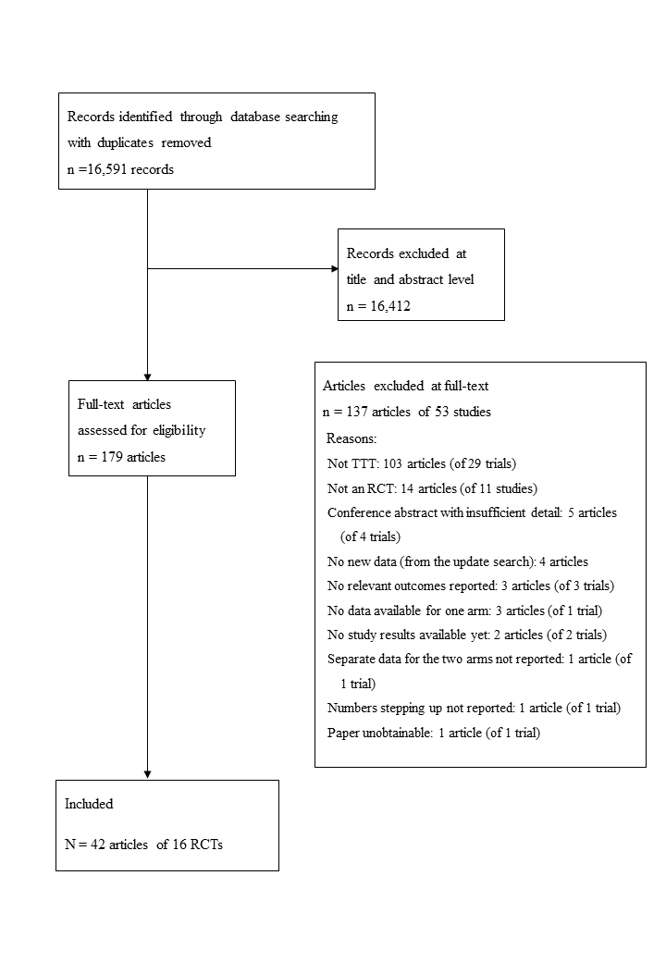

**Supplement 1 Table 5. Systematic Review of Trials Of Intensive Treatment as Treat-To-Target - Included Studies**

| **Trial** | **RA Population** | **Study Type** | **Trial Start** | **RA Diagnosis** | **Cases** | **Treatment Arms** | **Duration (Months)** | **Follow Up (Years)** | **Primary Outcome** | **Location** | **Funding** |
| --- | --- | --- | --- | --- | --- | --- | --- | --- | --- | --- | --- |
| ***Treat-to-target Vs Usual Care*** | | | | | | | | | | | |
| STREAM83 | Early | RCT | 2004 | 2-5 swollen joints | 82 | Conventional  Aggressive | 24 | 2 | Joint damage | Netherlands | Abbott |
| T-4 Study118 | Early | RCT | 2008 | ACR 1987 | 243 | Routine  MMP-3-driven  DAS28 driven  DAS28/MMP-3-driven | 12 | 1 | Remission | Japan | NR |
| Fransen103 | Established | Cluster RCT | 2000 | ACR | 384 | Usual care  DAS28 | 6 | <1 | Low disease activity | Netherlands | Pfizer |
| Optimisation Adalimumab110, 111 | Established | Cluster RCT | 2006 | NR | 308 | Routine  SJC target  DAS28 target | 18 | 1.5 | DAS28 | Canada | Abbott Canada |
| TICORA55 | Both | RCT | 1999 | DAS44 >2.4 | 111 | Routine  Intensive | 18 | 1.5 | DAS | UK (Scotland) | Government |
| Van Hulst 122 | Both | Cluster RCT | 2001 | NR | 248 | Usual care  Intervention | 18 | 1.5 | DAS28 | Netherlands | Academic |
| ***Comparison of Treatment Protocols*** | | | | | | | | | | | |
| BeSt88, 105 | Early | RCT | 2000 | ACR 1987 | 508 | Sequential monotherapy  Step-up combinations  Initial combinations - prednisone  Initial combinations - infliximab | 12 | 10 | HAQ and Joint Damage | Netherlands | Academic |
| CareRA98, 123, 124 | Early | RCT | 2009 | ACR 1987 | High-Risk:289 | 1. COBRA Classic  2. COBRA Slim  3. COBRA Avant-Garde | 4 | <1 | Remission | Flemish countries | Government |
| Low-Risk: 90 | 1. Methotrexate-TSU  2. COBRA Slim |
| COBRA-light 99, 117 | Early | RCT | 2008 | ACR 1987 | 164 | 1. COBRA  2. COBRA-light | 12 | 2 | DAS44 | Netherlands | Academic |
| FIN-RACo 109, 114 | Early | RCT | 1993 | ACR 1987 | 199 | 1. Single drug  2. Combination | 24 | 11 | Remission | Finland | Academic |
| Saunders 115 | Early | RCT | 2003 | NR | 96 | 1. Parallel triple  2. Step-up | 12 | 1 | DAS28 | UK | Government |
| TEAR67 | Early | RCT | 2004 | ACR 1987 | 755 | 1. Step-up triple  2. Step-up Etanercept  3. Immediate triple  4. Immediate Etanercept | 24 | 2 | DAS28 | USA | Government |
| U-Act-Early 40 | Early | RCT | 2010 | ACR 1987 or 2010 | 317 | 1. Methotrexate  2. Tocilizumab  3. Tocilizumab/ Methotrexate | 24 | 2 | Sustained remission | Netherlands | Hoffmann-La Roche |
| ***Comparison of Different Targets*** | | | | | | | | | | | |
| Hodkinson 104 | Early | RCT | 2011 | ACR 2010 | 102 | 1. SDAI  2. CDAI | 12 | 1 | Low disease activity | South Africa | Academic |
| Optimisation Adalimumab110, 111 | Established | Cluster RCT | 2006 | NR | 308 | 1. Routine  2. SJC target  3. DAS28 target | 18 | 1.5 | DAS28 | Canada | Abbott Canada |
| T-4 Study118 | Early | RCT | 2008 | ACR 1987 | 243 | 1. Routine  2. MMP-3-driven  3. DAS28 driven  4. DAS28/MMP-3-driven | 12 | 1 | Remission | Japan | NR |
| TEAR67 | Early | RCT | 2004 | ACR 1987 | 755 | 1. Step-up triple  2. Step-up Etanercept  3. Immediate triple  4. Immediate Etanercept | 24 | 2 | DAS28 | USA | Government |
| ***Other Comparisons*** | | | | | | | | | | | |
| CAMERA85, 127 | Early | RCT | 1999 | ACR 1987 | 299 | 1. Conventional  2. Intensive | 24 | 2 | Sustained remission | Netherlands | NR |
| BROSG 79, 116 | Established | RCT | 1997 | ACR 1987 | 466 | 1. Symptomatic  2. Aggressive | 36 | 3 | HAQ | UK | Government |

### Systematic Review of Reviews for Psychological Support

#### Literature Search

The search strategy followed that of one included in a protocol for a systematic review of self-management education programmes for RA Lefevre-Colau et al.128 This search strategy, originally for Ovid MEDLINE, was modified for this review and adapted for use with the other databases. All keywords in the search are based on Medical Subject Headings. Electronic searches of the following 6 databases were performed in March 2015 by the lead author to identify relevant articles: MEDLINE via Ovid, EMBASE via Ovid, CINAHL via EBSCOhost, PsycINFO via Ovid, CDSR and DARE. The reference lists of selected articles were also hand-searched. A further search of the same databases was conducted by the lead author in January 2018, to cover the three years since the previous search.

#### Inclusion Criteria

The criteria were systematic reviews: of randomized controlled trials, which test the efficacy of ≥1 psychological component listed in (**Supplement 1 Table 6**) as an adjunct to medication, with a population of adult participants ≥18 years, with a diagnosis of rheumatoid arthritis (reviews of patients with other health conditions were included if data for rheumatoid arthritis patients were reported separately), reporting findings for at least one of the following primary outcomes: pain, quality of life, functional disability, psychological status and disease activity (secondary outcomes included self-efficacy, coping and self-management behaviours), published in the English language, between January 2000 and March 2015 (updated to January 2018).

**Supplement 1 Table 6.** **Psychological Components in Protocol And Techniques**

|  |  |
| --- | --- |
| **Category** | **Example of Techniques** |
| Motivational interviewing | Affirmations, reflections |
| Cognitive behavioural therapy | Cognitive restructuring, behavioural activation |
| Supportive counselling | Reflection, supportive listening |
| Psychotherapy | Interpretation, confrontation |
| Self-regulatory techniques | Goal setting, action planning |
| Mindfulness-based cognitive therapy | Focus on changing relationship to thoughts |
| Disclosure therapy | Sharing information, often written down |

#### 

#### Selection of Reviews

One reviewer screened retrieved titles and abstracts to identify potentially relevant reviews. The full texts of these reviews were assessed independently with a second reviewer for eligibility. Discussion was used to resolve differences in selection. This was required for six of the full texts

#### Data Extraction

The following data were extracted by one reviewer author using a predesigned data extraction form: review details (author, year of publication); aim and inclusion/exclusion criteria; interventions (psychological content, comparator group); results (number of studies/participants, findings relating to primary/secondary outcomes of this review) and discussion points (key findings, suggestions for future research).

#### Reviews Identified

We identified 1120 citations; after removing duplicates and excluding articles based on their title and abstract, 38 reviews were reviewed in detail and nine were considered for inclusion, (**Supplement 1 Figure 5**). One review was subsequently excluded due to its low-quality score. The eight selected reviews129-136, including two Cochrane reviews, were published between 2002 and 2016 (**Supplement 1 Table 7**). For five reviews only findings from sub-group analyses were included. For three of these this was because a mixture of interventions were included e.g. psychoeducational and educational. For the fourth and fifth review this was because of a mixed patient group. Considering the complete and sub-group analyses, the number of randomized controlled trials included in the reviews ranged from 3 to 34 and the number of participants ranged from 194 to 2923. The reviews evaluated 66 primary studies published between 1981 and 2014 involved 7279 participants.

#### Quality Assessment

The methodological quality of all reviews was measured using the validated Assessment of Multiple Systematic Reviews (AMSTAR) checklist.137 The methodological quality of a 50% subsample of the reviews was assessed independently by two reviewers. We considered studies with a score between zero and four to be low quality, studies with a score between five and eight to be of moderate quality, and studies with a score between nine and eleven to be of high quality, consistent with previous studies.138, 139 Discussion between data abstracting team was used to resolve small differences in scoring.

Three of the excluded leaving eight included reviews. Three reviews met the predefined score for high quality130, 135, 136 and five for moderate quality studies.129, 131-134 Overall, the methodological quality of included reviews was moderate (mean AMSTAR score = eight).

**Supplement 1 Figure 5. PRISMA Flow Diagram Systematic Review of Reviews Of Psychological Interventions**

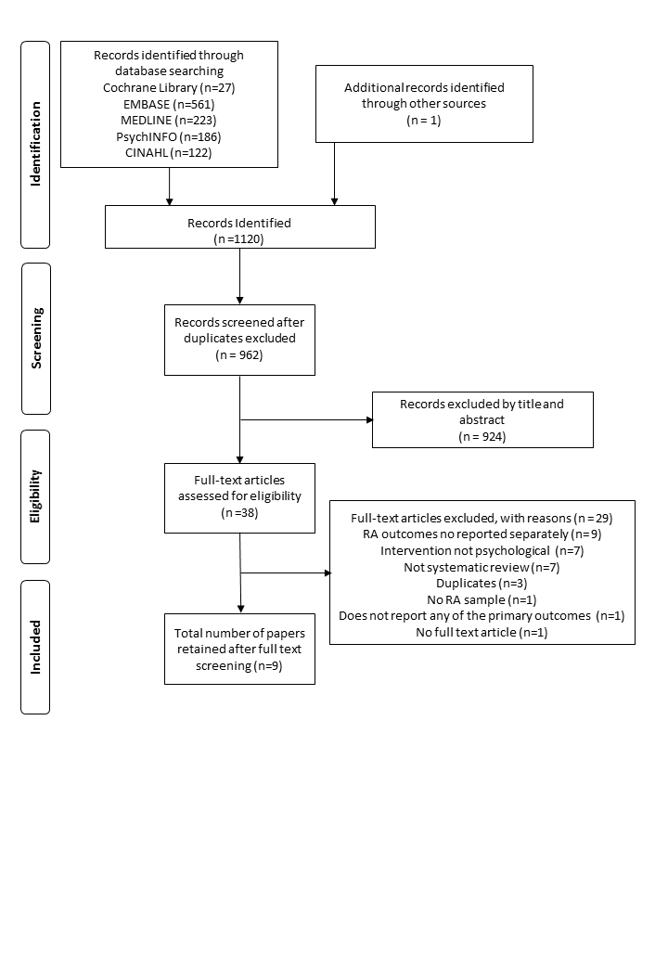

**Supplement 1 Table 7.** **Summary of Selected Systematic Reviews**

| **Author year** | **Aim** | **Number of studies included** | **Total no. of participants** | **Interventions included in each review** | **Outcomes** |
| --- | --- | --- | --- | --- | --- |
| *Astin et al. (2002)* | To carry out a meta-analytic review of studies that compared “psychosocial” (e.g. cognitive behavioural, psychoeducational) interventions to non-intervention controls (e.g. wait list, usual care, or attention placebo) in patients with RAb | 25 RCTsc | 1676 patients | CBTa (13 studies), biofeedback (5 studies), psychotherapeutic interventions (5 studies), disclosure therapy (2 studies) | Pain, functional disability, psychological status, coping, self-efficacy, tender joints |
| *Beltman et al. (2010)* | To conduct a meta-analysis of the effectiveness of CBTa for depression in people with underlying somatic disease | Sub-group of 3 RCTsc included patients with RAb | 194 patients | CBTa (3 studies) | Primary outcome depressive symptoms |
| *Cramp et al. (2013)* | To evaluate the benefit and harm of non-pharmacological interventions for the management of fatigue in people with RAb | Sub-group of 13 RCTsc included psychosocial interventions | 1556 patients | Self-management (3 studies), group education (3 studies), CBTa (3 studies), benefit finding (1 study), expressive writing (1 study), mindfulness (1 study), lifestyle management (1 study), energy conservation (1 study) | Primary outcomes were self-reported fatigue and adverse events. Secondary outcomes were pain, anxiety, depression, disability, tender and swollen joints |
| *Dissanayake and Bertouch (2010)* | To identify individual psychological interventions for which there is high quality evidence | 34 RCTsc | 2021 patients | CBT[a](https://www.sciencedirect.com/science/article/pii/S0020748918300592?via%3Dihub#tblfn0005) (16 studies), disclosure therapy (4 studies), counselling (3 studies), biofeedback (2 studies), relaxation training (2 studies), meditation and mindfulness (2 studies), psychotherapy (2 studies). | Pain, biomedical and clinical markers of disease, disability, mood and cognition, behaviour, patient satisfaction |
| *Knittle et al. (2010)* | To determine the overall efficacy of psychological interventions of increasing physical activity, as well as of reducing pain, disability, depressive symptoms, and anxiety among patients with RAb. Also, to determine whether interventions including more techniques derived from Self-Regulatory Theory produce greater treatment gains than those using fewer such techniques | 27 RCTsc | 1663 patients | Group education (8 studies), CBTa (7 studies), Education (3 studies), pain management (3 studies), stress management (2 studies), combination therapy CBTa and occupational therapy (1 study), relaxation (1 study), mindfulness (1 study), self-instruction (1 study) | Physical activity, pain, disability, depressive symptoms and anxiety |
| *Niedermann et al. (2004)* | To systematically collect RCTsc examining educational and psychoeducational interventions for RA[b](https://www.sciencedirect.com/science/article/pii/S0020748918300592?via%3Dihub#tblfn0010) patients, with focus on their long-term effectiveness | Sub-group of 4 RCTs[c](https://www.sciencedirect.com/science/article/pii/S0020748918300592?via%3Dihub#tblfn0015) included psychoeducational interventions | 369 patients | CBT[a](https://www.sciencedirect.com/science/article/pii/S0020748918300592?via%3Dihub#tblfn0005) (3 studies), stress management (1 study) | Improved knowledge, health behaviour, or skills to influence psychological or physical health status |
| *Nyssen et al. (2016)* | To review the clinical effectiveness and cost-effectiveness of therapeutic writing for people with long-term conditions compared with no writing, or other controls, reporting any relevant clinical outcomes | Sub-group of 4 RCTs[c](https://www.sciencedirect.com/science/article/pii/S0020748918300592?via%3Dihub#tblfn0015) included patients with RA[b](https://www.sciencedirect.com/science/article/pii/S0020748918300592?via%3Dihub#tblfn0010) | 380 patients | Therapeutic writing (4 studies) | Studies reporting any relevant clinical outcomes including both disease-specific outcomes and generic outcomes. |
| *Riemsma et al. (2003)* | To examine the effectiveness of patient education interventions on health status in patients with RA[b](https://www.sciencedirect.com/science/article/pii/S0020748918300592?via%3Dihub#tblfn0010) | Sub-group of 29 RCTs[c](https://www.sciencedirect.com/science/article/pii/S0020748918300592?via%3Dihub#tblfn0015) included psychological interventions | 2923 patients | Counselling (5 studies), Behavioural treatment (24 studies) | Pain, functional disability, psychological well-being, disease activity |

Reproduced with permission from Prothero *et al*.140 This is an Open Access article distributed in accordance with the terms of the Creative Commons Attribution Non-Commercial-No Derivatives (CC BY-NC-ND 4.0) license, which permits others to distribute this work, for non-commercial use, provided the original work is properly cited and no alteration is made to the material. See: https://creativecommons.org/licenses/by-nc-nd/4.0/.’

### Systematic Review of Motivational Interviewing In Rheumatic Diseases

#### Literature Search

We searched seven databases: MEDLINE, PsycARTICLES, PsycINFO, Embase, Web of Science, Ingenta Connect and Cumulative Index to Nursing and Allied Health Literature (CINAHL) from beginning to 4 July 2015. The search terms included MI, chronic disease, long-term conditions, health behaviours, physical activity/exercise, treatment adherence, musculoskeletal conditions, diet and substance abuse. The terms were searched separately and combined with Boolean operators (AND/OR).

#### Inclusion Criteria

The criteria were systematic reviews, randomised controlled trials, interventional studies and pilot studies examining the effects of motivational interviewing interventions on patients with musculoskeletal and rheumatic diseases in English until 4 July 2015.

#### Screening and Data Extraction

One researcher independently assessed studies for eligibility and extracted data. This included year, aims, design, intervention and outcome.

#### Studies Identified

We identified 920 publications; after removing duplicates and excluding articles based on their title and abstract, 15 studies were reviewed in detail and seven were included after full-text retrieval141-147 (**Supplement 1 Figure 6**) for more details. These studies comprised one systematic review, two randomized controlled trials, two interventional studies and two pilot studies. These are summarised in **Supplement 1 Table 8**.

#### Quality Assessment

The systematic review had moderate quality based on the Assessment of Multiple Systematic Reviews (AMSTAR) checklist.137 The two clinical trials had moderate levels of quality using the Cochrane Collaboration tool for assessing risk of bias89; in both the patients knew which treatments they were receiving. The pilot and interventional studies were all likely to involve bias and their quality was therefore uncertain; however, overall, they provided insufficient detail for definitive assessments of their quality.

**Supplement 1 Figure 6. PRISMA Flow Diagram Systematic Review of Motivational Interviewing**

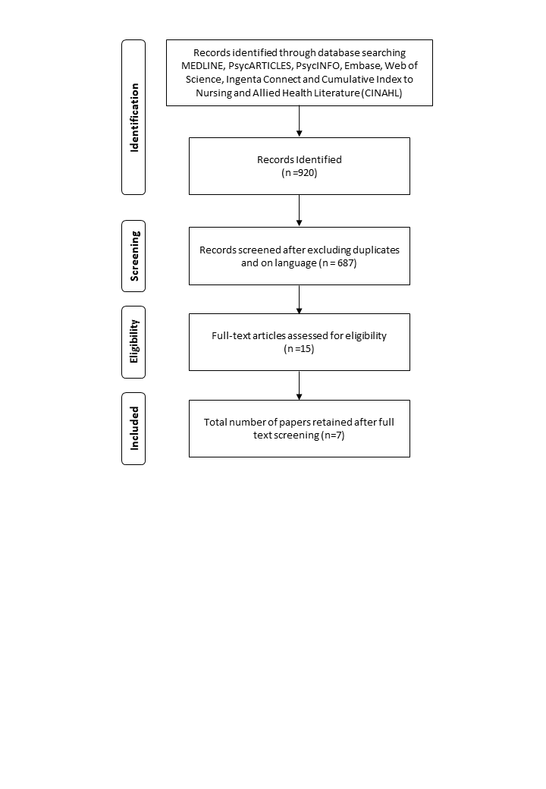

**Supplement 1 Table 8. Summary of Selected Studies For Systematic Review of Motivational Interviewing**

| **Authors** | **Year** | **Aims** | **Design** | **Intervention** | **Outcome** |
| --- | --- | --- | --- | --- | --- |
| Chilton et al 142 | 2012 | To evaluate the effectiveness of MI to create change within musculoskeletal health care and identify the level of training received | Systematic review | Five studies within chronic pain, low back pain, FM and osteoporosis (cluster/non/and randomized trials, and quasi-experimental studies) | Inconclusive due to great variation in delivery modality, musculoskeletal conditions, and type of MI intervention |
| Zwikker et al147 | 2014 | To assess the effect of an intervention based on MI on changes in medication beliefs and adherence in RA | RCT | MI-guided group sessions led by a pharmacist vs brochure about prescribed DMARD (information only) | No superiority of intervention over control arm in changing beliefs about medication and increasing adherence-related outcomes such as walking and cholesterol levels |
| Karlsson et al146 | 2014 | To develop and evaluate a method for smoking cessation support for patients with RA | Pilot study | Rheumatology nurse with MI and smoking cessation training provided individualized smoking cessation support every 4 weeks over 2 years | 43% of patients with RA within the smoking cessation programme stopped smoking |
| Ferguson et al145 | 2013 | To adapt a psychological intervention based on CBT and MI for RA patients and assess its effectiveness in terms of improving adherence and quality of life | Pilot study | Up to six individual sessions of compliance therapy vs usual care | Significant improvement in mean post-intervention scores on both adherence measures, but not in the control group |
| Ang et al 141 | 2013 | To test the efficacy of MI in promoting exercise and improve symptoms in patients with FM | RCT | Six MI sessions vs an equal number of FM self-management lessons (education) | Despite a lack of benefit in the long-term, MI appeared to confer short-term benefits about self-reported physical activity and clinical outcomes |
| Everett et al144 | 2012 | To evaluate the 6-month effect of INC on patients with SLE participating in an ongoing CVD prevention counselling programme | Interventional study | INC incorporated patient-centred methods (tailored nutrition education, goal setting and MI). Changes in select nutrients and diet habits, anthropometric measures and clinical outcomes were evaluated | A 6-month preliminary analysis suggested that INC using patient-centred methods was effective in promoting changes in nutrient intake, diet habits and possibly anthropometric measures (reduced fat and calorie intake and increased fruits, vegetables, and fibre) |
| De Gucht et al 143 | 2012 | To examine the effects of a theory-based psychological intervention to increase physical activity among patients with RA | Interventional study | A 1-hour patient education session, one MI and two SR sessions vs patient education alone | The MI + SR intervention outperformed the control group in terms of sustained increases in physical activity at 32 weeks |

CBT - cognitive behavioural therapy; CVD - cardiovascular disease; DTM - disease therapy management; HAQ - Health Assessment Questionnaire; INC - individualized nutrition counselling; MI - motivational interviewing; SR - self-regulation.

### Systematic Review of Nurse Provided Care In RA

#### Literature Search

A systematic literature search was carried out using Medline as well as hand searching the systematic reviews relevant to this topic. The key word search terms used were ‘arthritis, rheumatoid’ (MeSH) and “nursing”.

#### Inclusion/Exclusion Criteria

The inclusion criteria comprised: patients had a diagnosis of RA, the study investigated the role of specialist nurses in their management, the study design was a clinical trial, a qualitative research study or an observational study, the paper was in English, and the paper was published between January 2000 and August 2018.

#### Screening

One reviewer screened titles/abstracts identified in searches. A second reviewer independently screened the full text of 10% of all publications identified against agreed inclusion criteria.

#### Data Extraction

Two reviewers extracted data including study design, year, setting, patients, the questions addressed and main conclusions of the study.

#### Studies Identified

The PRISMA flow diagram is shown in **Supplement 1** Figure 7. The systematic review identified 657 publications with 52 selected for detailed review. 32 papers were excluded, comprising 11 on unrelated topics, eight editorial and opinion pieces, six secondary reports of included studies, four opinion surveys, and three systematic reviews. Twenty papers were included comprising: nine trials (1974 patients)148-155; seven qualitative studies (242 patients)156-162; and four observational studies (1234 patients)163-166 - two with cohort two with case control designs. Details of these studies are shown in **Supplement 1** Table 9.

#### Quality Assessment

These studies used multiple methods and their quality was assessed comparatively using CASP-UK Checklists for randomised controlled trials, qualitative studies, cohort and case control studies.167 These assessments (**Supplement 1** Tables 10-13) showed the studies had moderate to good quality. There were design challenges in the trials, because full blinding was impossible, they showed no differences between doctor and nurse led care, and assessing harms was difficult.

**Supplement 1 Figure 7. PRISMA Flow Diagram Systematic Review Nurse Provided Care In RA**

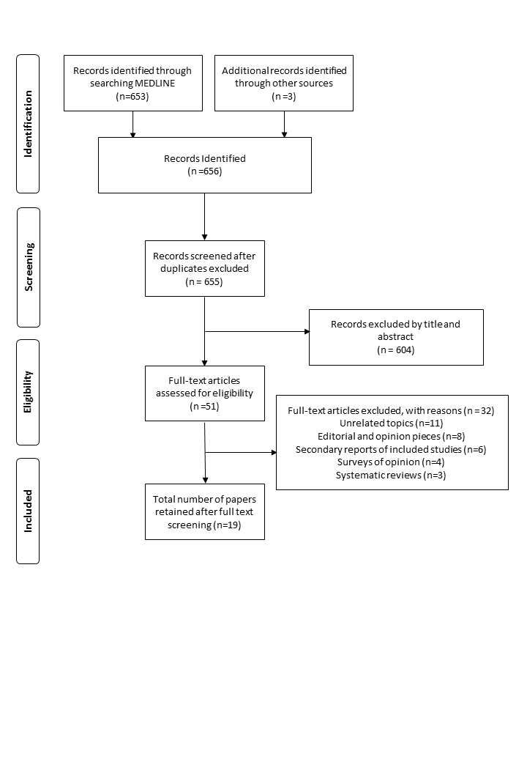

**Supplement 1 Table 9. Summary Of Selected Studies For Systematic Review Of Nurse Provided Care In RA**

| **Publication** | **Year** | **Setting** | **Patients** | **Questions** |
| --- | --- | --- | --- | --- |
| ***Trials*** | | | | |
| Tijhuis et al155 | 2002 | 12-month trial in 6 Dutch clinics | 210 | Differenced from nurse specialists, inpatient team and day patient teams |
| Hill et al149 | 2003 | 12-month trial in one English clinic | 80 | Difference between nurse and doctor care on outcomes and satisfaction |
| Ryan et al154 | 2006 | 12-month trial in one English clinic | 71 | Impact of rheumatology nurses in drug monitoring clinic |
| Koksvik et al150 | 2013 | 21-month trial in Norwegian clinic | 68 | Rheumatology nurses’ impact on patient satisfaction after starting drugs |
| Larsson et al151 | 2014 | 12-month trial in Swedish clinic | 107 | Differences in nurse and rheumatologist-led outcomes |
| Primdahl et al153 | 2014 | 24-month trial in two Danish clinics | 287 | Difference in rheumatologist, shared care and nurse consultations |
| Ndosi et al152 | 2014 | 12-month trial in 10 English clinics | 181 | Difference in rheumatologist, shared care and nurse consultation outcomes |
| Dougados et al148 | 2015 | 6-month trial in 19 French clinics | 970 | Impact of a nurse-led programme on comorbidities |
| ***Qualitative*** | | | | |
| Temmink et al161 | 2000 | Semi-structured telephone interviews across 6 rheumatology clinics in the Netherlands | 128 | Patients’ perceptions on quality of care in nurse clinics |
| Long et al159 | 2002 | Comparative study of three long-term conditions including RA in English region | 16 | How nurses assess patients’ needs |
| Arvidsson et al156 | 2006 | Specialist centre in Sweden | 16 | Nurse-led rheumatology clinic impact |
| Primdahl et al160 | 2011 | Comparing medical, nursing and shared-care outpatients in two Danish hospitals | 33 | Impact of different outpatient settings |
| Bala et al157 | 2012 | Three Swedish nurse-led rheumatology outpatient clinics | 18 | Care in nurse led rheumatology clinics |
| Larsson et al158 | 2012 | Swedish nurse-led rheumatology clinic for patients receiving biological therapy | 13 | Patients’ experiences of nurse-led clinic |
| van Eijk-Hustings et al162 | 2013 | Three outpatient rheumatology clinics in different areas of The Netherlands. | 18 | Expectations of rheumatology nursing care |
| ***Observational*** | | | | |
| Esselens et al163 | 2009 | Cross-sectional comparison of programmed multidisciplinary care with standard care in early RA in on Belgian centre | 191 | Benefit of programmed care involving specialist nurses |
| Watts et al166 | 2015 | Prospective study in 7 primary care practices one English rheumatology clinic | 349 | Determining outcome of nurse-led community care |
| Solomon et al165 | 2015 | Record reviews in 7 US rheumatology practices with/without nurses/physician assistants | 301 | Compared clinical outcomes |
| Muñoz-Fernández et al164 | 2016 | Prospective study in 39 Spanish rheumatology clinics | 393 | Comparing units with and without nurse-led clinics |

**Supplement 1 Table 10. Nurse Provided Care In RA: Quality of Randomised Controlled Trial on CASP-UK Checklist**

|  |  |  |  |  |  |  |  |  |
| --- | --- | --- | --- | --- | --- | --- | --- | --- |
| **Study** | **Tijhuis et al155** | **Hill et al149** | **Ryan et al154** | **Koksvik et al150** | **Larsson**  **et al151** | **Primdahl et al153** | **Ndosi et al152** | **Dougados et al148** |
| Did the trial address a clearly focused issue? | Y | N | Y | Y | Y | Y | Y | Y |
| Was the assignment of patients to treatments randomised? | Y | Y | Y | Y | Y | Y | Y | Y |
| Were all the patients who entered the trial properly accounted for at its conclusion? | Y | Y | Y | Y | Y | Y | Y | Y |
| Were patients, health workers and study personnel ‘blind’ to treatment? | N | N | N | N | N | N | N | N |
| Were the groups similar at the start of the trial | N | Y | N | Y | Y | Y | Y | Y |
| Aside from the experimental intervention, were the groups treated equally? | Y | Y | Y | Y | Y | Y | Y | Y |
| How large was the treatment effect? | N | N | N | N | N | N | N | N |
| How precise was the estimate of the treatment effect? | *N* | *N* | *N* | *Y* | *N* | *Y* | *Y* | *N* |
| Can the results be applied to the local population, or in your context? | *Y* | *Y* | *Y* | *Y* | *Y* | *Y* | *Y* | *Y* |
| Were all clinically important outcomes considered? | *N* | *N* | *N* | *N* | *Y* | *Y* | *Y* | *Y* |
| Are the benefits worth the harms and costs? | *N* | *N* | *N* | *N* | *Y* | *Y* | *Y* | *Y* |
| *Overall Score* | *5/11* | *5/11* | *5/11* | *7/11* | *8/11* | *9/11* | *9/11* | *8/11* |

**Supplement 1 Table 11. Nurse Provided Care In RA: Quality of Qualitative Studies on CASP-UK Checklist**

|  |  |  |  |  |  |  |  |
| --- | --- | --- | --- | --- | --- | --- | --- |
| **Study** | **Temmink et al161** | **Long et al159** | **Arvidsson et al156** | **Primdahl et al160** | **Bala et al157** | **Larsson et al158** | **van Eijk-Hustings et al162** |
| Was there a clear statement of the aims of the research? | *Y* | *Y* | *N* | *N* | *N* | *Y* | *Y* |
| Is a qualitative methodology appropriate? | Y | Y | Y | Y | Y | Y | Y |
| Was the research design appropriate to address the aims of the research? | Y | Y | Y | Y | Y | Y | Y |
| Was the recruitment strategy appropriate to the aims of the research? | Y | N | Y | Y | Y | Y | N |
| Was the data collected in a way that addressed the research issue? | Y | Y | Y | Y | Y | Y | Y |
| Has the relationship between researcher and participants been adequately considered? | Y | Y | Y | Y | Y | Y | Y |
| Have ethical issues been taken into consideration? | Y | Y | Y | Y | Y | Y | Y |
| Was the data analysis sufficiently rigorous? | *N* | *N* | *Y* | *Y* | *Y* | *Y* | *Y* |
| Is there a clear statement of findings? | *N* | *Y* | *N* | *N* | *N* | *N* | *N* |
| How valuable is the research? | *Y* | *N* | *N* | *N* | *Y* | *N* | *N* |
| *Overall Score* | *8/10* | *7/10* | *7/10* | *7/10* | *8/10* | *8/10* | *7/10* |

**Supplement 1 Table 12. Nurse Provided Care In RA: Quality of Cohort Studies On CASP-UK Checklist**

|  |  |  |
| --- | --- | --- |
| **Study** | **Muñoz-Fernández et al164** | **Solomon et al165** |
| Did the study address a clearly focused issue? | Y | Y |
| Was the cohort recruited in an acceptable way? | Y | Y |
| Was the exposure accurately measured to minimise bias? | Y | Y |
| Was the outcome accurately measured to minimise bias? | Y | Y |
| Have the authors identified all important confounding factors? | N | N |
| Have they taken account of the confounding factors in the design and/or analysis? | N | N |
| Was the follow up of subjects complete enough? | Y | N |
| Was the follow up of subjects long enough? | Y | Y |
| What are the results of this study? | Y | Y |
| How precise are the results? | N | N |
| Do you believe the results? | Y | Y |
| Can the results be applied to the local population? | Y | Y |
| Do the results of this study fit with other available evidence? | Y | Y |
| What are the implications of this study for practice? | Y | Y |
| *Overall Score* | *11/14* | *10/14* |

**Supplement 1 Table 13. Nurse Provided Care In RA: Quality of Case Control Studies on CASP-UK Checklist**

|  |  |  |
| --- | --- | --- |
| **Study** | **Esselens et al163** | **Watts et al166** |
| Did the study address a clearly focused issue? | Y | Y |
| Did the authors use an appropriate method to answer their question? | Y | Y |
| Were the cases recruited in an acceptable way? | Y | Y |
| Were the controls selected in an acceptable way? | N | Y |
| Was the exposure accurately measured to minimise bias? | N | N |
| Aside from the experimental intervention, were the groups treated equally? | N | N |
| Have the authors taken account of the potential confounding factors in the design and/or in their analysis? | N | N |
| How large was the treatment effect? | Y | N |
| How precise was the estimate of the treatment effect? | Y | N |
| Do you believe the results? | Y | Y |
| Can the results be applied to the local population? | Y | Y |
| Do the results of this study fit with other available evidence? | Y | Y |
| *Overall Score* | *8/12* | *7/12* |

### Portrayal of RA By UK National Newspapers

#### Patient and Public Involvement Approach

The study was based on a patient and public involvement approach and involved academics and people with RA working together on this project. One impetus for the study was the frustration of service users with RA about society’s lack of awareness of RA and its impact on people with the disease. Another impetus was the mistaken assumption that RA is a natural consequence of ageing

#### Data Collection

The LexisNexis professional electronic newspaper database was searched for articles from national and non-specialist UK newspapers. The tabloid, middle market, and broadsheet newspapers included in this study and their circulation figures are shown in **Supplement 1** Table 14.

**Supplement 1 Table 14. Newspapers Included In The Study**

|  |  |  |
| --- | --- | --- |
| **Tabloid/Mass Market** | **Middle Market** | **Broadsheet/Quality Press** |
| The Sun (1,666,715) #  Daily Mirror (724,888) #  Daily Star (443,452) #  The People (240,846) # | Daily Mail (1,511,357) #  Daily Express (392,526) #  The Mail on Sunday (168,164) # | Daily Telegraph (472,258) #  The Times (451,261) #  The Guardian (156,756) #  The Independent (55,193) *  The I (266,768) #  The Sunday Times (792,324) #  The Sunday Telegraph (359,400) #  The Observer (185,752) # |

#Figures shown by average circulation for January 2017. *No figures are available for the Independent broadsheet newspaper for January 2017, as publication ceased in print form, and it is now only available online. The stated figure is therefore based on average circulation for January 2016 when it was still in print.

Reproduced with permission from Bassett *et al*.168 This is an Open Access article distributed in accordance with the terms of the Creative Commons Attribution (CC BY 4.0) license, which permits others to distribute, remix, adapt and build upon this work, for commercial use, provided the original work is properly cited. See: https://creativecommons.org/licenses/by/4.0/. The text below includes minor additions and formatting changes to the original text.

Tabloids can be defined by their straightforward use of language, the shortness of their articles and the use of many illustrations that appeal to a wide readership. In addition, the colourful imagery that is typical of a tabloid’s front page is anchored by striking headlines. Another feature of these mass market newspapers is the subject matter of entertainment, sports, crime, and celebrity stories that often invoke scandal or have a sexual element. Although these characteristics are also found in the broadsheet newspapers, they assume greater importance and prominence in the tabloids.

By contrast, broadsheets also known as quality newspapers were traditionally defined by their large format and their higher level of language compared to tabloids. Furthermore, they are characterised by an editorial and presentational style where the focus is on the ‘serious news’ of politics, business, economics, and world affairs. The middle market newspapers in contrast, combine the entertainment features of the tabloids with the coverage of ‘serious’ topics associated with the quality press.

#### Data Selection

The inclusion criteria for the analysis were: (i) articles with the phrase ‘rheumatoid arthritis’ in the headline and/or lead paragraph, and (ii) published between 26th July 2011 and 26th July 2016. As one person had primary responsibility for the analysis of the newspaper items, a five-year time span for the identification of articles was agreed among the authors as manageable given the amount of data. A 5-year time period has also been deemed appropriate in other research on newspaper portrayals of long-term illnesses.

The exclusion criteria were: (i) items which referred to RA only once, (ii) duplicate articles, (iii) letters that sought medical advice, and (iv) product advertisements.

#### Data Analysis

All articles were uploaded to NVivo Pro 11 to aid the analytical process. A thematic analysis based on a realist perspective was applied to the dataset of newspaper articles. In this approach, codes and themes were not predetermined deductively by a theoretical framework but were generated inductively from the data. As the results of the literature search/review discovered little information about the language used in the popular press to portray RA, an inductive orientation to the analysis fitted in with the explorative nature of the research.

In reference to a grounded theory approach, the second author systematically interrogated the data set through ‘open coding’ with the ‘constant comparative’ method. In this way, simultaneous comparison of codes and data were identified, followed by the refinement of codes into themes. A random sample of 25% of the coded data was then cross-checked by the third author and a consensus was reached on final codes and themes. This form of triangulation was designed to limit researcher subjectivity during the analytical process. The results of the thematic analysis were member checked by proxy with a group of clinicians (e.g. nurses and doctors) drawn from the authors’ academic rheumatology department. We used this strategy, because departmental expert service users recommended not to approach service users for the validation of findings, but instead involve clinicians in this process. Service users have at times disclosed negative reactions to media coverage of RA to clinical staff during consultations.

#### Articles Identified

The initial search in the LexisNexis database generated 413 articles from 15 national and non-specialist newspapers, of which 147 qualified according to the inclusion criteria. **Supplement 1 Table 15** provides a breakdown of the frequency of articles about RA by newspaper source. The majority (*n* = 106, 72%) appeared in tabloid/middle market newspapers, with just 28% (*n* = 41) featured in broadsheets. 81% (*n* = 86) of tabloid/middle market articles were printed in the Daily Express, Daily Mail, and Daily Mirror. 56% (*n* = 23) of broadsheet items were in the Daily Telegraph alone.

**Supplement 1 Table 15.** **Frequency of Articles About RA By Newspaper Source**

|  |  |
| --- | --- |
| **Newspaper Source** | **Number of Articles About RA** |
| Daily Express | 31 |
| Daily Mail | 28 |
| Daily Mirror | 27 |
| Daily Telegraph | 23 |
| The Sun | 13 |
| The Times | 5 |
| The Guardian | 4 |
| The Sunday Times | 3 |
| Daily Star | 3 |
| Sunday Telegraph | 2 |
| Mail on Sunday | 2 |
| The I | 2 |
| The Independent | 2 |
| The People | 2 |
| The Observer | 0 |
| Total | 147 |

'Reproduced with permission from Bassett *et al*.168 This is an Open Access article distributed in accordance with the terms of the Creative Commons Attribution (CC BY 4.0) license, which permits others to distribute, remix, adapt and build upon this work, for commercial use, provided the original work is properly cited. See: https://creativecommons.org/licenses/by/4.0/. The text below includes minor additions and formatting changes to the original text.

## 

## REFERENCES

1. Bridges SL, Jr., Causey ZL, Burgos PI, Huynh BQ, Hughes LB, Danila MI*, et al.* Radiographic severity of rheumatoid arthritis in African Americans: results from a multicenter observational study. *Arthritis care & research* 2010;**62**:624-31. <https://doi.org/10.1002/acr.20040>

2. Courvoisier N, Dougados M, Cantagrel A, Goupille P, Meyer O, Sibilia J*, et al.* Prognostic factors of 10-year radiographic outcome in early rheumatoid arthritis: a prospective study. *Arthritis research & therapy* 2008;**10**:R106. <https://doi.org/10.1186/ar2498>

3. James D, Young A, Kulinskaya E, Knight E, Thompson W, Ollier W*, et al.* Orthopaedic intervention in early rheumatoid arthritis. Occurrence and predictive factors in an inception cohort of 1064 patients followed for 5 years. *Rheumatology (Oxford, England)* 2004;**43**:369-76. <https://doi.org/10.1093/rheumatology/keh059>

4. Kaarela K, Kautiainen H. Continuous progression of radiological destruction in seropositive rheumatoid arthritis. *The Journal of rheumatology* 1997;**24**:1285-7.

5. Knevel R, Kwok KY, de Rooy DP, Posthumus MD, Huizinga TW, Brouwer E*, et al.* Evaluating joint destruction in rheumatoid arthritis: is it necessary to radiograph both hands and feet? *Annals of the rheumatic diseases* 2013;**72**:345-9. <https://doi.org/10.1136/annrheumdis-2012-201391>

6. Kuper HH, van Leeuwen MA, van Riel PL, Prevoo ML, Houtman PM, Lolkema WF*, et al.* Radiographic damage in large joints in early rheumatoid arthritis: relationship with radiographic damage in hands and feet, disease activity, and physical disability. *British journal of rheumatology* 1997;**36**:855-60.

7. Kapetanovic MC, Lindqvist E, Algulin J, Jonsson K, Saxne T, Eberhardt K*, et al.* Early changes in bone mineral density measured by digital X-ray radiogrammetry predict up to 20 years radiological outcome in rheumatoid arthritis. *Arthritis research & therapy* 2011;**13**:R31. <https://doi.org/10.1186/ar3259>

8. Tanaka N, Sakahashi H, Ishii S, Sato E, Hirose K, Ishima T. Synovial membrane enhancement and bone erosion by magnetic resonance imaging for prediction of radiologic progression in patients with early rheumatoid arthritis. *Rheumatology international* 2005;**25**:103-7. <https://doi.org/10.1007/s00296-003-0404-2>

9. Viatte S, Plant D, Lunt M, Fu B, Flynn E, Parker BJ*, et al.* Investigation of rheumatoid arthritis genetic susceptibility markers in the early rheumatoid arthritis study further replicates the TRAF1 association with radiological damage. *The Journal of rheumatology* 2013;**40**:144-56. <https://doi.org/10.3899/jrheum.121034>

10. Downs SH, Black N. The feasibility of creating a checklist for the assessment of the methodological quality both of randomised and non-randomised studies of health care interventions. *Journal of epidemiology and community health* 1998;**52**:377-84.

11. Carpenter L, Nikiphorou E, Sharpe R, Norton S, Rennie K, Bunn F*, et al.* Have radiographic progression rates in early rheumatoid arthritis changed? A systematic review and meta-analysis of long-term cohorts. *Rheumatology (Oxford, England)* 2016; 10.1093/rheumatology/kew004. <https://doi.org/10.1093/rheumatology/kew004>

12. Rheumatoid Arthritis: National Clinical Guideline for Management and Treatment in Adults. In:London; 2009.

13. *Clinical guideline for the diagnosis and management of early rheumatoid arthritis*. August 2009. URL: <https://www.racgp.org.au/your-practice/guidelines/musculoskeletal/rheumatoidarthritis/> (accessed 25th March 2019).

14. *Update Of The Clinical Practice Guideline For The Management Of Rheumatoid Arthritis In Spain*. December 2011. URL: <https://www.ser.es/wp-content/uploads/2016/01/GUIPCAR_31Marzo2012_ENG.pdf> (accessed).

15. *Management of early rheumatoid arthritis. A national clinical guideline.* . February 2011. URL: <http://www.sign.ac.uk/assets/sign123.pdf> (accessed).

16. *Rheumatoid Arthritis: Diagnosis, Management and Monitoring.*; September 2012. URL: <https://www2.gov.bc.ca/gov/content/health/practitioner-professional-resources/bc-guidelines/rheumatoid-arthritis> (accessed).

17. Albrecht K, Kruger K, Wollenhaupt J, Alten R, Backhaus M, Baerwald C*, et al.* German guidelines for the sequential medical treatment of rheumatoid arthritis with traditional and biologic disease-modifying antirheumatic drugs. *Rheumatology international* 2014;**34**:1-9. <https://doi.org/10.1007/s00296-013-2848-3>

18. Ataman S, Borman P, Evcik D, Aydog E, Ayhan F, Yildizlar D*, et al.* Management of Rheumatoid Arthritis: Consensus Recommendations From the Turkish League Against Rheumatism. *Turk J Rheumatol* 2011;**26**:273-94. <https://doi.org/10.5606/tjr.2011.046>

19. Bykerk VP, Akhavan P, Hazlewood GS, Schieir O, Dooley A, Haraoui B*, et al.* Canadian Rheumatology Association recommendations for pharmacological management of rheumatoid arthritis with traditional and biologic disease-modifying antirheumatic drugs. *The Journal of rheumatology* 2012;**39**:1559-82. <https://doi.org/10.3899/jrheum.110207>

20. Cardiel MH. First Latin American position paper on the pharmacological treatment of rheumatoid arthritis. *Rheumatology (Oxford, England)* 2006;**45 Suppl 2**:ii7-ii22. <https://doi.org/10.1093/rheumatology/kei500>

21. Cardiel MH, Diaz-Borjon A, Vazquez del Mercado Espinosa M, Gamez-Nava JI, Barile Fabris LA, Pacheco Tena C*, et al.* Update of the Mexican College of Rheumatology guidelines for the pharmacologic treatment of rheumatoid arthritis. *Reumatologia clinica* 2014;**10**:227-40. <https://doi.org/10.1016/j.reuma.2013.10.006>

22. Gaujoux-Viala C, Gossec L, Cantagrel A, Dougados M, Fautrel B, Mariette X*, et al.* Recommendations of the French Society for Rheumatology for managing rheumatoid arthritis. *Joint, bone, spine : revue du rhumatisme* 2014;**81**:287-97. <https://doi.org/10.1016/j.jbspin.2014.05.002>

23. Hodkinson B, Van Duuren E, Pettipher C, Kalla A. South African recommendations for the management of rheumatoid arthritis: an algorithm for the standard of care in 2013. *South African medical journal = Suid-Afrikaanse tydskrif vir geneeskunde* 2013;**103**:576-85. <https://doi.org/10.7196/samj.7047>

24. Lau CS, Chia F, Harrison A, Hsieh TY, Jain R, Jung SM*, et al.* APLAR rheumatoid arthritis treatment recommendations. *International journal of rheumatic diseases* 2015;**18**:685-713. <https://doi.org/10.1111/1756-185x.12754>

25. Luqmani R, Hennell S, Estrach C, Birrell F, Bosworth A, Davenport G*, et al.* British Society for Rheumatology and british health professionals in Rheumatology guideline for the management of rheumatoid arthritis (the first two years). *Rheumatology (Oxford, England)* 2006;**45**:1167-9. <https://doi.org/10.1093/rheumatology/kel215a>

26. Luqmani R, Hennell S, Estrach C, Basher D, Birrell F, Bosworth A*, et al.* British Society for Rheumatology and British Health Professionals in Rheumatology guideline for the management of rheumatoid arthritis (after the first 2 years). *Rheumatology (Oxford, England)* 2009;**48**:436-9. <https://doi.org/10.1093/rheumatology/ken450a>

27. Misra R, Sharma B, Gupta R, Pandya S, Agarwal S, Agarwal P*, et al.* Indian Rheumatology Association consensus statement on the management of adults with rheumatoid arthritis. *Indian Journal of Rheumatology* 2008;**3**:S1-S16.

28. Mok CC, Tam LS, Chan TH, Lee GK, Li EK. Management of rheumatoid arthritis: consensus recommendations from the Hong Kong Society of Rheumatology. *Clinical rheumatology* 2011;**30**:303-12. <https://doi.org/10.1007/s10067-010-1596-y>

29. Mota LM, Cruz BA, Brenol CV, Pereira IA, Rezende-Fronza LS, Bertolo MB*, et al.* Guidelines for the drug treatment of rheumatoid arthritis. *Revista brasileira de reumatologia* 2013;**53**:158-83.

30. Singh JA, Saag KG, Bridges SL, Jr., Akl EA, Bannuru RR, Sullivan MC*, et al.* 2015 American College of Rheumatology Guideline for the Treatment of Rheumatoid Arthritis. *Arthritis & rheumatology (Hoboken, NJ)* 2016;**68**:1-26. <https://doi.org/10.1002/art.39480>

31. Smolen JS, Breedveld FC, Burmester GR, Bykerk V, Dougados M, Emery P*, et al.* Treating rheumatoid arthritis to target: 2014 update of the recommendations of an international task force. *Annals of the rheumatic diseases* 2016;**75**:3-15. <https://doi.org/10.1136/annrheumdis-2015-207524>

32. Smolen JS, Landewe R, Bijlsma J, Burmester G, Chatzidionysiou K, Dougados M*, et al.* EULAR recommendations for the management of rheumatoid arthritis with synthetic and biological disease-modifying antirheumatic drugs: 2016 update. *Annals of the rheumatic diseases* 2017;**76**:960-77. <https://doi.org/10.1136/annrheumdis-2016-210715>

33. *Guidelines for the Pharmaceutical Management of Rheumatoid Arthritis. Swedish Society of Rheumatology*. April 14, 2011 URL: <http://svenskreumatologi.se/wp-content/uploads/2016/08/guidelines_for_the_pharmaceutical_management_of_rheumatoid_arthritis.pdf> (accessed).

34. *Agree (Advancing The Science Of Practice Guidelines)*. URL: <https://www.agreetrust.org> (accessed 25th March 2018).

35. *ADAPTE (Collaboration from Guidelines International)*. URL: <http://www.g-i-n.net/> (accessed 25th March 2018).

36. *Grade (Grading of Recommendations Assessment, Development and Evaluation)*. URL: <http://www.gradeworkinggroup.org> (accessed 25th March 2018).

37. *NICE (National Institute For Health And Clinical Excellence)*. URL: <https://www.nice.org.uk/> (accessed 25th March 2018).

38. Atsumi T, Yamamoto K, Takeuchi T, Yamanaka H, Ishiguro N, Tanaka Y*, et al.* The first double-blind, randomised, parallel-group certolizumab pegol study in methotrexate-naive early rheumatoid arthritis patients with poor prognostic factors, C-OPERA, shows inhibition of radiographic progression. *Annals of the rheumatic diseases* 2016;**75**:75-83. <https://doi.org/10.1136/annrheumdis-2015-207511>

39. Bakker MF, Jacobs JW, Welsing PM, Verstappen SM, Tekstra J, Ton E*, et al.* Low-dose prednisone inclusion in a methotrexate-based, tight control strategy for early rheumatoid arthritis: a randomized trial. *Annals of internal medicine* 2012;**156**:329-39. <https://doi.org/10.7326/0003-4819-156-5-201203060-00004>

40. Bijlsma JWJ, Welsing PMJ, Woodworth TG, Middelink LM, Petho-Schramm A, Bernasconi C*, et al.* Early rheumatoid arthritis treated with tocilizumab, methotrexate, or their combination (U-Act-Early): a multicentre, randomised, double-blind, double-dummy, strategy trial. *Lancet (London, England)* 2016;**388**:343-55. <https://doi.org/10.1016/s0140-6736(16)30363-4>

41. Breedveld FC, Weisman MH, Kavanaugh AF, Cohen SB, Pavelka K, van Vollenhoven R*, et al.* The PREMIER study - A multicenter, randomized, double-blind clinical trial of combination therapy with adalimumab plus methotrexate versus methotrexate alone or adalimumab alone in patients with early, aggressive rheumatoid arthritis who had not had previous methotrexate treatment. *Arthritis and rheumatism* 2006;**54**:26-37. <https://doi.org/10.1002/art.21519>

42. Burmester GR, Rigby WF, van Vollenhoven RF, Kay J, Rubbert-Roth A, Kelman A*, et al.* Tocilizumab in early progressive rheumatoid arthritis: FUNCTION, a randomised controlled trial. *Annals of the rheumatic diseases* 2016;**75**:1081-91. <https://doi.org/10.1136/annrheumdis-2015-207628>

43. Capell HA, Madhok R, Porter DR, Munro RA, McInnes IB, Hunter JA*, et al.* Combination therapy with sulfasalazine and methotrexate is more effective than either drug alone in patients with rheumatoid arthritis with a suboptimal response to sulfasalazine: results from the double-blind placebo-controlled MASCOT study. *Annals of the rheumatic diseases* 2007;**66**:235-41. <https://doi.org/10.1136/ard.2006.057133>

44. Cohen SB, Emery P, Greenwald MW, Dougados M, Furie RA, Genovese MC*, et al.* Rituximab for rheumatoid arthritis refractory to anti-tumor necrosis factor therapy: Results of a multicenter, randomized, double-blind, placebo-controlled, phase III trial evaluating primary efficacy and safety at twenty-four weeks. *Arthritis and rheumatism* 2006;**54**:2793-806. <https://doi.org/10.1002/art.22025>

45. Detert J, Bastian H, Listing J, Weiss A, Wassenberg S, Liebhaber A*, et al.* Induction therapy with adalimumab plus methotrexate for 24 weeks followed by methotrexate monotherapy up to week 48 versus methotrexate therapy alone for DMARD-naive patients with early rheumatoid arthritis: HIT HARD, an investigator-initiated study. *Annals of the rheumatic diseases* 2013;**72**:844-50. <https://doi.org/10.1136/annrheumdis-2012-201612>

46. Dougados M, Kissel K, Sheeran T, Tak PP, Conaghan PG, Mola EM*, et al.* Adding tocilizumab or switching to tocilizumab monotherapy in methotrexate inadequate responders: 24-week symptomatic and structural results of a 2-year randomised controlled strategy trial in rheumatoid arthritis (ACT-RAY). *Annals of the rheumatic diseases* 2013;**72**:43-50. <https://doi.org/10.1136/annrheumdis-2011-201282>

47. Emery P, Burmester GR, Bykerk VP, Combe BG, Furst DE, Barre E*, et al.* Evaluating drug-free remission with abatacept in early rheumatoid arthritis: results from the phase 3b, multicentre, randomised, active-controlled AVERT study of 24 months, with a 12-month, double-blind treatment period. *Annals of the rheumatic diseases* 2015;**74**:19-26. <https://doi.org/10.1136/annrheumdis-2014-206106>

48. Emery P, Breedveld FC, Hall S, Durez P, Chang DJ, Robertson D*, et al.* Comparison of methotrexate monotherapy with a combination of methotrexate and etanercept in active, early, moderate to severe rheumatoid arthritis (COMET): a randomised, double-blind, parallel treatment trial. *Lancet (London, England)* 2008;**372**:375-82. <https://doi.org/10.1016/s0140-6736(08)61000-4>

49. Emery P, Fleischmann RM, Moreland LW, Hsia EC, Strusberg I, Durez P*, et al.* Golimumab, a human anti-tumor necrosis factor alpha monoclonal antibody, injected subcutaneously every four weeks in methotrexate-naive patients with active rheumatoid arthritis: twenty-four-week results of a phase III, multicenter, randomized, double-blind, placebo-controlled study of golimumab before methotrexate as first-line therapy for early-onset rheumatoid arthritis. *Arthritis and rheumatism* 2009;**60**:2272-83. <https://doi.org/10.1002/art.24638>

50. Emery P, Keystone E, Tony HP, Cantagrel A, van Vollenhoven R, Sanchez A*, et al.* IL-6 receptor inhibition with tocilizumab improves treatment outcomes in patients with rheumatoid arthritis refractory to anti-tumour necrosis factor biologicals: results from a 24-week multicentre randomised placebo-controlled trial. *Annals of the rheumatic diseases* 2008;**67**:1516-23. <https://doi.org/10.1136/ard.2008.092932>

51. Emery P, Deodhar A, Rigby WF, Isaacs JD, Combe B, Racewicz AJ*, et al.* Efficacy and safety of different doses and retreatment of rituximab: a randomised, placebo-controlled trial in patients who are biological naive with active rheumatoid arthritis and an inadequate response to methotrexate (Study Evaluating Rituximab's Efficacy in MTX iNadequate rEsponders (SERENE)). *Annals of the rheumatic diseases* 2010;**69**:1629-35. <https://doi.org/10.1136/ard.2009.119933>

52. Emery P, Bingham CO, 3rd, Burmester GR, Bykerk VP, Furst DE, Mariette X*, et al.* Certolizumab pegol in combination with dose-optimised methotrexate in DMARD-naive patients with early, active rheumatoid arthritis with poor prognostic factors: 1-year results from C-EARLY, a randomised, double-blind, placebo-controlled phase III study. *Annals of the rheumatic diseases* 2017;**76**:96-104. <https://doi.org/10.1136/annrheumdis-2015-209057>

53. Genovese MC, Kremer J, Zamani O, Ludivico C, Krogulec M, Xie L*, et al.* Baricitinib in Patients with Refractory Rheumatoid Arthritis. *The New England journal of medicine* 2016;**374**:1243-52. <https://doi.org/10.1056/NEJMoa1507247>

54. Genovese MC, McKay JD, Nasonov EL, Mysler EF, da Silva NA, Alecock E*, et al.* Interleukin-6 receptor inhibition with tocilizumab reduces disease activity in rheumatoid arthritis with inadequate response to disease-modifying antirheumatic drugs: the tocilizumab in combination with traditional disease-modifying antirheumatic drug therapy study. *Arthritis and rheumatism* 2008;**58**:2968-80. <https://doi.org/10.1002/art.23940>

55. Grigor C, Capell H, Stirling A, McMahon AD, Lock P, Vallance R*, et al.* Effect of a treatment strategy of tight control for rheumatoid arthritis (the TICORA study): a single-blind randomised controlled trial. *Lancet (London, England)* 2004;**364**:263-9. <https://doi.org/10.1016/s0140-6736(04)16676-2>

56. Heimans L, Wevers-de Boer KV, Visser K, Goekoop RJ, van Oosterhout M, Harbers JB*, et al.* A two-step treatment strategy trial in patients with early arthritis aimed at achieving remission: the IMPROVED study. *Annals of the rheumatic diseases* 2014;**73**:1356-61. <https://doi.org/10.1136/annrheumdis-2013-203243>

57. Hetland ML, Stengaard-Pedersen K, Junker P, Lottenburger T, Ellingsen T, Andersen LS*, et al.* Combination treatment with methotrexate, cyclosporine, and intraarticular betamethasone compared with methotrexate and intraarticular betamethasone in early active rheumatoid arthritis: an investigator-initiated, multicenter, randomized, double-blind, parallel-group, placebo-controlled study. *Arthritis and rheumatism* 2006;**54**:1401-9. <https://doi.org/10.1002/art.21796>

58. Horslev-Petersen K, Hetland ML, Junker P, Podenphant J, Ellingsen T, Ahlquist P*, et al.* Adalimumab added to a treat-to-target strategy with methotrexate and intra-articular triamcinolone in early rheumatoid arthritis increased remission rates, function and quality of life. The OPERA Study: an investigator-initiated, randomised, double-blind, parallel-group, placebo-controlled trial. *Annals of the rheumatic diseases* 2014;**73**:654-61. <https://doi.org/10.1136/annrheumdis-2012-202735>

59. Kavanaugh A, Fleischmann RM, Emery P, Kupper H, Redden L, Guerette B*, et al.* Clinical, functional and radiographic consequences of achieving stable low disease activity and remission with adalimumab plus methotrexate or methotrexate alone in early rheumatoid arthritis: 26-week results from the randomised, controlled OPTIMA study. *Annals of the rheumatic diseases* 2013;**72**:64-71. <https://doi.org/10.1136/annrheumdis-2011-201247>

60. Kivitz A, Olech E, Borofsky M, Zazueta BM, Navarro-Sarabia F, Radominski SC*, et al.* Subcutaneous tocilizumab versus placebo in combination with disease-modifying antirheumatic drugs in patients with rheumatoid arthritis. *Arthritis care & research* 2014;**66**:1653-61. <https://doi.org/10.1002/acr.22384>

61. Klareskog L, van der Heijde D, de Jager JP, Gough A, Kalden J, Malaise M*, et al.* Therapeutic effect of the combination of etanercept and methotrexate compared with each treatment alone in patients with rheumatoid arthritis: double-blind randomised controlled trial. *Lancet (London, England)* 2004;**363**:675-81. <https://doi.org/10.1016/s0140-6736(04)15640-7>

62. Kremer J, Li ZG, Hall S, Fleischmann R, Genovese M, Martin-Mola E*, et al.* Tofacitinib in combination with nonbiologic disease-modifying antirheumatic drugs in patients with active rheumatoid arthritis: a randomized trial. *Annals of internal medicine* 2013;**159**:253-61. <https://doi.org/10.7326/0003-4819-159-4-201308200-00006>

63. Kremer JM, Blanco R, Brzosko M, Burgos-Vargas R, Halland AM, Vernon E*, et al.* Tocilizumab inhibits structural joint damage in rheumatoid arthritis patients with inadequate responses to methotrexate: results from the double-blind treatment phase of a randomized placebo-controlled trial of tocilizumab safety and prevention of structural joint damage at one year. *Arthritis and rheumatism* 2011;**63**:609-21. <https://doi.org/10.1002/art.30158>

64. Kremer JM, Cohen S, Wilkinson BE, Connell CA, French JL, Gomez-Reino J*, et al.* A phase IIb dose-ranging study of the oral JAK inhibitor tofacitinib (CP-690,550) versus placebo in combination with background methotrexate in patients with active rheumatoid arthritis and an inadequate response to methotrexate alone. *Arthritis and rheumatism* 2012;**64**:970-81. <https://doi.org/10.1002/art.33419>

65. Kremer JM, Dougados M, Emery P, Durez P, Sibilia J, Shergy W*, et al.* Treatment of rheumatoid arthritis with the selective costimulation modulator abatacept: twelve-month results of a phase iib, double-blind, randomized, placebo-controlled trial. *Arthritis and rheumatism* 2005;**52**:2263-71. <https://doi.org/10.1002/art.21201>

66. Leirisalo-Repo M, Kautiainen H, Laasonen L, Korpela M, Kauppi MJ, Kaipiainen-Seppanen O*, et al.* Infliximab for 6 months added on combination therapy in early rheumatoid arthritis: 2-year results from an investigator-initiated, randomised, double-blind, placebo-controlled study (the NEO-RACo Study). *Annals of the rheumatic diseases* 2013;**72**:851-7. <https://doi.org/10.1136/annrheumdis-2012-201365>

67. Moreland LW, O'Dell JR, Paulus HE, Curtis JR, Bathon JM, St Clair EW*, et al.* A randomized comparative effectiveness study of oral triple therapy versus etanercept plus methotrexate in early aggressive rheumatoid arthritis: the treatment of Early Aggressive Rheumatoid Arthritis Trial. *Arthritis and rheumatism* 2012;**64**:2824-35. <https://doi.org/10.1002/art.34498>

68. Nam JL, Villeneuve E, Hensor EM, Wakefield RJ, Conaghan PG, Green MJ*, et al.* A randomised controlled trial of etanercept and methotrexate to induce remission in early inflammatory arthritis: the EMPIRE trial. *Annals of the rheumatic diseases* 2014;**73**:1027-36. <https://doi.org/10.1136/annrheumdis-2013-204882>

69. O'Dell JR, Mikuls TR, Taylor TH, Ahluwalia V, Brophy M, Warren SR*, et al.* Therapies for active rheumatoid arthritis after methotrexate failure. *The New England journal of medicine* 2013;**369**:307-18. <https://doi.org/10.1056/NEJMoa1303006>

70. Schiff M, Keiserman M, Codding C, Songcharoen S, Berman A, Nayiager S*, et al.* Efficacy and safety of abatacept or infliximab vs placebo in ATTEST: a phase III, multi-centre, randomised, double-blind, placebo-controlled study in patients with rheumatoid arthritis and an inadequate response to methotrexate. *Annals of the rheumatic diseases* 2008;**67**:1096-103. <https://doi.org/10.1136/ard.2007.080002>

71. Schipper LG, Vermeer M, Kuper HH, Hoekstra MO, Haagsma CJ, Den Broeder AA*, et al.* A tight control treatment strategy aiming for remission in early rheumatoid arthritis is more effective than usual care treatment in daily clinical practice: a study of two cohorts in the Dutch Rheumatoid Arthritis Monitoring registry. *Annals of the rheumatic diseases* 2012;**71**:845-50. <https://doi.org/10.1136/annrheumdis-2011-200274>

72. Scott DL, Ibrahim F, Farewell V, O'Keeffe AG, Walker D, Kelly C*, et al.* Tumour necrosis factor inhibitors versus combination intensive therapy with conventional disease modifying anti-rheumatic drugs in established rheumatoid arthritis: TACIT non-inferiority randomised controlled trial. *BMJ (Clinical research ed)* 2015;**350**:h1046. <https://doi.org/10.1136/bmj.h1046>

73. Smolen J, Landewe RB, Mease P, Brzezicki J, Mason D, Luijtens K*, et al.* Efficacy and safety of certolizumab pegol plus methotrexate in active rheumatoid arthritis: the RAPID 2 study. A randomised controlled trial. *Annals of the rheumatic diseases* 2009;**68**:797-804. <https://doi.org/10.1136/ard.2008.101659>

74. Smolen JS, Beaulieu A, Rubbert-Roth A, Ramos-Remus C, Rovensky J, Alecock E*, et al.* Effect of interleukin-6 receptor inhibition with tocilizumab in patients with rheumatoid arthritis (OPTION study): a double-blind, placebo-controlled, randomised trial. *Lancet (London, England)* 2008;**371**:987-97. <https://doi.org/10.1016/s0140-6736(08)60453-5>

75. Smolen JS, Emery P, Ferraccioli GF, Samborski W, Berenbaum F, Davies OR*, et al.* Certolizumab pegol in rheumatoid arthritis patients with low to moderate activity: the CERTAIN double-blind, randomised, placebo-controlled trial. *Annals of the rheumatic diseases* 2015;**74**:843-50. <https://doi.org/10.1136/annrheumdis-2013-204632>

76. Smolen JS, Kay J, Doyle MK, Landewe R, Matteson EL, Wollenhaupt J*, et al.* Golimumab in patients with active rheumatoid arthritis after treatment with tumour necrosis factor alpha inhibitors (GO-AFTER study): a multicentre, randomised, double-blind, placebo-controlled, phase III trial. *Lancet (London, England)* 2009;**374**:210-21. <https://doi.org/10.1016/s0140-6736(09)60506-7>

77. Soubrier M, Puechal X, Sibilia J, Mariette X, Meyer O, Combe B*, et al.* Evaluation of two strategies (initial methotrexate monotherapy vs its combination with adalimumab) in management of early active rheumatoid arthritis: data from the GUEPARD trial. *Rheumatology (Oxford, England)* 2009;**48**:1429-34. <https://doi.org/10.1093/rheumatology/kep261>

78. St Clair EW, van der Heijde DM, Smolen JS, Maini RN, Bathon JM, Emery P*, et al.* Combination of infliximab and methotrexate therapy for early rheumatoid arthritis: a randomized, controlled trial. *Arthritis and rheumatism* 2004;**50**:3432-43. <https://doi.org/10.1002/art.20568>

79. Symmons D, Tricker K, Harrison M, Roberts C, Davis M, Dawes P*, et al.* Patients with stable long-standing rheumatoid arthritis continue to deteriorate despite intensified treatment with traditional disease modifying anti-rheumatic drugs--results of the British Rheumatoid Outcome Study Group randomized controlled clinical trial. *Rheumatology (Oxford, England)* 2006;**45**:558-65. <https://doi.org/10.1093/rheumatology/kei169>

80. Takeuchi T, Yamanaka H, Ishiguro N, Miyasaka N, Mukai M, Matsubara T*, et al.* Adalimumab, a human anti-TNF monoclonal antibody, outcome study for the prevention of joint damage in Japanese patients with early rheumatoid arthritis: the HOPEFUL 1 study. *Annals of the rheumatic diseases* 2014;**73**:536-43. <https://doi.org/10.1136/annrheumdis-2012-202433>

81. Taylor PC, Keystone EC, van der Heijde D, Weinblatt ME, Del Carmen Morales L, Reyes Gonzaga J*, et al.* Baricitinib versus Placebo or Adalimumab in Rheumatoid Arthritis. *The New England journal of medicine* 2017;**376**:652-62. <https://doi.org/10.1056/NEJMoa1608345>

82. van der Heijde D, Tanaka Y, Fleischmann R, Keystone E, Kremer J, Zerbini C*, et al.* Tofacitinib (CP-690,550) in patients with rheumatoid arthritis receiving methotrexate: twelve-month data from a twenty-four-month phase III randomized radiographic study. *Arthritis and rheumatism* 2013;**65**:559-70. <https://doi.org/10.1002/art.37816>

83. van Eijk IC, Nielen MM, van der Horst-Bruinsma I, Tijhuis GJ, Boers M, Dijkmans BA*, et al.* Aggressive therapy in patients with early arthritis results in similar outcome compared with conventional care: the STREAM randomized trial. *Rheumatology (Oxford, England)* 2012;**51**:686-94. <https://doi.org/10.1093/rheumatology/ker355>

84. van Vollenhoven RF, Fleischmann R, Cohen S, Lee EB, Garcia Meijide JA, Wagner S*, et al.* Tofacitinib or adalimumab versus placebo in rheumatoid arthritis. *The New England journal of medicine* 2012;**367**:508-19. <https://doi.org/10.1056/NEJMoa1112072>

85. Verstappen SM, Jacobs JW, van der Veen MJ, Heurkens AH, Schenk Y, ter Borg EJ*, et al.* Intensive treatment with methotrexate in early rheumatoid arthritis: aiming for remission. Computer Assisted Management in Early Rheumatoid Arthritis (CAMERA, an open-label strategy trial). *Annals of the rheumatic diseases* 2007;**66**:1443-9. <https://doi.org/10.1136/ard.2007.071092>

86. Weinblatt ME, Bingham CO, 3rd, Mendelsohn AM, Kim L, Mack M, Lu J*, et al.* Intravenous golimumab is effective in patients with active rheumatoid arthritis despite methotrexate therapy with responses as early as week 2: results of the phase 3, randomised, multicentre, double-blind, placebo-controlled GO-FURTHER trial. *Annals of the rheumatic diseases* 2013;**72**:381-9. <https://doi.org/10.1136/annrheumdis-2012-201411>

87. Westhovens R, Robles M, Ximenes AC, Nayiager S, Wollenhaupt J, Durez P*, et al.* Clinical efficacy and safety of abatacept in methotrexate-naive patients with early rheumatoid arthritis and poor prognostic factors. *Annals of the rheumatic diseases* 2009;**68**:1870-7. <https://doi.org/10.1136/ard.2008.101121>

88. Goekoop-Ruiterman YP, de Vries-Bouwstra JK, Allaart CF, van Zeben D, Kerstens PJ, Hazes JM*, et al.* Clinical and radiographic outcomes of four different treatment strategies in patients with early rheumatoid arthritis (the BeSt study): a randomized, controlled trial. *Arthritis and rheumatism* 2005;**52**:3381-90. <https://doi.org/10.1002/art.21405>

89. GS HJ. *In: Cochrane Handbook for Systematic Reviews of Interventions Version 510 [updated March 2011] The Cochrane Collaboration, 2011* 2011 URL: www.cochrane-handbook.org; 2011 (accessed).

90. Sterne JA, Sutton AJ, Ioannidis JP, Terrin N, Jones DR, Lau J*, et al.* Recommendations for examining and interpreting funnel plot asymmetry in meta-analyses of randomised controlled trials. *BMJ (Clinical research ed)* 2011;**343**:d4002. <https://doi.org/10.1136/bmj.d4002>

91. Tak PP, Rigby WF, Rubbert-Roth A, Peterfy CG, van Vollenhoven RF, Stohl W*, et al.* Inhibition of joint damage and improved clinical outcomes with rituximab plus methotrexate in early active rheumatoid arthritis: the IMAGE trial. *Annals of the rheumatic diseases* 2011;**70**:39-46. <https://doi.org/10.1136/ard.2010.137703>

92. Hughes CD, Scott DL, Ibrahim F. Intensive therapy and remissions in rheumatoid arthritis: a systematic review. *BMC musculoskeletal disorders* 2018;**19**:389. <https://doi.org/10.1186/s12891-018-2302-5>

93. Schoels M, Knevel R, Aletaha D, Bijlsma JWJ, Breedveld FC, Boumpas DT*, et al.* Evidence for treating rheumatoid arthritis to target: results of a systematic literature search. *Annals of the rheumatic diseases* 2010;**69**:638-43. <https://doi.org/10.1136/ard.2009.123976>

94. Allaart CF, Breedveld FC, Dijkmans BA. Treatment of recent-onset rheumatoid arthritis: lessons from the BeSt study. *The Journal of rheumatology Supplement* 2007;**80**:25-33.

95. Allaart CF, Goekoop-Ruiterman YP, de Vries-Bouwstra JK, Breedveld FC, Dijkmans BA. Aiming at low disease activity in rheumatoid arthritis with initial combination therapy or initial monotherapy strategies: the BeSt study. *Clinical and experimental rheumatology* 2006;**24**:S-77-82.

96. Bakker MF, Jacobs JW, Welsing PM, Vreugdenhil SA, van Booma-Frankfort C, Linn-Rasker SP*, et al.* Early clinical response to treatment predicts 5-year outcome in RA patients: follow-up results from the CAMERA study. *Annals of the rheumatic diseases* 2011;**70**:1099-103. <https://doi.org/10.1136/ard.2010.137943>

97. De Cock D, Meyfroidt S, Joly J, Van der Elst K, Westhovens R, Verschueren P. For Remission Induction with Glucocorticoid Bridging, Methotrexate Monotherapy Is As Effective As a Combination with Other Dmards, with Fewer Reported Side Effects: 4 Month Primary Outcome of Carera, a Randomized Induction Strategy and Treat to Target Trial in Early Rheumatoid Arthritis. *Arthritis and rheumatism* 2013;**65**:3325-6.

98. De Cock D, Westhovens R, Corluy L, Joos R, Langenaken C, Taelman V*, et al.* Comparison of Mtx Therapy with or without a Moderate Dose Glucocorticoid Bridging Scheme in Early Rheumatoid Arthritis Patients Lacking Classical Poor Prognostic Markers: Week 16 Results from the Randomized Multicenter Carera Trial. *Annals of the rheumatic diseases* 2014;**73**:220-. <https://doi.org/10.1136/annrheumdis-2014-eular.2144>

99. den Uyl D, ter Wee M, Boers M, Kerstens P, Voskuyl A, Nurmohamed M*, et al.* A non-inferiority trial of an attenuated combination strategy ('COBRA-light') compared to the original COBRA strategy: clinical results after 26 weeks. *Annals of the rheumatic diseases* 2014;**73**:1071-8. <https://doi.org/10.1136/annrheumdis-2012-202818>

100. den Uyl D, ter Wee MM, Boers M, Voskuyl AE, Kerstens PJ, Nurmohamed MT*, et al.* Cobra-Light Therapy Is Clinically Non-Inferior to Original Cobra Therapy in the Treatment of Early Rheumatoid Arthritis. *Annals of the rheumatic diseases* 2013;**71**:104-5. <https://doi.org/DOI> 10.1136/annrheumdis-2012-eular.1834

101. Dirven L, van den Broek M, Klarenbeek N, Van Krugten M, Van Der Lubbe P, Kerstens P. Seven year results of DAS steered treatment in the best study: clinical and radiological outcomes. *Arthritis and rheumatism* 2010;**62**:334.

102. Dirven L, van den Broek M, Klarenbeek NB, Han KH, Ronday HK, Kerstens PJSM*, et al.* Eight Year Results of Disease Activity Steered Treatment in a Large Recent Rheumatoid Arthritis Cohort: Clinical and Radiological Outcomes. *Arthritis and rheumatism* 2011;**63**:S858-S.

103. Fransen J, Moens HB, Speyer I, van Riel PL. Effectiveness of systematic monitoring of rheumatoid arthritis disease activity in daily practice: a multicentre, cluster randomised controlled trial. *Annals of the rheumatic diseases* 2005;**64**:1294-8. <https://doi.org/10.1136/ard.2004.030924>

104. Hodkinson B, Musenge E, Tikly M. Tight control of rheumatoid arthritis in a resource-constrained setting: a randomized controlled study comparing the clinical disease activity index and simplified disease activity index. *Rheumatology (Oxford, England)* 2015;**54**:1033-8. <https://doi.org/10.1093/rheumatology/keu443>

105. Klarenbeek NB, Guler-Yuksel M, van der Kooij SM, Han KH, Ronday HK, Kerstens PJ*, et al.* The impact of four dynamic, goal-steered treatment strategies on the 5-year outcomes of rheumatoid arthritis patients in the BeSt study. *Annals of the rheumatic diseases* 2011;**70**:1039-46. <https://doi.org/10.1136/ard.2010.141234>

106. Koevoets R, Dirven L, Klarenbeek NB, van Krugten MV, Ronday HK, van der Heijde DM*, et al.* 'Insights in the relationship of joint space narrowing versus erosive joint damage and physical functioning of patients with RA'. *Annals of the rheumatic diseases* 2013;**72**:870-4. <https://doi.org/10.1136/annrheumdis-2011-201191>

107. Markusse IM, Akdemir G, Dirven L, Goekoop-Ruiterman YP, van Groenendael JH, Han KH*, et al.* Long-Term Outcomes of Patients With Recent-Onset Rheumatoid Arthritis After 10 Years of Tight Controlled Treatment: A Randomized Trial. *Annals of internal medicine* 2016;**164**:523-31. <https://doi.org/10.7326/m15-0919>

108. Markusse IM, Dirven L, van Groenendael JH, Han KH, Ronday HK, Kerstens PJSM*, et al.* Mortality in a Large Cohort of Patients with Early Rheumatoid Arthritis That Were Treated-to-Target for 10 Years. *Arthritis & Rheumatology* 2014;**66**:S359-S.

109. Mottonen T, Hannonen P, Leirisalo-Repo M, Nissila M, Kautiainen H, Korpela M*, et al.* Comparison of combination therapy with single-drug therapy in early rheumatoid arthritis: a randomised trial. FIN-RACo trial group. *Lancet (London, England)* 1999;**353**:1568-73.

110. Pope J, Thorne J, Haraoui B, Sampalis J. Treating to target with TNFi in active established rheumatoid arthritis results in longer drug survival than routine care with TNFi: results from the optimization of Humira RCT. *Arthritis and rheumatism* 2010;**62**:344.

111. Pope JE, Haraoui B, Rampakakis E, Psaradellis E, Thorne C, Sampalis JS. Treating to a target in established active rheumatoid arthritis patients receiving a tumor necrosis factor inhibitor: results from a real-world cluster-randomized adalimumab trial. *Arthritis care & research* 2013;**65**:1401-9. <https://doi.org/10.1002/acr.22010>

112. Rantalaiho V, Korpela M, Hannonen P, Kautiainen H, Jarvenpaa S, Leirisalo-Repo M*, et al.* The good initial response to therapy with a combination of traditional disease-modifying antirheumatic drugs is sustained over time: the eleven-year results of the Finnish rheumatoid arthritis combination therapy trial. *Arthritis and rheumatism* 2009;**60**:1222-31. <https://doi.org/10.1002/art.24447>

113. Rantalaiho V, Korpela M, Laasonen L, Kautiainen H, Jarvenpaa S, Hannonen P*, et al.* Early combination disease-modifying antirheumatic drug therapy and tight disease control improve long-term radiologic outcome in patients with early rheumatoid arthritis: the 11-year results of the Finnish Rheumatoid Arthritis Combination Therapy trial. *Arthritis research & therapy* 2010;**12**:R122. <https://doi.org/10.1186/ar3060>

114. Rantalaiho V, Puolakka K, Korpela M, Hannonen P, Mottonen T. Long-term results of the FIN-RACo trial; treatment with a combination of traditional disease-modifying anti-rheumatic drugs is an excellent option in early rheumatoid arthritis. *Clinical and experimental rheumatology* 2012;**30**:S27-31.

115. Saunders SA, Capell HA, Stirling A, Vallance R, Kincaid W, McMahon AD*, et al.* Triple therapy in early active rheumatoid arthritis: a randomized, single-blind, controlled trial comparing step-up and parallel treatment strategies. *Arthritis and rheumatism* 2008;**58**:1310-7. <https://doi.org/10.1002/art.23449>

116. Symmons D, Tricker K, Roberts C, Davies L, Dawes P, Scott DL. The British Rheumatoid Outcome Study Group (BROSG) randomised controlled trial to compare the effectiveness and cost-effectiveness of aggressive versus symptomatic therapy in established rheumatoid arthritis. *Health technology assessment (Winchester, England)* 2005;**9**:iii-iv, ix-x, 1-78.

117. ter Wee MM, den Uyl D, Boers M, Kerstens P, Nurmohamed M, van Schaardenburg D*, et al.* Intensive combination treatment regimens, including prednisolone, are effective in treating patients with early rheumatoid arthritis regardless of additional etanercept: 1-year results of the COBRA-light open-label, randomised, non-inferiority trial. *Annals of the rheumatic diseases* 2015;**74**:1233-40. <https://doi.org/10.1136/annrheumdis-2013-205143>

118. Urata Y, Uesato R, Tanaka D, Nakamura Y, Motomura S. Treating to target matrix metalloproteinase 3 normalisation together with disease activity score below 2.6 yields better effects than each alone in rheumatoid arthritis patients: T-4 Study. *Annals of the rheumatic diseases* 2012;**71**:534-40. <https://doi.org/10.1136/annrheumdis-2011-200108>

119. van den Broek M, Dirven L, Klarenbeek N, van Krugten M, Ronday H, Kerstens P*, et al.* Clinical and Radiological Outcomes of Four Disease Activity Driven Treatment Strategies: 8-Year Results of the Best Study. *Annals of the rheumatic diseases* 2013;**71**:106-. <https://doi.org/DOI> 10.1136/annrheumdis-2012-eular.1837

120. van den Broek M, Lems WF, Allaart CF. BeSt practice: the success of early-targeted treatment in rheumatoid arthritis. *Clinical and experimental rheumatology* 2012;**30**:S35-S8.

121. van der Kooij SM, de Vries-Bouwstra JK, Goekoop-Ruiterman YP, Ewals JA, Han KH, Hazes JM*, et al.* Patient-reported outcomes in a randomized trial comparing four different treatment strategies in recent-onset rheumatoid arthritis. *Arthritis and rheumatism* 2009;**61**:4-12. <https://doi.org/10.1002/art.24367>

122. van Hulst LT, Creemers MC, Fransen J, Li LC, Grol R, Hulscher ME*, et al.* How to improve DAS28 use in daily clinical practice?--a pilot study of a nurse-led intervention. *Rheumatology (Oxford, England)* 2010;**49**:741-8. <https://doi.org/10.1093/rheumatology/kep407>

123. Verschueren P, De Cock D, Corluy L, Joos R, Langenaken C, Taelman V*, et al.* Associated with a Glucocorticoid Bridging Scheme, Methotrexate Is as Effective Alone as in Combination with Other Dmards for Early Rheumatoid Arthritis, with Fewer Reported Side Effects: 16 Weeks Remission Induction Data from the Carera Trial. *Annals of the rheumatic diseases* 2014;**73**:226-. <https://doi.org/10.1136/annrheumdis-2014-eular.2137>

124. Verschueren P, De Cock D, Corluy L, Joos R, Langenaken C, Taelman V*, et al.* Patients lacking classical poor prognostic markers might also benefit from a step-down glucocorticoid bridging scheme in early rheumatoid arthritis: week 16 results from the randomized multicenter CareRA trial. *Arthritis research & therapy* 2015;**17**:97. <https://doi.org/10.1186/s13075-015-0611-8>

125. Verschueren P, De Cock D, Corluy L, Joos R, Langenaken C, Taelman V*, et al.* Methotrexate in combination with other DMARDs is not superior to methotrexate alone for remission induction with moderate-to-high-dose glucocorticoid bridging in early rheumatoid arthritis after 16 weeks of treatment: the CareRA trial. *Annals of the rheumatic diseases* 2015;**74**:27-34. <https://doi.org/10.1136/annrheumdis-2014-205489>

126. Verschueren P, De Cock D, Corluy L, Joos R, Langenaken C, Taelman V*, et al.* Effectiveness of methotrexate with step-down glucocorticoid remission induction (COBRA Slim) versus other intensive treatment strategies for early rheumatoid arthritis in a treat-to-target approach: 1-year results of CareRA, a randomised pragmatic open-label superiority trial. *Annals of the rheumatic diseases* 2017;**76**:511-20. <https://doi.org/10.1136/annrheumdis-2016-209212>

127. Verstappen SM, Bakker MF, Heurkens AH, van der Veen MJ, Kruize AA, Geurts MA*, et al.* Adverse events and factors associated with toxicity in patients with early rheumatoid arthritis treated with methotrexate tight control therapy: the CAMERA study. *Annals of the rheumatic diseases* 2010;**69**:1044-8. <https://doi.org/10.1136/ard.2008.106617>

128. Lefevre‐Colau MM, Buchbinder R, Regnaux JP, Roren A, Poiraudeau S, Boutron I. Self‐management education programmes for rheumatoid arthritis. *Cochrane Database of Systematic Reviews* 2014.

129. Astin JA, Beckner W, Soeken K, Hochberg MC, Berman B. Psychological interventions for rheumatoid arthritis: a meta-analysis of randomized controlled trials. *Arthritis and rheumatism* 2002;**47**:291-302. <https://doi.org/10.1002/art.10416>

130. Riemsma RP, Kirwan JR, Taal E, Rasker JJ. Patient education for adults with rheumatoid arthritis. *The Cochrane database of systematic reviews* 2003; 10.1002/14651858.cd003688:Cd003688. <https://doi.org/10.1002/14651858.cd003688>

131. Niedermann K, Fransen J, Knols R, Uebelhart D. Gap between short- and long-term effects of patient education in rheumatoid arthritis patients: a systematic review. *Arthritis and rheumatism* 2004;**51**:388-98. <https://doi.org/10.1002/art.20399>

132. Beltman MW, Voshaar RC, Speckens AE. Cognitive-behavioural therapy for depression in people with a somatic disease: meta-analysis of randomised controlled trials. *The British journal of psychiatry : the journal of mental science* 2010;**197**:11-9. <https://doi.org/10.1192/bjp.bp.109.064675>

133. Dissanayake RK, Bertouch JV. Psychosocial interventions as adjunct therapy for patients with rheumatoid arthritis: a systematic review. *International journal of rheumatic diseases* 2010;**13**:324-34. <https://doi.org/10.1111/j.1756-185X.2010.01563.x>

134. Knittle K, Maes S, de Gucht V. Psychological interventions for rheumatoid arthritis: examining the role of self-regulation with a systematic review and meta-analysis of randomized controlled trials. *Arthritis care & research* 2010;**62**:1460-72. <https://doi.org/10.1002/acr.20251>

135. Cramp F, Hewlett S, Almeida C, Kirwan JR, Choy EH, Chalder T*, et al.* Non-pharmacological interventions for fatigue in rheumatoid arthritis. *The Cochrane database of systematic reviews* 2013; 10.1002/14651858.CD008322.pub2:Cd008322. <https://doi.org/10.1002/14651858.CD008322.pub2>

136. Nyssen OP, Taylor SJ, Wong G, Steed E, Bourke L, Lord J*, et al.* Does therapeutic writing help people with long-term conditions? Systematic review, realist synthesis and economic considerations. *Health technology assessment (Winchester, England)* 2016;**20**:vii-xxxvii, 1-367. <https://doi.org/10.3310/hta20270>

137. Shea BJ, Hamel C, Wells GA, Bouter LM, Kristjansson E, Grimshaw J*, et al.* AMSTAR is a reliable and valid measurement tool to assess the methodological quality of systematic reviews. *Journal of clinical epidemiology* 2009;**62**:1013-20. <https://doi.org/10.1016/j.jclinepi.2008.10.009>

138. Monasta L, Batty GD, Cattaneo A, Lutje V, Ronfani L, Van Lenthe FJ*, et al.* Early-life determinants of overweight and obesity: a review of systematic reviews. *Obesity reviews : an official journal of the International Association for the Study of Obesity* 2010;**11**:695-708. <https://doi.org/10.1111/j.1467-789X.2010.00735.x>

139. Rebar AL, Stanton R, Geard D, Short C, Duncan MJ, Vandelanotte C. A meta-meta-analysis of the effect of physical activity on depression and anxiety in non-clinical adult populations. *Health psychology review* 2015;**9**:366-78. <https://doi.org/10.1080/17437199.2015.1022901>

140. Prothero L, Barley E, Galloway J, Georgopoulou S, Sturt J. The evidence base for psychological interventions for rheumatoid arthritis: A systematic review of reviews. *International journal of nursing studies* 2018;**82**:20-9. <https://doi.org/10.1016/j.ijnurstu.2018.03.008>

141. Ang DC, Kaleth AS, Bigatti S, Mazzuca SA, Jensen MP, Hilligoss J*, et al.* Research to encourage exercise for fibromyalgia (REEF): use of motivational interviewing, outcomes from a randomized-controlled trial. *The Clinical journal of pain* 2013;**29**:296-304. <https://doi.org/10.1097/AJP.0b013e318254ac76>

142. Chilton R, Pires-Yfantouda R, Wylie M. A systematic review of motivational interviewing within musculoskeletal health. *Psychology, health & medicine* 2012;**17**:392-407. <https://doi.org/10.1080/13548506.2011.635661>

143. De Gucht V. Motivational interviewing and self-regulation to increase physical activity in patients with rheumatoid arthritis. *International Journal of Psychology* 2012;**47**:455.

144. Everett S, Haiduc V, Richey M, Erkan D. The short term effect of individualized nutrition counseling on nutrients and select cardiovascular risk factors in patients with systemic lupus erythematosus (SLE). *Arthritis and rheumatism* 2012;**64**:S1143.

145. Ferguson A, Ibrahim FA, Thomas V, Weinman J, Simpson C, Cope AP*, et al.* Improving medication adherence in rheumatoid arthritis (RA): a pilot study. *Psychology, health & medicine* 2015;**20**:781-9. <https://doi.org/10.1080/13548506.2015.1009917>

146. Karlsson ML, Pettersson S, Lundberg I. Smoking cessation in patients with rheumatic disease. *Scandinavian journal of rheumatology* 2014;**43**:78-.

147. Zwikker HE, van den Ende CH, van Lankveld WG, den Broeder AA, van den Hoogen FH, van de Mosselaar B*, et al.* Effectiveness of a group-based intervention to change medication beliefs and improve medication adherence in patients with rheumatoid arthritis: a randomized controlled trial. *Patient education and counseling* 2014;**94**:356-61. <https://doi.org/10.1016/j.pec.2013.12.002>

148. Dougados M, Soubrier M, Perrodeau E, Gossec L, Fayet F, Gilson M*, et al.* Impact of a nurse-led programme on comorbidity management and impact of a patient self-assessment of disease activity on the management of rheumatoid arthritis: results of a prospective, multicentre, randomised, controlled trial (COMEDRA). *Annals of the rheumatic diseases* 2015;**74**:1725-33. <https://doi.org/10.1136/annrheumdis-2013-204733>

149. Hill J, Thorpe R, Bird H. Outcomes for patients with RA: a rheumatology nurse practitioner clinic compared to standard outpatient care. *Musculoskeletal care* 2003;**1**:5-20. <https://doi.org/10.1002/msc.35>

150. Koksvik HS, Hagen KB, Rodevand E, Mowinckel P, Kvien TK, Zangi HA. Patient satisfaction with nursing consultations in a rheumatology outpatient clinic: a 21-month randomised controlled trial in patients with inflammatory arthritides. *Annals of the rheumatic diseases* 2013;**72**:836-43. <https://doi.org/10.1136/annrheumdis-2012-202296>

151. Larsson I, Fridlund B, Arvidsson B, Teleman A, Bergman S. Randomized controlled trial of a nurse-led rheumatology clinic for monitoring biological therapy. *Journal of advanced nursing* 2014;**70**:164-75. <https://doi.org/10.1111/jan.12183>

152. Ndosi M, Lewis M, Hale C, Quinn H, Ryan S, Emery P*, et al.* The outcome and cost-effectiveness of nurse-led care in people with rheumatoid arthritis: a multicentre randomised controlled trial. *Annals of the rheumatic diseases* 2014;**73**:1975-82. <https://doi.org/10.1136/annrheumdis-2013-203403>

153. Primdahl J, Sorensen J, Horn HC, Petersen R, Horslev-Petersen K. Shared care or nursing consultations as an alternative to rheumatologist follow-up for rheumatoid arthritis outpatients with low disease activity--patient outcomes from a 2-year, randomised controlled trial. *Annals of the rheumatic diseases* 2014;**73**:357-64. <https://doi.org/10.1136/annrheumdis-2012-202695>

154. Ryan S, Hassell AB, Lewis M, Farrell A. Impact of a rheumatology expert nurse on the wellbeing of patients attending a drug monitoring clinic. *Journal of advanced nursing* 2006;**53**:277-86. <https://doi.org/10.1111/j.1365-2648.2006.03725.x>

155. Tijhuis GJ, Zwinderman AH, Hazes JM, Van Den Hout WB, Breedveld FC, Vliet Vlieland TP. A randomized comparison of care provided by a clinical nurse specialist, an inpatient team, and a day patient team in rheumatoid arthritis. *Arthritis and rheumatism* 2002;**47**:525-31. <https://doi.org/10.1002/art.10665>

156. Arvidsson SB, Petersson A, Nilsson I, Andersson B, Arvidsson BI, Petersson IF*, et al.* A nurse-led rheumatology clinic's impact on empowering patients with rheumatoid arthritis: A qualitative study. *Nursing & health sciences* 2006;**8**:133-9. <https://doi.org/10.1111/j.1442-2018.2006.00269.x>

157. Bala SV, Samuelson K, Hagell P, Svensson B, Fridlund B, Hesselgard K. The experience of care at nurse-led rheumatology clinics. *Musculoskeletal care* 2012;**10**:202-11. <https://doi.org/10.1002/msc.1021>

158. Larsson I, Bergman S, Fridlund B, Arvidsson B. Patients' experiences of a nurse-led rheumatology clinic in Sweden: a qualitative study. *Nursing & health sciences* 2012;**14**:501-7. <https://doi.org/10.1111/j.1442-2018.2012.00723.x>

159. Long AF, Kneafsey R, Ryan J, Berry J. The role of the nurse within the multi-professional rehabilitation team. *Journal of advanced nursing* 2002;**37**:70-8.

160. Primdahl J, Wagner L, Horslev-Petersen K. Being an outpatient with rheumatoid arthritis--a focus group study on patients' self-efficacy and experiences from participation in a short course and one of three different outpatient settings. *Scandinavian journal of caring sciences* 2011;**25**:394-403. <https://doi.org/10.1111/j.1471-6712.2010.00854.x>

161. Temmink D, Hutten JB, Francke AL, Abu-Saad HH, van der Zee J. Quality and continuity of care in Dutch nurse clinics for people with rheumatic diseases. *International journal for quality in health care : journal of the International Society for Quality in Health Care* 2000;**12**:89-95.

162. van Eijk-Hustings Y, Ammerlaan J, Voorneveld-Nieuwenhuis H, Maat B, Veldhuizen C, Repping-Wuts H. Patients' needs and expectations with regard to rheumatology nursing care: results of multicentre focus group interviews. *Annals of the rheumatic diseases* 2013;**72**:831-5. <https://doi.org/10.1136/annrheumdis-2012-202810>

163. Esselens G, Westhovens R, Verschueren P. Effectiveness of an integrated outpatient care programme compared with present-day standard care in early rheumatoid arthritis. *Musculoskeletal care* 2009;**7**:1-16. <https://doi.org/10.1002/msc.136>

164. Munoz-Fernandez S, Aguilar MD, Rodriguez A, Almodovar R, Cano-Garcia L, Gracia LA*, et al.* Evaluation of the impact of nursing clinics in the rheumatology services. *Rheumatology international* 2016;**36**:1309-17. <https://doi.org/10.1007/s00296-016-3518-z>

165. Solomon DH, Fraenkel L, Lu B, Brown E, Tsao P, Losina E*, et al.* Comparison of Care Provided in Practices With Nurse Practitioners and Physician Assistants Versus Subspecialist Physicians Only: A Cohort Study of Rheumatoid Arthritis. *Arthritis care & research* 2015;**67**:1664-70. <https://doi.org/10.1002/acr.22643>

166. Watts RA, Mooney J, Barton G, MacGregor AJ, Shepstone L, Irvine L*, et al.* The outcome and cost-effectiveness of nurse-led care in the community for people with rheumatoid arthritis: a non-randomised pragmatic study. *BMJ open* 2015;**5**:e007696. <https://doi.org/10.1136/bmjopen-2015-007696>

167. *Critical Appraisals Skills Programme (CASP) checklists*. URL: <https://casp-uk.net/casp-tools-checklists/> (accessed 25th March 2018).

168. Bassett AM, de Souza S, Williams R, Lempp H. Rheumatoid Arthritis Portrayal by UK National Newspapers 2011–2016: A Service User-Led Thematic Analysis of Language Used. *BMC Rheumatology* 2018;**2**:5.